The Eukaryotic Cell Operation

(Name)
(Course)
(Date)

The Eukaryotic Cell Operation
Eukaryotic cell has been known as the complex form of a cell that might have evolved from the prokaryotic cell. The two are the subject of discussion for many years in the field of biology as they are considered as the basic unit of life. Every organism is made up of the cell that allows it to survive and flourish in the environment.
Prokaryotes are considered to be the ancient form of the cell because of their structure. The prokaryotic cell does not have a true nucleus and no membrane for its organelles. Despite of the lack of nucleus, there is still a region where the genetic material can be found which is called the nucleoid (eTeaching Assistance Program). That type of cell is usually existing alone to comprise an individual organism, but some prokaryotes are multicellular organisms.
Eukaryotes differ from prokaryotes because the former are usually multicellular organisms. They have millions of cells in their body to exist. When it comes to the eukaryotic cell, its components are complicated with structures that have different appearance and functions like cytoskeleton. Another characteristic that is exclusive for eukaryotic cell is the presence of membrane-bound organelles. The organelle is the organ-like structures found inside of the cell and they are protected by membrane. The noticeable part of the cell with the membrane is called the nucleus which contains the genetic material of the eukaryotic cell. Its existence has given the cell its name as eukaryote because the etymology of the term comes from two Greek words which mean true nucleus (Droual). Almost all kingdoms of organisms are eukaryotes except for Archaea and Eubacteria.
When it comes to cell division, eukaryotic cell differs from prokaryotic cell. Eukaryotic cell has duplication called mitosis that happens when the microtubule moves. It involves the creation of two identical copies and it does not stop there. Another division stage is set for eukaryotic cell which is called the meiosis wherein the diploid cell is divided into two haploid cells necessary for sexual reproduction. Afterwards, there should be recombination of the chromosomes going to the production of gametes.
The eukaryotic cell is involved in making antibodies for the survival of the organism. It is needed to protect the individual from harm and boosts its immune system. It acts like a security for the organism to resist the foreign body inside it avoids sickness. In the process, nucleus, rough endoplasmic reticulum, golgi apparatus and vesicles are involved to create the antibodies.
Nucleus is the core of the cell which contains the genetic material in the form of DNA and RNA. The chromosomes are formed from the long strands created by the DNA molecules and they contain the genes which are passed to the offspring. Nucleus functions as the protector of the blueprint of life through regulation of cell activity. It acts like a brain because it controls the functions of the whole cell. That region is covered by an envelope with two membranes that separates the nucleus from cytoplasm. It also has nuclear skeleton that supports the structure of the nucleus especially during transport across the membranes when proteins are transferred. That should be needed to maintain the quality of genes inside it. The inside of the nucleus does not have any separating membrane and the parts there are somehow mixed. It contains proteins and other sub-nuclear entities. One popular form of it is the nucleolus which takes part in creating ribosomes. After creating the ribosomes, they are transported from the nucleolus to the cytoplasm for its job as the converter of the mRNA.
The rough endoplasmic reticulum is also involved in creating antibodies as it produces proteins. Because of its function, that organelle looks rough. It contains ribosomes bounded by translocon. It binds to rough ER for protein creation before secretin (Lodish et al. 2000).
Since the other organelles in the cell create macromolecules, those are actually categorized and packaged by Golgi Apparatus in preparation for secretion or release of those substances towards the outside of the cell. Golgi has also been involved in making some changes with the proteins coming from the rough ER. It also produces lysosomes which act as antibodies (College of DuPage).
Lastly, vesicles would act as the tubes or pathway for the transport of the substances across organelles and toward the release of the substances and antibodies (Lodish et al. 2000).
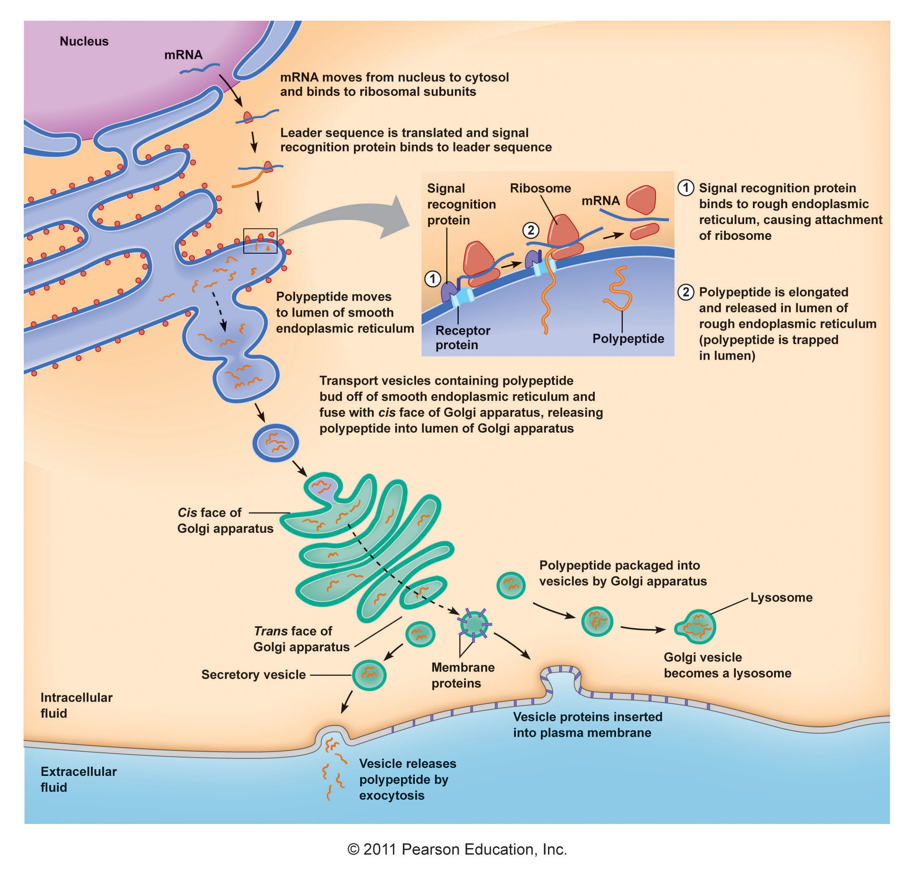
(Source: Droual, 2012)

References
College of DuPage (2000) Prokaryotic and Eukaryotic Cells [Internet], Center for Independent Learning. Available from <http://www.cod.edu/people/faculty/fancher/prokeuk.htm> [accessed 23 January 2013].
Droual, R. (2012) Chapter 2 - The Cell: Structure and Function [Internet], Physiology 101. Available from: <http://virtual.yosemite.cc.ca.us/rdroual/Course%20Materials/ Physiology%20101/Chapter%20Notes/Fall%202011/chapter_2%20Fall%202011.htm> [Accessed 23 January 2013].
eTeaching Assistance Program (n.d.) Prokaryotic and Eukaryotic Cells [Internet], Biology 1. Accessed from <http://etap.org/demo/biology1/instruction3tutor.html> [Accessed 23 January 2013].
Lodish, H., Berk, A. and Zipursky, S. (2000) Molecular Cell Biology [Internet]. New York, W H Freeman. Available from NCBI < https://www.ncbi.nlm.nih.gov/books/NBK21743/> [Accessed 23 January 2013].

