# Customer Relationship Management and Marketing in the Event Management (Entertainment) Business

## Table of Contents

1. Introduction 3

1.1. Research Background 3

1.2. Problem Statement 4

1.3. Research Aim & Objectives 5

1.4. Research Questions 5

1.5. Rationale of the Study 6

2. Literature Review 7

2.1. A Brief Understanding of CRM, Its Features and Solutions 7

2.2. Application of CRM and Its Practices in the Event Management (Entertainment) Business 8

2.3. Advantages and Demerits of Spasster in Improving CRM in the Event Planning Business 10

2.4. Positive and Negative Impacts of Using Spasster 12

3. Methodology 14

3.1. Research Method 14

3.2. Research Philosophy 14

3.3. Research Approach 15

3.4. Research Design 15

3.5. Data Collection Methods 16

3.6. Study Population, Sample Size & Sampling Method 16

3.7. Data Analysis 16

4. Results 17

4.1. Survey Responses 17

4.2. Interview Findings 23

5. Analysis and Discussion 25

5.1. CRM Features or Solutions Currently Being Practiced in an Event Management (Entertainment) Business 25

5.2. Case Study Analysis for Launching a New CRM Solution Spasster on the Market 26

5.3. Determination of Whether the Spasster Application is Unique, Customer-Oriented and Reliable 28

5.4. Ways to Utilize Spasster to Solve Current Challenges in the Event Management (Entertainment) Industry 29

6. Conclusions 31

References 34

Appendices 36

Appendix 1: Questionnaire 36

Appendix 2: Interview Questions 39

## 1. Introduction

### 1.1. Research Background

Customer relationship management (CRM) is an integrated approach aimed towards managing associations with the end users by emphasizing customer retention and relationship advancement. It combines procedures, people and technology that help in understanding the customers of a specific business firm (Catalan-Matamoros, 2004). The notion of CRM can be described from various perspectives, in terms of a strategy, a capability, a mechanism and a technological instrument to form, develop and preserve effective communication with the potential customers (Mishra & Mishra, 2009). The functionalities of CRM fundamentally encompass supporting a business enterprise to recognize its potential customers and deliver adequate information to the employees that are indispensable to understand their individual needs (Mohammed & Rashid, 2012). CRM is being used in almost every form of business or industry to enhance efficiency as well as effectiveness of the sales force, incorporating offerings throughout the operational channels and increasing ability towards targeting the profitable end users (Catalan-Matamoros, 2004). Similarly, the use of CRM can be witnessed in the event management (entertainment) business as an effective technology tool to understand the choices along with the preferences of the customers including the event goers and ensure growth in productivity along with profitability levels by creating strong relationship with them (Future Simple, Inc., 2013).

Use of CRM in events industry or an event management (entertainment) business is not a new phenomenon, as it facilitates seamless control and total visibility of all the associated members including the attendees, speakers, organizers and the planners. The advantages of using CRM in this particular industry or business are manifold that encompass better compliance as well as control with every activity associated with the events, enhanced event planning with seamless collaborative capabilities along with field feedback and streamlined events management procedure (Veeva Systems, 2017). Considering these benefits of CRM, Spasster Company intends to launch a new CRM solution called Spasster in the respective market with the objective of attaining predetermined business targets. The company has accordingly decided to take support from one of the most efficient event marketing groups throughout the globe named Bold Marketing Group in order to accomplish long-term success. This group contributed immensely in bridging the gap persisting between the event planners and the potential customers, which might create wider possibility for Spasster Company not only to preserve its competitiveness but also to ensure long-term sustainability in the respective industry.

### 1.2. Problem Statement

The focus of this study is to determine to the extent to which the Spasster is unique, reliable and customer oriented in nature. The issue is to be studied in order to acquire a concise understanding about how well this CRM application tool is aimed for the customers, reasons to regard this application as unique and the causes to rely on the same by the customers. In this context, various significant aspects, such as the current practices in the customer relationship management within the event planning business and the negative as well as the positive impacts of selecting Spasster as a CRM solution for a successful event management, will be addressed through this study. The other factors that will be addressed in this study are the advantages as well as the disadvantages of the new product, Spasster, and determining the ways through which this particular product in the form of an application is likely to solve any operational issue.

### 1.3. Research Aim & Objectives

Considering the need to analyze the application of CRM in the event business management procedure, this research aimed to investigate the level up to which the event planners and the organizers shall accept Spasster as an exceptional, customer oriented and a consistent application tool. The following research objectives have been accordingly framed for the purpose of this study.

* To acquire a brief understanding about the notion of CRM and its different features and solutions
* To determine the application of CRM in the event management (entertainment) business
* To evaluate the CRM practices that are currently existing in the event planning business
* To assess the positive and the negative impacts of the chosen CRM solution, Spasster, on the success of an event planning business
* To identify the advantages and the demerits of Spasster in improving CRM in the event planning business
* To suggest how Spasster can be used to solve the present challenges face by an event management business

### 1.4. Research Questions

* What are the CRM features or solutions currently being practiced in the event planning business?
* What will be the positive and the negative consequences of selecting Spasster, as an effective CRM solution for a successful event management business?
* What are the benefits and the disadvantages associated with Spasster?
* How Spasster will resolve few of the challenges that emerge during the conduct of operations within an event management business?

### 1.5. Rationale of the Study

Businesses operating in this modern day context desire to adopt effective measures and strategies to preserve competitiveness and sustainability. These measures and strategies fundamentally comprise improving product or service quality and accomplishing the requirements of the individual customers by constructing and developing strong relationship with them. The study is therefore expected to help in understanding the needs and the contributions of deploying CRM tools in supporting an event management (entertainment) business to attract the end users by offering them with exceptional event experiences. Irrespective of the fact that earlier studies have duly focused on the identified research issue, focusing on the affiliation existing between CRM and the overall performance of a business, there is a literature gap identifiable when determining the extent of this relationship, specifically in the context of event management (entertainment) business. Considering that the events industry is changing rapidly with the growing use of tools and applications to attract the event goers, it is expected that past researches have lost relevance to justify the identified study issue entirely and critically. Retrieving first hand data through questionnaire survey and interview is also expected to help in understanding the experiences of the potential customers and the event planners about boosting CRM in the event planning process by introducing Spasster in the market.

## 2. Literature Review

### 2.1. A Brief Understanding of CRM, Its Features and Solutions

According to Sharma (2012), CRM is regarded as an approach to enhance the performance of a business by facilitating it to move way from product-centric marketing approach and attracting the customers with greater intensity. Based on the observations made by Abu (2011), CRM can thus be defined as a strategic tool, which is concerned with the generation of enhanced shareholder value by forming, developing and maintaining suitable affiliations with the main end users and their respective segments. It delivers wider prospects to utilize data and extract complete information that can help in understanding the needs of the customers and creating greater organizational value (Abu, 2011). In relation to the study functions of Catalan-Matamoros (2004), the CRM approach combines three most significant factors, i.e. procedure, technology and people, to ensure seamless integration of data with improved marketing capabilities. This particular approach evolved as a major driver of maximizing overall customer value by identifying the distinctions existing in the purchasing habits and the preferences of the end users (Sharma, 2012, Abu, 2011). The study findings of Jelonek (2015) also highlighted that the distinctive characteristics of CRM approach include quick reaction towards the queries and the doubts of the customers, identifying their individual needs in an appropriate way and increasing the satisfaction level to the maximum possible extent.

Mishra & Mishra (2009) argued that gaining customer loyalty, ensuring customer retention, providing quality customer service and reducing customer complaints as the other vital characteristics of CRM approach. According to Jelonek (2015), CRM approach, under such circumstances, helps the business organizations to maintain customer loyalty by providing the end users with their required products on a continuous basis. Correspondingly, as mentioned in the study of Mishra & Mishra (2009), customer retention is ensured through CRM approach by addressing the fundamental needs of the end users that relate to quality and affordability of the respective products and/or services. Customer service and customer complaints are also interrelated to one another under the CRM approach, as the deliverance of effective customer service, in terms of time efficient response process to their queries as well as sufficing the desires of the end users, is likely to diminish the level of complaints made by them in a natural setting (Jelonek, 2015; Mishra & Mishra, 2009). According to Kale (2015) further, CRM applications or solutions deliver a common platform for the business organizations operating in this present competitive world wherein they can communicate and interact with the potential customers. It is hence believed that successful utilization of various CRM solutions ensures higher business growth by enhancing the level of customer responsiveness (Kale, 2015).

Notably, in relation to the study findings of Kale (2015), SAP CRM can be viewed as one of the efficient applications or solutions to support a business firm to remain connected with the potential end users. This particular CRM application offers open and flexible solutions that support databases, operating systems, applications and hardware platforms (Kale, 2015). It was thus that Kale (2015) noted the benefits associated with SAP CRM to include precise documentation of the operational systems, ensure consistent quality of functions being delivered and better substantiation of users’ requirements.

### 2.2. Application of CRM and Its Practices in the Event Management (Entertainment) Business

According to Mishra & Mishra (2009) and Catalan-Matamoros (2004), CRM approach represents the practices, technologies and the tactics used by the business firms to manage as well as examine customer interactions, leading towards improved relationship with the clients and driving product sales growth. Correspondingly, as identified by Abraham (2004), event management engages planning, arranging and performing various live events that might include a concert, a brand or product launch, a conference or even an exhibition. The distinct facets of an efficient event management process include selecting sites, scheduling tasks, setting budgets, obtaining required permits to host any event, arranging decor, managing parking along with transportation and preparing emergency plans among others (Abraham, 2004). In agreement to this notion, Capell (2013) were also of the view that the application of CRM in the event management (entertainment) business can be witnessed in the different forms of interacting with the customers by maintaining a database in MS-excel spreadsheet or in any other software to store their personal data. The use of CRM in the event management (entertainment) business will not only ensure greater interaction with the event goers, but also increase their satisfaction level at large by satisfying their individual desires based on the feedbacks obtained for a specific product and/or service (Capell, 2013).

Furthermore, Capell (2013) argued that the application of CRM in the event management (entertainment) business is expected to facilitate performing effective marketing of the events by motivating the event goers to share their individual contents through internet. Damm (2010) also mentioned that the application of CRM approach in this particular business segment provides a central knowledge base, which can be used to promote as well as raise the event numbers, leading towards increased profits. The notion of CRM has found its place in the event management or planning (entertainment) business owing to its capability to increase customer loyalty by providing event reminders as well as notifications to the individual attendees of an event (Damm, 2010). According to Capell (2013) and Damm (2010), the structured content management of an event management (entertainment) business is expected to be developed with the application of CRM approach. For instance, event classifications along with listings, integration of social media, featured events and member as well as non-member pricing are expected to be managed efficiently through the use of CRM, facilitating the business corporations to attain their predetermined objectives (Capell, 2013; Damm, 2010).

Therefore, with regard to the study findings of Capell (2013), CRM can be argued as playing an important role to ensure better management and improved performances of an event management (entertainment) business by tracking, storing and retrieving valuable information of the attendees. This feature of CRM is anticipated to support this kind of business to ensure maximum growth in the future by identifying the personal needs of the clients and providing them with excellent services (Capell, 2013). As depicted in the studies of Capell (2013) and Damm (2010), combination of people, procedure and technology through CRM approach may support an event management (entertainment) business not only to maintain its competitiveness level, but also to ensure sustainability for a longer time.

### 2.3. Advantages and Demerits of Spasster in Improving CRM in the Event Planning Business

According to Spasster (n.d.), privacy is a luxury and the event organizers possess an insignificant amount of customer data to enhance their business performance due to lack in forming, developing and preserving relationship with the end users. This particular factor also restricts an event management (entertainment) business to raise revenues as per the desired level by targeting their marketing on the correct channels (Spasster, n.d.). The report of Spasster (n.d.) also noted that the company provides exceptional services, such as collecting customer data, performing customer data trend analysis, developing event publishing as well as targeted marketing and improving the CRM procedure in alignment with its determined objectives. Notably, Spasster Company intends to launch a new CRM application or solution on the market named Spasster in order to enhance the association persisting with the customers, developing customer retention, escalating sales growth and thereby attaining a superior competitive positioning (Spasster, n.d.).

The findings presented in the report of Spasster (n.d.) elaborated that Spasster Company provides an exceptional service of using web interface to the event planners and the owners of an event management (entertainment) business. This particular service of the company enables the event planners as well as the business owners to understand their potential customers and perform effective marketing based on the strategies undertaken by them. Therefore, based on this deliverable of Spasster, a key advantage of the newly launched application in enhancing CRM within the event planning business is its contribution to the formation of direct communication with the end users, as per their obtained feedbacks. Furthermore, attracting the end users (i.e. the event goers) by publishing offers, providing discounts to them and decreasing the entry fee amounts, was the other fundamental advantage of Spasster, which helped in increasing profits of the company by an extensive level (Spasster, n.d.). According to the report published by Spasster (n.d.), there are numerous sites of event management available in the respective business markets, with the help of which the event planners or the owners of an event management (entertainment) business can attain their business goals within a specified timeframe. Thus, the launch of Spasster, as an effective CRM tool or application, is expected to facilitate the company in differentiating itself from others in terms of delivering quality services to the customers and conducting successful customer trend analysis (Spasster, n.d.).

Correspondingly, as identified in the report of Spasster (n.d.), there are certain disadvantages of developing and using the CRM application of Spasster. For instance, Spasster Company requires developing an efficient marketing strategy and a viable business plan to increase the sales of the new product. Moreover, a few cross-platforms including Android, Windows and IOS are required to be used while developing the CRM tool or application. This can be a costly attempt and time consuming as well, restricting the event planners or the owners of an event management (entertainment) business to maximize revenues. Even though the level of competitive advantage of Spasster is high, the personal investments specifically from the developers, sales team and the business owners will be extensive to attain desired objectives (Spasster, n.d.). According to the report published by Spasster (n.d.), another disadvantage of Spasster can be identified as the reluctance of the end users, such as the attendees, in using this particular CRM application or tool due to excessive time required to check-in and check-out. Increased focus on conducting SWOT analysis appropriately, which necessitates business management knowledge of the members, might prove to be another disadvantage of using Spasster making the decision-making process more complicated and time consuming (Spasster, n.d.).

### 2.4. Positive and Negative Impacts of Using Spasster

Considering that the event management market is still quite young, introduction and use of Spasster will have a positive impact on the improvement of CRM in an event planning business. With regard to the report published by Spasster (n.d.), event management tools or applications, based on the CRM approach, provide exceptional services to the end users that encompass table management, customer trend analysis and guest list among others. Successful deliverance of these services is likely to have a further impact on both the event planners and the owners of an event management (entertainment) business. For instance, the positive impacts of using the CRM tool or the application of Spasster on the event planners can be recognized as an indication of improved relationship with the attendees, higher interaction with them, proper identification of their individual needs and increased scope to raise customer loyalty. Correspondingly, in case of the owners of an event management (entertainment) business, the positive impacts of using Spasster can be determined as improved operational productivity, increased product sales, rise in profits in terms of market share and chance of attaining higher level of competitive advantage in the respective industry (Spasster, n.d.).

As already mentioned, Spasster Company is interested to acquire support from Bold Marketing Group with the intention of attaining long-term success. This is likely to impose positive impacts on the business performance of this company by implementing new ideas to convince more people, develop effective communication and interact with them as per the desired level (Spasster, n.d.). Considering the findings presented in the report of Spasster (n.d.), Bold Marketing Group is expected to help Spasster Company in pushing the customers to use the new CRM application, Spasster, along with certain value added services including decline in the entry levels of the end users during check in as well as check out and developing social gaming attributes, as per the needs and the choices of the customers (Spasster, n.d.). According to Spasster (n.d.), the positive impacts of introducing the CRM tool or the application of Spasster can be identified in terms of customers’ encouragement to use this app extensively and enhance CRM in the event planning business by providing smart as well as quick check-in/check-out options. However, introduction of Spasster involve certain disadvantages as well, having a negative influence on the business performance of Spasster Company. These advantages are related to cost and time that might restrict the company to attain superior level of competitive positioning in the respective industry as compared to others (Spasster, n.d.).

## 3. Methodology

### 3.1. Research Method

A qualitative research method is adopted for this study in order to explore the phenomenon about the degree up to which the event planners and the business owners find the CRM tool or the application of Spasster as reliable, customer-oriented or exceptional in nature. This particular research method helped the study to determine the CRM features or solutions being currently practiced in an event management (entertainment) business. Moreover, the positive along with the negative impacts of the selected CRM solution, of Spasster, on the success of an event planning business and examining the ways through which this solution can resolve any sort of operational challenge have been explored in this study through the utilization of the qualitative method. The qualitative research method selected for this study supported performing a systematic examination about the roles played by CRM based tools or applications, such as Spasster on the overall performance of an event management (entertainment) business (Kruger, 2010).

## **3.2. Research Philosophy**

Realism research philosophy was adopted for this study in order to determine the ways through which behaviors and attitudes help in creating and changing the social world (Gerrish & Lacey, 2010). With regard to the identified study issue, analyzing the effectiveness of CRM and marketing in an event management (entertainment) business, launching Spasster in the market, can be considered as one of the behavioral attitudes of Spasster Company, which assist in transforming the social world by attracting the attendees towards a specific event. Execution of realism research philosophy also assisted this research to assess the impacts of Spasster on the success of an event planning business, suggesting the measures through which this CRM tool or application can be utilized to solve the challenges that are presently facing by an event management business. This particular research philosophy is deemed as relevant to the research, as a critical discussion can be made about the advantages as well as the demerits of launching Spasster.

### 3.3. Research Approach

Considering that a qualitative method is adopted for this study, execution of deductive approach is deemed as appropriate to draw valid inferences. Use of deductive research approach proved to be beneficial for this study, as it helped extracting information from more general to more specific observations (Collins, 2010). For instance, the research initially started with providing a brief introduction about the identified study issue, followed by reviewing relevant literatures, understanding methodologies to be used, presenting results along with analyzing the same and discussing as well as drawing valid conclusions. This top-down approach certainly helped in addressing the aim, objectives and the research questions determined for this study.

### 3.4. Research Design

A case study based research design has been explored in this research in order to investigate the launch of a new product in depth, which can be used for testing theoretical frameworks in real world situations (Zainal, 2007). In accordance, an attempt was made to examine the possible impacts of Spasster on the success of an event management (entertainment) business. The case study based research design for this study helped in understanding the complex issues faced by an event management (entertainment) business and the capability of Spasster to resolve the problems noted.

### 3.5. Data Collection Methods

Both primary and secondary methods of data collection have been utilized for this study in order to draw valid conclusions. Stating precisely, secondary data is collected from scholarly journals, books, articles and authentic online reports that relate to the study issue identified. Correspondingly, primary data is gathered from the conduct of questionnaire survey and interview.

### 3.6. Study Population, Sample Size & Sampling Method

Questionnaire survey is conducted with the potential customers related to an event management (entertainment) business that included the students and the party-goers. The sample size considered for the survey was 40. Non-probability sampling method was used while selecting the survey participants based on their availability. Correspondingly, an attempt was made to interview 5 event planners based on the convenience sampling method. The reasons for selecting non-probability and convenience sampling procedures for this study were eradicating collection of ambiguous data due to having lower study population, cost along with time-effectiveness, easy to process and ensuring better access to the participants’ responses (Sekaran & Bougie, 2010).

### 3.7. Data Analysis

After the collection of both primary and secondary data for this study, the data gathered were analyzed through the portrayal of charts along with graphs and case study analysis method. Simultaneously, the case study focused on the launch of a new CRM solution called Spasster on the market by Spasster Company.

## 4. Results

The results retrieved from questionnaire survey and interview have been analyzed and discussed in this particular chapter through the depiction of charts or graphs and undertaking a case study analysis to extract information from the data gathered.

### 4.1. Survey Responses

Question number 1 was designed for this study in order to obtain the personal information of the involved survey participants, i.e. the students and the party-goers, regarding their age. Based on the responses obtained, 35% of the total respondents affirmed to belong to the age group of 15-20 years, indicating their interest level to attend any specific event. Another set of 30% respondents were from the age group of 20-25 years, while only 10% of the involved survey respondents were aged above 30 years (refer to figure 1 below).

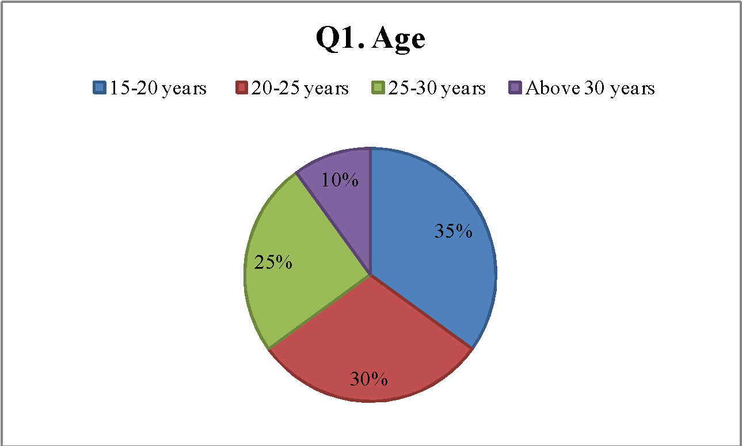

**Fig.1: Age**

With reference to the questionnaire prepared for this study, the second question was designed in order to understand whether the participants involved in the survey have interest to attend any particular event being held in different locations. In response, 25% of these respondents stated that they have an interest to attend events, whereas the remaining 15% of them showed no interest (refer to figure 2 below). Better performance of the artists and attractive location can also be considered as the important factors that create an interest amid the individuals to attend any event.

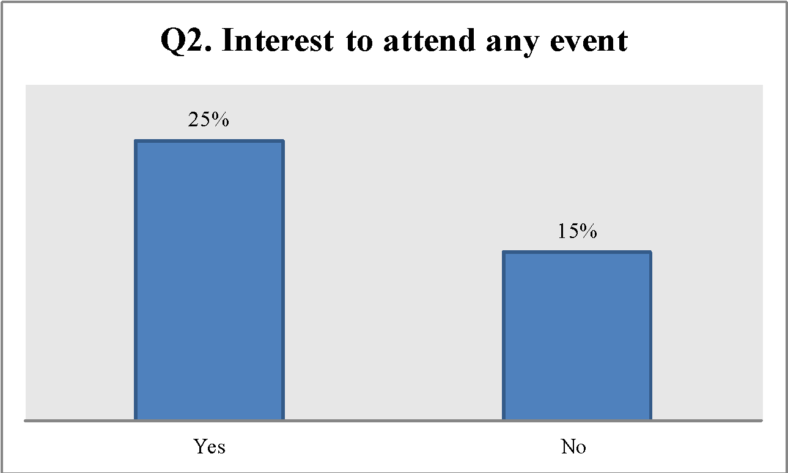

**Fig.2: Interest to attend any event**

Based on the responses acquired from question number 3, 21% of the involved survey participants responded that they regularly attend events that take place in any particular location. However, the remaining 19% of the participants answered that they occasionally attend events being held in any place (refer to figure 3).

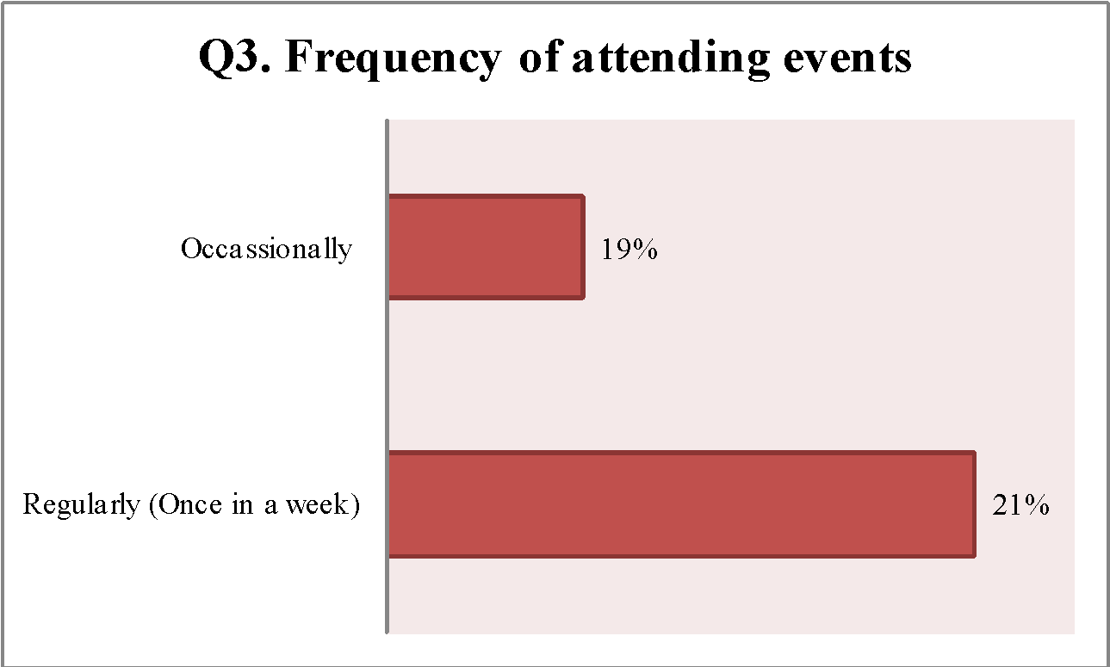

**Fig.3: Frequency of attending events**

The 4th question was aimed at determining whether the event attendees, such as the students and the partygoers are updated with any kind of information regarding an event prior to attending the same. In response, 75% of the participants involved in the survey answered that that they are updated with every kind of event related information before attending the same. Correspondingly, 25% of these participants replied that they are not updated with any kind of information associated with an event prior to attending the same (refer to figure 4).

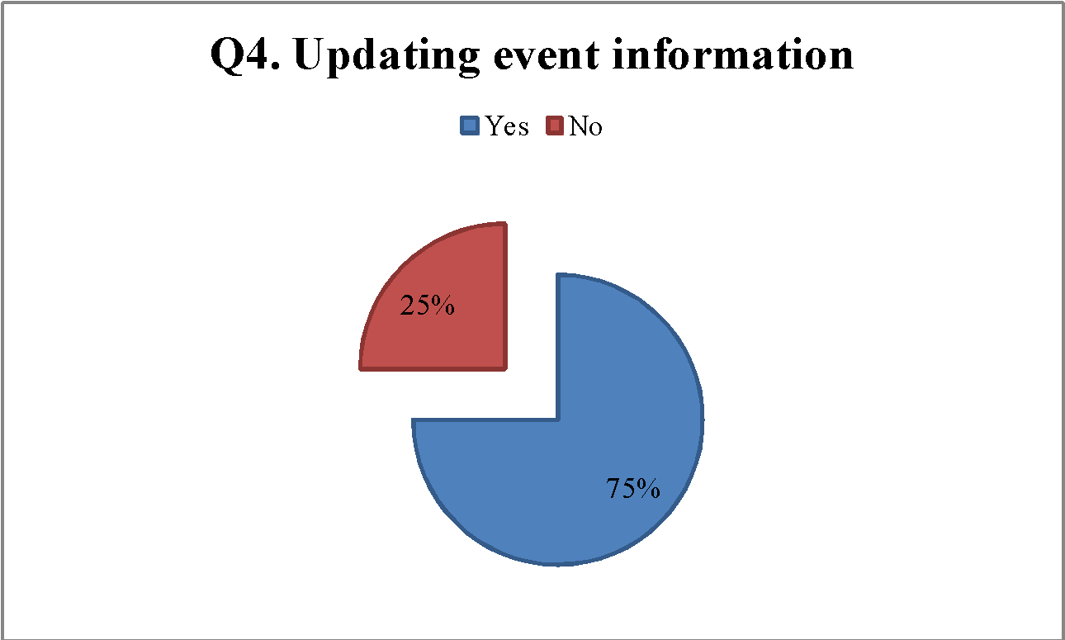

**Fig.4: Keeping the event goers updated about event information**

Question number 5 intended to identify and analyze whether the event management companies provide information to the attendees regarding any event. In this context, 27% of the participants answered that the event management companies offer vital information to them, which may include event details, timing and the artists to be participating in the stated event. Nonetheless, the remaining 13% of the survey participants asserted that the event management companies do not provide any sort of event related information to them (refer to figure 5 below).

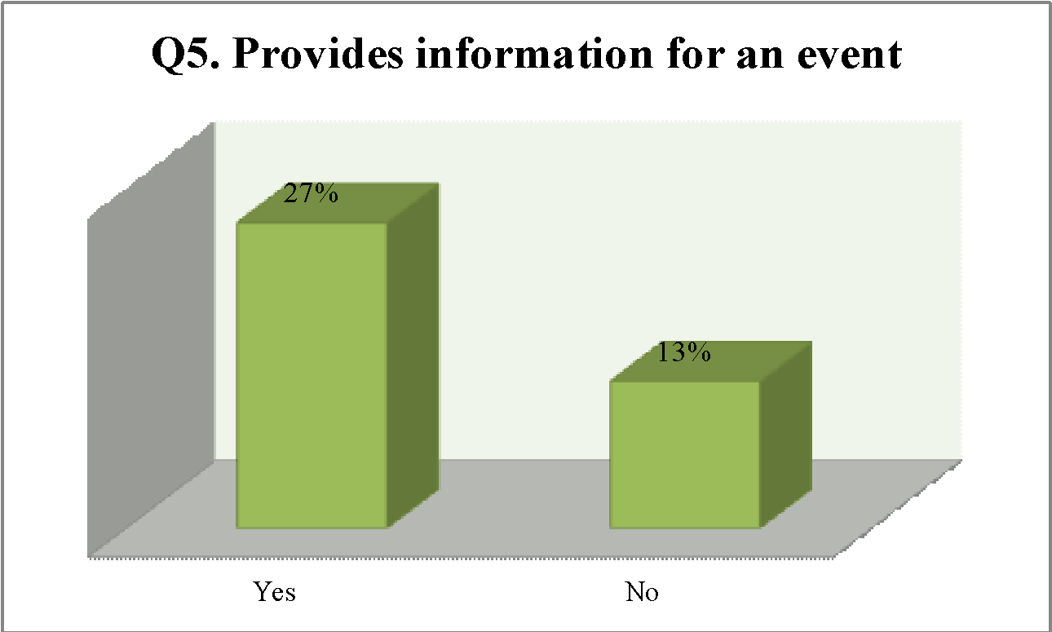

**Fig.5: Provide information regarding an event by the event management companies**

The 6th question was designed for this study with the objective of examining whether the use of different apps by the event management companies help the event-goers to obtain ample information about any particular event in detail. In response to this question, 11% of the survey respondents strongly agreed and 9% agreed to the statement that the event management companies use different applications to provide them with any kind of event related information. Based on the obtained literature review findings, it is therefore apparent that the event management companies desire to introduce and launch applications for the purposes of developing relationship with the customers and interact with them (Spasster, n.d.). However, 6% of the involved survey respondents strongly disagreed to the notion (refer to figure 6 below).

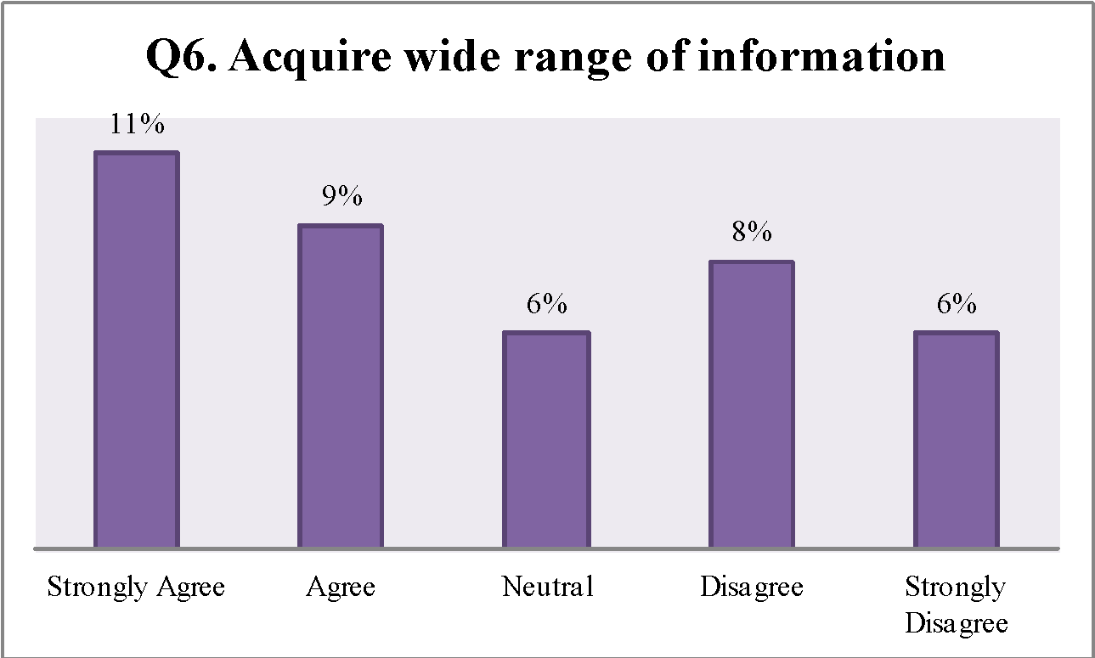

**Fig.6: Use of different apps to acquire ample information about an event**

In relation to question number 7 designed for this study, 14% of the involved survey respondents asserted that they can adopt decisions regarding the selection and the visit of any event through the information presented in the apps by the respective event management companies. However, only 6% of these respondents disagreed to the statement (refer to figure 7 below).

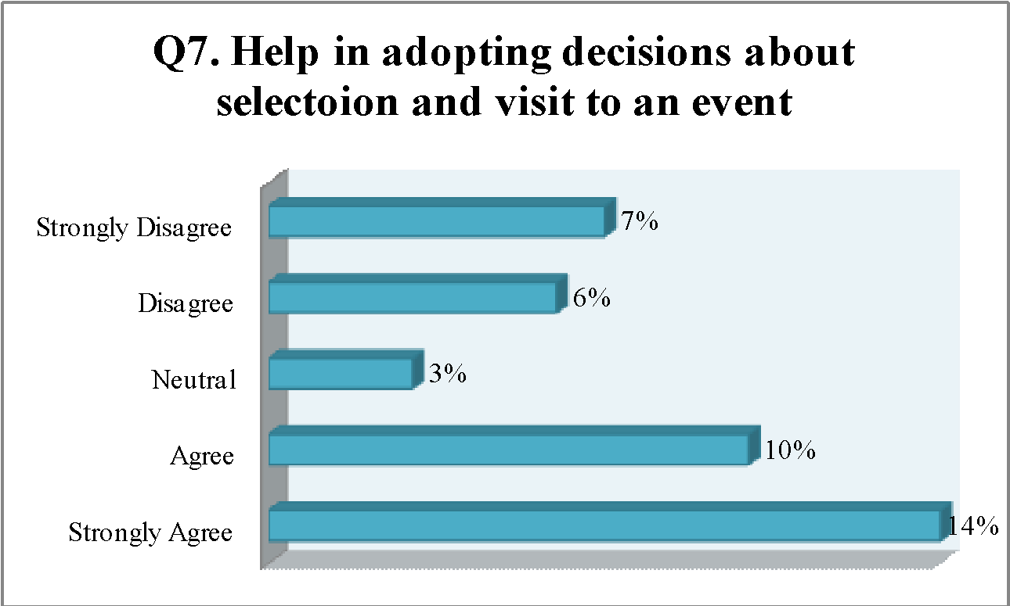

**Fig.7: Information provided in the apps helps in adopting decisions about selection and visit of an event**

Based on the responses retrieved from question number 8, 23% of the involved survey respondents strongly agreed that introduction of apps by the event management companies motivates them to share individual contents about an event through internet. Correspondingly, a small number of these respondents i.e. 2% of them strongly disagreed to the mentioned statement (refer to figure 8 below).

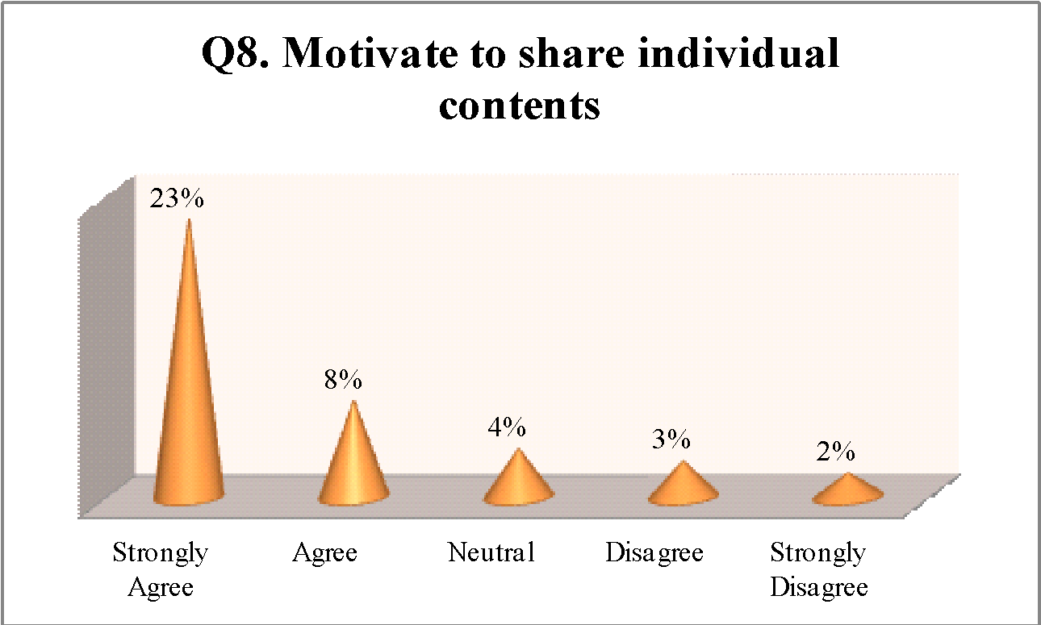

**Fig.8: Motivate to share individual contents about an event by the apps**

According to the responses received from question number 9 designed for this study, 70% of the participants involved in the survey think that event related information, which is presented in the apps by the event management companies, provide benefits and excellent services to them. These benefits and services may encompass reduction on entry during check-in as well as check-out and performing social gaming functions in the future. However, the remaining survey respondents i.e. 30% of them opposed to the statement (refer to figure 9 below).

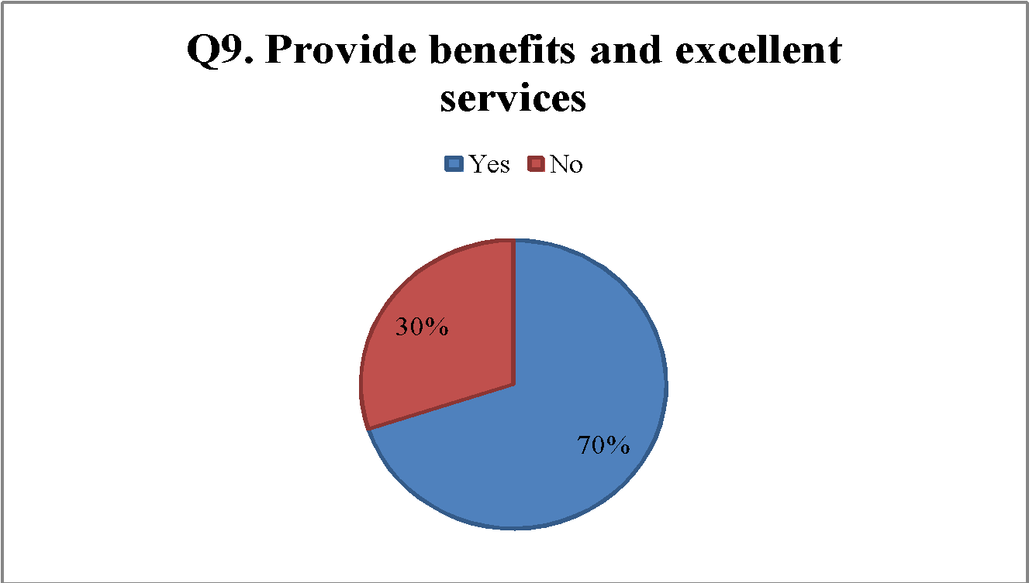

**Fig.9: Information presented in the apps provides benefits and excellent services to the event attendees**

Question number 10 designed for this study provided a better understanding about the notion that the apps utilized by the different event management companies attract the event goers to stay connected with them and create an interest to visit any kind of event further. According to the obtained survey results, 20% of the involved participants responded that they are interested to stay connected with different event management companies and desire to visit any kind of event further because of useful and required information delivered to them through apps. However, only 3% of the respondents strongly disagreed to such a belief (refer to figure 10 below).

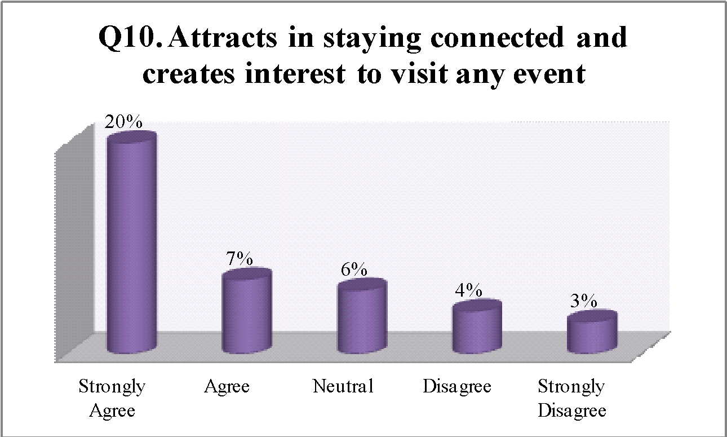

**Fig.10: Use of apps attracts the event goers to stay connected and increase their interest to visit any event further**

### 4.2. Interview Findings

Interview results were gathered from the event planners who have been working in the event management industry for numerous years for the purpose of this study. Most of the interviewees responded that the clients in this present day context have become quite demanding about obtaining quality products and/or services with a growing tendency to shift from one specific business firm to the other. This can be owing to the reasons of continuously changing business market conditions and the introduction of new technologies in the market (Abu, 2011). According to a major proportion of these interviewees, use of CRM tools or applications by the companies help in ensuring better interaction with the customers, such as the event goers or the attendees by ensuring seamless integration of data and enhancing marketing skills. Moreover, other features of CRM applications that include quick response towards the queries along with the doubts of the end users and recognizing their individual needs cannot also be ignored to have helped the companies to interact proficiently with them (Jelonek, 2015; Sharma, 2012; Abu, 2011).

With regard to the interview results obtained for this study, it can thus be inferred that the launch of Spasster application will provide significant benefits to Spasster Company not only in terms of developing effective communication with the end users, but also by obtaining greater level of competitive advantages as well. According to most of the interviewees, the introduction and the launch of Spasster is likely to enhance the CRM procedure of the company by gathering ample customer related data, improving event publishing as well as targeted marketing and conducting customers trend data analysis efficiently. The obtained interview results also suggested that the Spasster Company should perform certain activities in order to ensure successful launch of Spasster and thereby, attain predetermined goals. These activities might comprise crafting a successful marketing strategy and preparing a viable business plan among others.

## 5. Analysis and Discussion

### 5.1. CRM Features or Solutions Currently Being Practiced in an Event Management (Entertainment) Business

The secondary sources reviewed in this study revealed that the CRM approach has evolved as an important strategic tool, which facilitates the business corporations to generate improved shareholder value by maintaining smooth relationships with the potential customers (Sharma, 2012; Abu, 2011). This particular concept and its associated features or solutions are identified to be practiced in an event management (entertainment) business as well. For instance, as per the obtained literature review findings, this kind of business can form, develop and maintain a successful relationship with the customers besides interacting with them by constructing a database in excel spreadsheet or in any other software. It is therefore expected that personal data of the customers is being stored in this database with the objective of communicating with them further by providing them with any kind of information relating to any event (Capell, 2013). Similar findings can also be witnessed in the primary data collected for this study through the questionnaire survey, wherein 27% of the involved students and the party-goers agreed that the event management companies provide them relevant and valuable information to them regarding any event.

The literature review results obtained for this particular research further denoted that there are numerous CRM solutions, utilized by the business firms to strengthen the communication procedure with the potential customers and thereby, ensure increased operational growth. According to these findings, one of these CRM solutions entails SAP CRM, which provides flexible and open solutions towards supporting operating systems, databases and hardware platforms as well (Kale, 2015). It is accordingly expected that this particular CRM solution can also be related to an event management (entertainment) business with the help of which various significant benefits can be obtained, especially in terms of accurate documentation of the operational systems and consistent development in the quality of functions. These benefits, as associated with SAP CRM, are likely to support this kind of business not only to interact heavily with the customers, but also to attain higher comparative advantage in comparison with others (Kale, 2015). In general, the characteristics of an event management procedure fundamentally encompass selecting locations, delegating tasks to the appropriate members, preparing budgets and organizing logistics among others. Under this circumstance, use of effective CRM tools or applications is likely to raise the potentiality of an event management (entertainment) business to improve coordination amid the members and ensure long-term sustainability by captivating the interests of both the stakeholders and the customers (Abraham, 2004).

### 5.2. Case Study Analysis for Launching a New CRM Solution Spasster on the Market

Considering that the notion of CRM has emerged as a vital area of concern for any venture to maintain competiveness in this contemporary business world, Spasster Company decided to launch a new app named Spasster in the respective market. According to the company, the key deliverables of this application will be to mitigate the gap persisting amid the entertainment industry and its potential customers. The company has accordingly thus decided to take assistance from Bold Marketing Group, which has its huge contribution in bridging the gap prevailing between the event planners and the customers. In accordance, the findings obtained through the literature review helped identify that there are several applications, such as Pinterest and Evernote, which are currently being used by the event planners to conduct a successful event with attracting huge figures of the customers and thereby increasing the revenues earned. Illustratively, Pinterest is a commonly used app, which is renowned for the collection and the sharing of images, while Evernote is known for helping in keeping texts, notes or images in one convenient place. This particular app is likely to help the event planners in organizing any event by categorizing materials through adding tags, leading towards smooth and successful completion of an event (Haselmayr, 2015). Thus, it is apparent that Spasster Company is likely to face tough business competition while launching the Spasster in the respective market.

Based on the provided case study information, the other deliverable of the Spasster application to be launched by Spasster Company, it can be forecasted to help the event management (entertainment) industry in organizing various parties efficiently that included regular club nights, parties, gigs, concerts and bar events. The fundamental characteristic of this application will accordingly be to assist the event organizers in collecting reliable data of the customers, including information on their age, nationality and gender. Considering that Spasster will also be featured with an easy web interface technology infrastructure for the event planners, it is likely to maintain customer relationships via tailored messaging and targeted offers (Linof & Berry, 2011). In this competitive business setting wherein creating and attracting new potential customers are regarded as the most difficult tasks for the firms, there is a necessity for them to retain the present customers, as they are the ones who generate new sales in frequent intervals and thereby raise organizational efficiency. Therefore, based on these notions, it can be stated that launching Spasster as a new CRM solution in the respective market will not be easy for Spasster Company, as there are numerous apps in the market to attract the customers. Under this circumstance, the company needs to adopt certain effective measures and apply strategies not only to develop effective relationships with the end users, but also to retain competitiveness by an extensive level.

Suggestively however, the Spasster Company can adopt the measure or apply the strategy of explaining the fundamental key performance indicators (KPIs) for Spasster to the customers.

According to one of the literature review findings, the KPIs for this new application can be better explained as Join vs Check-in, Nationality vs Check-in, Age vs Check-in, Satisfaction vs Check-in, City vs Check-in and Gender vs Check-in. Based on these findings, the KPI of Join vs Check-in focuses on determining the number of people who have joined any party through the event page checked in at reception. Correspondingly, the response of the people towards any marketing campaign held by an organization based on age is determined through the KPI of Age vs Check-in. Satisfaction vs Check-in, in this context implies evaluating the feelings and the happiness of the people based on certain potential assumptions. The KPI of Nationality vs Check-in emphasizes increased focus on the development of marketing campaigns, as per the nationality of the people. People attending a specific party and thereby driving longer distances in comparison with others are determined through the KPI of City vs Check-in. In accordance, Gender vs Check-in assists in comprehending the trends of the males and the females in joining parties instead of others (Spasster, n.d.).

### 5.3. Determination of Whether the Spasster Application is Unique, Customer-Oriented and Reliable

According to the secondary research findings, Spasster will be introduced and launched as a new application in the market with the objective of supporting the event management (entertainment) industry to organize various events including parties and bar events efficiently. It is expected that the event planners will be able to collect as well as store customer data relating to their joining in any event based on age, nationality and gender among others through the use of the new application. This particular application is hence deemed as unique and customer oriented in nature due to its capability to provide options for the customers to give their individual feedbacks and enable them to directly communicate with the event organizers (Spasster, n.d.). Similar viewpoints have also been retrieved from the obtained primary data through questionnaire survey, revealing that the introduction of apps by the event management companies motivate the attendees to share individual contents about an event through internet, establishing strong and effective communication with the event organizers or the planners. Correspondingly, the interview results also portrayed that the CRMN based applications used by the event management companies, help in ensuring higher interaction with the customers through promoting seamless integration of data and developing marketing skills.

With regard to the information provided in the case study further, reliability of the new application to be launched in the market, Spasster, can be determined based on its capacity to offer quick and smart check-in/check-out options to the end users including principally the party goers. Successful execution of this ability of the new application is also much likely to help Spasster Company in attracting huge figures of the customers and thereby raising profits by generating interest amid the attendees to visit any event further. The primary data acquired for this study through the questionnaire survey also represented similar findings implying that effective utilization of apps by the different event management companies attract the attendees to stay connected with the event planners or the organizers and thereby augment an interest to visit in every sort of events in the future.

### 5.4. Ways to Utilize Spasster to Solve Current Challenges in the Event Management (Entertainment) Industry

Based on the given case study information, business owners involved in the entertainment industry do not possess any way to form, develop as well as maintain effective relationship with the customers and analyze their individual choices or preferences. This can be owing to the reason of extreme dependence over the people, process and the modern technologies as well. Arguably, the mentioned detail is deemed as a challenge for an event management (entertainment) industry, as this restricts the gap existing between this specific industry and the customers. Suggestively thus, an event management (entertainment) industry should focus on retaining its present customers and attracting the new ones in order to maintain competiveness and ensure long-term sustainability. Since Spasster Company is attempting to launch Spasster, it is forecasted that this new application will help in constructing favorable relationship with the customers and retaining them for a longer time by collecting along with storing customer data in a database and providing an easy to execute web interface to the event planners.

In today’ marketplace, which is competitive to its highest potentials in nature, the event management (entertainment) industry should transform their business or operational strategies from becoming more customer focused than being product oriented. This requirement of change from developing product and/or service quality to construct a favorable relationship with the customers has certainly led towards the creation of a new marketing era of ‘rethinking marketing’. Presently further, the notion of CRM is regarded as the most effective tool, which helps an organization to attain its predetermined business or operational targets within a specified timeframe. Based on the findings retrieved from one of the secondary sources for this study, publishing offers along with discounts through Spasster and decreasing entry fees for the party-goers can be considered as the ways through which the identified challenges being faced by an event management (entertainment) industry are resolved to the maximum possible extent.

### 6. Conclusions

The different CRM features or solutions that are currently being practiced in an event management (entertainment) business are creating a database in MS-excel spreadsheet or in any other software wherein customer related information can be stored and maintained through hardware platforms using the SAP CRM program. Based on the findings retrieved from case study analysis approach adopted for this study, Spasster Company, with the intention to launch Spasster application in the market, has been aiming to bridge the gap existing between the entertainment industry and the customers. There is substantial degree of business market competition in this particular industry, as the event management companies adopt significant measures and apply strategies to attract the event attendees at large. One of these measures and/or strategies includes using various applications, so that the customers are attracted towards visiting any event by providing them with necessary information or data. A few of the applications that are presently being practiced in an event management (entertainment) business or industry are Pinterest and Evernote among others. Therefore, launching Spasster in the respective market will be tough for the company for which it needs to apply certain effective strategies, such as creating a viable business plan.

The positive and the negative impacts associated with the use of Spasster include enhanced relationship with the end users, better prospect to increase customer loyalty and difficulty to attain competitive advantages because of the involvement of high costs as well as time. According to the case study analysis findings thus, the event management (entertainment) industry is facing the challenge of maintaining favorable relationship with the customers due to heavy reliance on technology, people and process. Use of Spasster is likely to mitigate this challenge by gathering along with storing customer information in a database and offering an easy to use web interface to the event organizers and the planners as well. Furthermore, the overall primary data obtained for this study through questionnaire survey and interview highlighted that the business owners of an event management (entertainment) can develop a strong and a favorable relationship with the customers by motivating them to share individual contents about an event through the application of Spasster. In addition, considering that successful execution of Spasster will attract the event goers to stay connected with the event organizers or the planners and thereby raise their interest to visit any kind of event in thr future. It is thus that the business owners are expected to ensure long-term sustainability in the respective industry.

Selection of appropriate literature relating to the identified study issue had certainly increased the reliability of this research by a considerable level. Moreover, conduct of few ethical practices that encompassed obtaining informed consent from the involved respondents prior to their participation in survey and interview procedures also increased the reliability of the findings retrieved for this study. Irrespective that previous researches have covered the research issue, focusing on the relationship existing between CRM and improved business or operational performance, there is a literature gap identifiable when determining the extent of this relationship, specifically in an event management (entertainment) industry. Notably, as the research was performed with the objectives of identifying and analyzing the extent of the stated relationship from a broad perspective, is the findings can be noted as applicable to event management (entertainment) industry fundamentally, besides supporting the event managers and the planners to attract the attendees by offering them with exceptional event experiences. Considering that this particular industry is transforming rapidly, it is quite likely that previous studies have failed to maintain relevancy while addressing the identified research issue critically. Addressing this particular gap identified in the literary field, this research emphasized obtaining primary data via questionnaire survey and interview techniques. Obtaining first hand data through these methods of data collection is expected to help in understanding the impacts of Spasster application on the performance of event management (entertainment) business or industry in the future.

## References

Abu, L. E. B., 2011. Chapter Two: Literature Review. *Customer Relationship Management as A Strategic Tool for Competitive Advantage: (A Case of Sic Insurance Company Limited), pp. 23-27.*

Abraham, S., 2004. Introduction to Events. *Event Management, pp. 3-4.*

Catalan-Matamoros, D., 2004. The Concept of CRM. *An Overview to Customer Relationship Management, p. 2.*

Capell, L., 2013. *Event Management for Dummies*. John Wiley & Sons.

Collins, H., 2010. *Creative Research: The Theory and Practice of Research for the Creative Industries.* AVA Publishing.

Damm, S., 2010. *The Implications of Best Practice Event Management When Applied To Small-Scale Local Events.* diplom.de.

Future Simple, Inc., 2013. A CRM Software for Event Organizers Can Help You Gather Valuable Analytics. *CRM Software for Event Organizers. [Online]* Available at: https://www.futuresimple.com/crm-software-for-event-organizers/ [Accessed June 17, 2017].

Gerrish, K. & Lacey, A., 2010. *The Research Process in Nursing*. John Wiley & Sons.

Haselmayr, M., 2015. 9 Great Apps for Event Planners and Wedding Planners. *Entrepreneurs. [Online]* Available at: https://www.forbes.com/sites/allbusiness/2015/05/02/9-great-apps-for-event-planners-and-wedding-planners/#436fdd7679ff [Accessed June 19, 2017].

Jelonek, D., 2015. The Evolution of Customer Relationship Management System. *Recent Advances in Computer Science, pp. 29-30.*

Kale, V., 2015. Introduction to Customer Relationship Management (CRM) Systems. *Chapter 2: Customer Relationship Management (CRM) System, pp. 67-69.*

Kruger, H. H., 2010. *Qualitative Analysis and Documentary Method in International Educational Research.* Barbara Budrich.

Linoff, G. S. & Berry, M. J., 2011. *Data Mining Techniques: For Marketing, Sales, and Customer Relationship Management*. John Wiley & Sons.

Mishra, A. & Mishra, D., 2009. Customer Relationship Management: Implementation Process Perspective. *Acta Polytechnica Hungarica, Vol. 6, No. 4, pp. 83-87.*

Mohammed, A. A. & Rashid, B. B., 2012. Customer Relationship Management (CRM) in Hotel Industry: A Framework Proposal on the Relationship among CRM Dimensions, Marketing Capabilities and Hotel Performance. *International Review of Management and Marketing, Vol. 2, No. 4, pp. 220-230.*

Sekaran, U. & Bougie, R., 2010. *Research Methods for Business: A Skill Building Approach*. John Wiley & Sons.

Sharma, J. K., 2012. Review of Literature on CRM. *Literature Review, pp. 1-3.*

Veeva Systems, 2017. Veeva CRM Events Management. *Products. [Online]* Available at: https://www.veeva.com/products/multichannel-crm/events-management/ [Accessed June 17, 2017].

Zainal, Z., 2007. Case Study as a Research Method. *Jurnal Kemanusiaan bil.9, pp. 1-2.*

## Appendices

### Appendix 1: Questionnaire

Q1.) Age

15-20 years [ ]

20-25 years [ ]

25-30 years [ ]

Above 30 years [ ]

Q2.) Do you have interests to attend any particular event held in different locations?

Yes [ ]

No [ ]

Q3.) How frequently you attend events that take place in any particular location?

Regularly (Once in a Week) [ ]

Occasionally [ ]

Q4.) Are you updated with any kind of information related to an event prior to attending the same?

Yes [ ]

No [ ]

Q5.) Do event management companies provide you any information regarding an event?

Yes [ ]

No [ ]

Q6.) Use of different apps by the event management companies helps you to acquire wide range of information regarding any specific event in a detailed way.

Strongly Agree [ ]

Agree [ ]

Neutral [ ]

Disagree [ ]

Strongly Disagree [ ]

Q7.) Information presented in the apps by the event management companies help you to adopt decisions regarding the selection and the visit of any event.

Strongly Agree [ ]

Agree [ ]

Neutral [ ]

Disagree [ ]

Strongly Disagree [ ]

Q8.) Introduction of apps by the event management companies motivate you to share individual contents about an event through internet.

Strongly Agree [ ]

Agree [ ]

Neutral [ ]

Disagree [ ]

Strongly Disagree [ ]

Q9.) Do you think that the event related information, which is presented in the apps by the event management companies, provide you benefits and excellent services?

Yes [ ]

No [ ]

Q10.) Apps utilize by the different event management companies attract you to stay connected with them and create an interest to visit any kind of event further.

Strongly Agree [ ]

Agree [ ]

Neutral [ ]

Disagree [ ]

Strongly Disagree [ ]

### Appendix 2: Interview Questions

Q1.) For how many years you have been working in the event management industry?

Q2.) Do you think that nowadays the clients have become demanding about obtaining quality products and/or services with an increasing tendency of shifting from one particular company to another?

Q3.) Does use of CRM based tools or applications by the companies help in ensuring better interaction with the end users such as the event goers or the attendees? If so, how?

Q4.) Do you believe that the launch of Spasster application will provide significant benefits to Spasster Company?

Q5.) According to you, what activities does Spasster Company should perform in order to ensure successful launch of Spasster and thereby attain predetermined goals?