G.I.S and Its Application In Archeology

Introduction
Geographical Information Systems (GIS) were a groundbreaking technology for which archeologists have developed multiple uses since its inception. GIS has grown to be an important tool in archaeological investigation as it is used in various areas, ranging from the identification of sites to the analysis of archaeological material. The nature of archaeological data, i.e. being spread over space and time, makes GIS an indispensable tool as it is flexible and arguably the best-suited system to analyze the spatial context of data from the historical and pre-historical eras. The current paper reviews the application of GIS in archaeological work, beginning with a discussion of what GIS is and how it works, and then its applications in archeology. The paper concludes with a discussion of how it has contributed to archeology at present and in the future.

GIS defined
Star and Estes (1990, p. 2), defined Geographical information systems as “An information system that is designed to work with data referenced by spatial or geographic coordinates. In other words, a GIS is both a database system with specific capabilities for spatially-referenced data as well as a set of operations for working (analysis) with the data.” Another definition by Burrough (1986, p. 6) is that it is a “powerful set of tools for collecting, storing, retrieving at will, transforming, and displaying spatial data from the real world for a particular set of purposes.” GIS then can be defined as computer systems that can be used to keep, manipulate, dissect and display data about geographic space.
GIS is a combination of a number of technologies, ranging from computer-aided mapping and cartography, database technology, spatial analysis and statistical application software, data visualization, computer graphics and image processing among others (Renfrew and Bahn 2011). Subsequently, GIS is a crucial software for scientists who wish to manage, analyze and display geographic data as it also comprises of key concepts like metadata, logic workflows, Geodatabases as well as maps and globes.

How GIS works
GIS was developed based on knowledge drawn from the fields of mathematics, computer science, cartography, and geography. According to Renfrew and Bahn (2011), some of the key functions that make GIS appropriate for archeological investigations include data entry, the ability to store and retrieve data, manipulate and analyze data, information visualization and reporting, and a user interface. Data entry involves the conversion of either unprocessed or partially processed data into a sequence of data elements which have controlled and known characteristics. This is the first step in the sequence of geospatial work, and it involves collecting data that is in digital form. The function of storage and retrieval of data facilitates the storage of geospatial, qualitative, and topological data and also ensuring it is linked with other external database systems. The function of manipulation and analysis facilitates the transformation of data among other roles such as spatial analysis and modeling. Analysis in GIS can be done through data mining and forecasting, surface generation, use of cost path tools, and visibility analysis using viewshed and observer points. Visualization and reporting are important for reporting findings of the queries and geospatial data analyses done from maps, graphics as well as text.

Applications of GIS in archaeology
In archeology, GIS has become an invaluable tool as it enables researchers to geographically reference nearly all the data they collect in the field. This, according to Wheatley and Gillings (2002, p. 2) leaves archeologists with an “enormous amount of spatial data” that they have to sort out, put into categories, and analyze. The process of collecting data starts off with the first survey whose aim is to locate a cultural site. Presently, maps created using GIS are the most extensively used at these initial stages of an archeological investigation because they can serve more than one purpose. Compared to scientists in other fields, researchers in an archeological site are faced with specific questions, but the main questions is always where?; where are the ideals conditions for the location of this site, where are the most important cultural artifacts, where would other sites similar to this one be located in this area, among others (see appendix 1). Answers to the above questions provide the researcher with the proper footing to commence their investigation (Neubauer 2004).
In establishing a specific geographic area of study, the researcher can make use of the various features of GIS such as terrain modeling or soil, geographical and hydrological maps. Sometimes these maps also include sites in the region that have been excavated before as well as significant artifacts that were discovered in order to provide a better perspective of prime locations (Moscati and Djindjian 1998). There is also a broad range of environmental data that can be found in this system that according to Whitcher (as cited in Gillings, Mattingly and Dalen 2000, p. 25) can “quickly generate endless environmental variables, such as slope, and aspect” when accessed and applied through overlay and other basic procedures. Although some archaeologists are fond of surveying on foot, walking a region as they search for potent indications of archeological deposits, these systems can be an additional tool to aid in the analysis of possible locations. It also has the added advantage that it easily includes other regions that may be difficult to access on foot.
An aspect of survey technique that has been significantly improved by the use of GIS technologies is recording and documentation. Before the advent of GIS, researchers in archeology relied on hand-drawn maps of significant areas and had to make use of “conventional tapes and scale bars” (Bryan 2010, p. 26). In addition to the problems of access mentioned above, the accuracy of those methods also relied greatly on the “drawing standards of the surveyors and their ability to interpret detailing” making them highly susceptible to human error (Bryan 2010, p. 26). Manual methods of survey and documentations are still valuable in archeology because they allow direct contact with the cultural artifacts and therefore offer an interactive process of analysis. However, in the past human error has led to inaccurate readings and interpretation of data. Components of GIS such as Total stations and global positioning system (GPS) devices provide higher accuracy in the mapping of identified sites.
Although they may be more expensive than the traditional methods, GIS techniques save valuable time that is spent on invasive archeological excavations and also allow for comparisons between all the sites that might be existing in the same region (Bevan and Conolly 2004). Furthermore, when digitized photography from aerial surveys is used together with transit information and GPS coordinates, the researchers can get a more accurate scale of the area that is vital before one commences on an invasive research project. However, because Total stations, GPS devices, and aerial photography are very expensive archeological researchers may prefer photography from digital cameras for getting a record of the region, using handheld devices to get the coordinates, and document the dig site using digitized hand-drawn scale maps. Digitized hand-drawn maps that have been drawn to scale also enable spatial referencing of artifacts and can still be incorporated into GIS maps despite the fact that they do not make use of the latest equipment in the world of spatial technology.
As noted, there is a need for a survey of the site in most of the archeological research projects. A relevant example is archaeological visibility studies that seek to investigate and analyze the perception of the landscape that surrounds a culturally significant region. Among the most important factor in this analysis are the visible features of the landscape and they can be recorded through the use of viewshed maps in GIS (Lake and Woodman 2003). For example, researchers in an archeological project can create a viewshed map originating from the coordinates of a culturally significant monument in the region. From the results that follow, the researchers can then analyze the landscape to see if there are features that seem to interact with the original point of interest. Visibility studies may not require invasive action, but many archeological questions are investigated through surveys combined with the techniques of excavation. GIS can provide valuable help in the excavation process if used properly and there is adequate information about scale relative to the site of interest. Even in in situ explorations that rely more on manual labor as compared to technology, GIS technologies can be used to record the coordinates of the location where major cultural material and features are uncovered. This is mainly done to identify clusters within the material remains and come up with data sets to which researchers can apply interpolation methods and gain a better understanding of patterns of distribution on and in areas surrounding the site (Bevan and Conolly 2004).
The final step in an archeological investigation is the analysis of the remains. As noted earlier, the application of interpolated methods on the distribution of material remains makes it possible to conduct a detailed analysis of the location of artifacts in relation to space at archeological sites. This analysis can produce valuable information concerning the use of space which is important for landscape archeologists. Various other methods of analysis using GIS are also important in the final stages of archeological research. For instance, use of GIS increases the possibility of identifying closely related or similar features that could help in the future identification of sites (Bevan and Conolly 2004). Furthermore, view shed maps are also important in the analysis as through them researchers can gain insights into the viewpoint of the original inhabitants of the region they are investigating. These maps provide a deeper understanding of the cultural perspective with regards to the surrounding environment, which is in turn important in when it comes to the interpretation of the site as a whole.

Contributions of GIS to archaeology now and in the future
Geographical information systems are relatively new technology as they only emerged less than half a century ago but are now applied in a wide variety of disciplinary contexts. Today, archeologists widely use GIS technologies such as Remote Sensing and GPS to create large-scale databases that can be used to organize, analyze and share the products of their field research. An example where GIS has played a major role in landscape management is during the recordings of Stonehenge which were done using aerial photography. Today this prehistoric monument is technically managed by using data collected through satellite imagery color aerial photography as well as high-resolution height data (Fowler 1995). Improved digital terrain models that could be used to investigate invisibility and spatial relationships in the region surrounding the heritage site were generated by use of SPOT imagery (see appendix 2).By using GIS, archeologists have been able to integrate existing graphic and textual data and create a more efficient tool for managing, analyzing and presenting data.
Strides continue to be made by various scholars and practitioners. Examples include Llobera (2003) whose work with visuals capes addresses the issue of dynamic perception and Lake and Woodman (2003) who came up with a function for GIS packages which allow researchers to calculate movement into perspective maps. The more archaeologists get educated on the use of GIS technology, the methodology, as well as its application in the field, is bound to improve even more.

Conclusion
It is now apparent that archeology can only maximize the full potential of GIS and other spatial technologies if more researchers are aware of the potentials as well as limitations that the archeological research process and data faces. In this regard, the use of technologies such as GIS in can help in the analysis and interpretation of geospatial data as well as the temporal properties and patterns that emerge in archeology. Research in archaeology that leans towards a uniquely archaeological approach when it comes to information processing can generate qualitative methods as well as computer application software that can be a meaningful boost to understanding and problem-solving in archeology. For instance, archeologists must recognize that cartographic representations should not be the final analysis of archeological artifacts but is only one of the tools they can use in an arsenal of analytical materials for a better understanding of landscapes as well as the relationships with cultural development. With such thinking, GIS technology when combined with remote sensing can make immense contributions to the preservation of cultural heritage across the globe.

Bibliography
Bevan, Andrew, and James Conolly. 2004. "GIS, Archaeological Survey, And Landscape Archaeology On The Island Of Kythera, Greece". Journal Of Field Archaeology 29 (1-2): 123-138. doi:10.1179/jfa.2004.29.1-2.123.
Bryan, Paul. 2010. "Metric Survey for Preservation Uses: Past, Present, and Future". APT Bulletin. 41 (4): 25-29.
Burrough, P. A. 1986. Principles Of Geographical Information Systems For Land Resources Assessment. 1st ed. Oxford: Clarendon Press.
Fowler, Martin J.F., 1995. “Detection of archaeological features on satellite imagery.” AARGnews10, 7–14.
Lake, Mark W, and Patricia E Woodman. 2003. "Visibility Studies In Archaeology: A Review And Case Study". Environment And Planning B: Planning And Design 30 (5): 689-707. doi:10.1068/b29122.
Llobera, M. 2003. "Extending GIS-Based Visual Analysis: The Concept Of Visualscapes". International Journal Of Geographical Information Science 17 (1): 25-48. doi:10.1080/713811741.
Moscati P., and Djindjian, F. 1998. GIS usage in worldwide archaeology. Edizioni All'Insegna del Giglio.
Neubauer, Wolfgang. 2004. "GIS In Archaeology—The Interface Between Prospection And Excavation". Archaeological Prospection 11 (3): 159-166. doi:10.1002/arp.231.
Renfrew, Colin, and Paul G Bahn. 2011. Archaeology Essentials. 2nd ed. London: Thames & Hudson.
Star, Jeffrey, and John E. Estes.1990. Geographic Information Systems: an introduction Englewood Cliffs: Prentice Hall.
Wheatley, David W, and Mark Gillings. 2002. Spatial Technology And Archaeology. 1st ed. London [etc.]: Taylor & Francis.
Whitcher, Robert. “GIS and landscape perceptions”, In Gillings, Mark, D. J Mattingly, and Jan van Dalen. 2000. Geographical Information Systems And Landscape Archaeology. 3rd ed. Oxford: Oxbow.

Appendices
Appendix 1: The major monuments within the Stonehenge study area. The Ordnance Survey National Grid (within the SU 100km grid square) is shown at l km intervals.
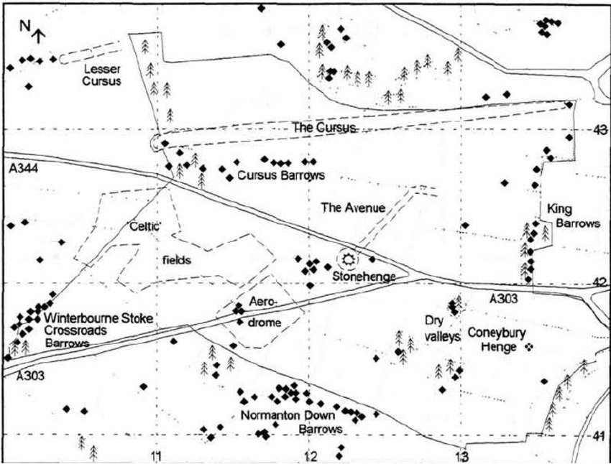
Source: Fowler, Martin J.F., 1995. “Detection of archaeological features on satellite imagery.” AARGnews10, 7–14.

Appendix 2: SPOT Panchromatic image of the Stonehenge study area acquired on 8 May 1987. The National Grid is shown at 1 km intervals. Key to annotated features: S - Stonehenge, C - The Cursus, B - Barrows.
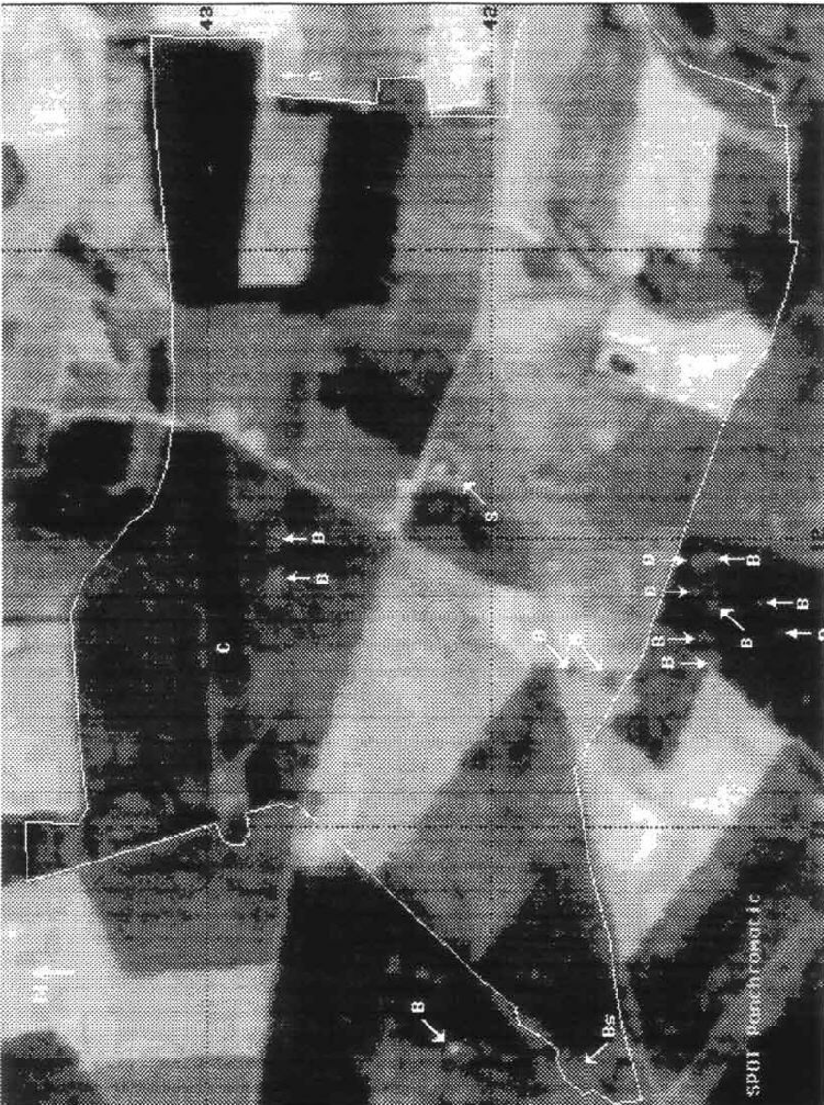
Source: Fowler, Martin J.F., 1995. “Detection of archaeological features on satellite imagery.” AARGnews10, 7–14.

