# Globalization and Companies

With the rapid development of globalization in recent years, new firms, ideas and innovation have led to a wider range of businesses in many areas. This creates challenges for firms looking to locate into new areas, with regards to understanding the business environment. The only way to successfully operate in any part of the world is to take time and understand the business environment in which you intent to operate. According to Business Studies (n.d, p. 53), all aspects of a business are largely influenced by the existing environmental factors such as personnel policies, distribution systems, product prices, business location, as well as the nature of the business. Therefore, it is important for any business that wants to establish operations in a new location to study the different components that constitute a business environment. Examples of such components include technological aspects, legal aspects, the political framework, the socio-cultural framework, as well the economic aspects (Kennerley & Neely, 2003, p. 213). This paper will critically evaluate the methods used to carry out an environmental audit for a new business environment and the same time provide an environmental audit for Apple as it plans to move to the Swansea area in the UK as a potential investment destination.

## What is a Business Environment?

Adaptation to the existing business environment is very critical for the success of any business in a new location. For instance, changes in government policy mean that all businesses have to respond accordingly and adopt the new changes (Kennerley & Neely, 2003, p. 214). Also, a business can be rendered obsolete when the owners fail to adopt the new technological changes. Therefore, the only way to survive in any business environment is by adapting to the changes. According to Business Studies (n.d, p. 53), a business environment can be described as “external forces, factors and institutions that are beyond the control of the business and they affect the functioning of a business enterprise”. Examples of external factors or forces that can affect the daily operation of a business enterprise include; technological factors, legal factors, socio-political factors, government, suppliers, competitors, and customers. The functioning of a business is affected directly or indirectly by the external forces or factors. Apart from affecting major business decisions, all the mentioned factors are uncontrollable. Also, it is important to point out that a business environment keeps on changing from time to time as a result of its dynamic nature. In most instances, changes in business environment are unpredictable especially when it comes to the social, political, and economic environment (Kennerley & Neely, 2003, p. 214). Therefore, it is always the desire of every organization to move to a location with a favorable business environment. In addition, business environments vary from country to country, region to region, and place to place. You cannot expect a similar business environment in two different countries or region. For instance, the political environment in Pakistan is different from the political environment in India.

As mentioned earlier, the existing business environment determines the success of a business as the two have close interaction. A business is always in a better position to effectively use its resources and establish itself in the market when it has a close interaction with its interaction Business Studies (n.d, p. 54). A proper understanding of the local business environment helps a business to; identify its strengths and weaknesses, meet competition, build its image, know how to deal with existing business challenges, get direction for growth, and at the same time determine its opportunities and threats.

## Methods Used to carry out an Environment Audit

The type of auditing method that is used for environmental auditing largely depends on the type of information that is required for the study. Preliminary studies by an organization lead to various assumptions about the existing real life problems and this assumptions help in determining the auditing method (De Moor, & De Beelde, 2005, p. 211). It is important to consider the audit expectations, how data analysis will be done, how data will be collected, and the type of data to be collected, and the relevance of the data to be found. Environmental auditing methods might vary from one organization to another depending on how the nature of the business. Most performance audits use some of the basic data collection methods to collect data during an environmental audit. When it comes to collecting verbal data in an environmental data, some of the data collection methods that are commonly used include; Enquiry, Delphi Survey, Surveys, Expert opinion, and Interviews. Auditors that are interested in visual data can use the site visits observation method (De Moor, & De Beelde, 2005, p. 212). For textual data, some of the most notable methods of data include statistics, inspection, and documentary.

The most notable data collection methods for compliance and financial audit include; sampling and compiling checklists (De Moor, & De Beelde, 2005, p. 2009). Environmental audit checklists include all the major audit issues that need to be compared to the set audit objectives. The auditor comes up with conclusion based on how the audit objectives compare with the existing audit issues. The audit process may also involve the use of different types of sampling techniques such as purposive sampling, judgmental sampling, stratified random sampling, and random sampling.

## Environmental Audit for Apple Inc. in the Swansea Area

Apple is one of the leading technology companies in the world and the company is known globally for its commitment to producing quality electronic products in a sustainable environment. According to Lock and Yao, (2015, p. 7), Apple’s environmental sustainability objectives include:

* Adopting 100% renewable energy
* To measure the carbon foot-print for all suppliers
* To continuously reduce emissions through transformation of manufacturing processes
* To help suppliers switch to renewable energy
* Reduce average energy consumption by Apple products
* To fully take responsibility for recycling and shipping energy
* Maintain commitment to pollution prevention
* Build partnerships with local communities and share knowledge of sustainability
* Support research in sustainable development
* Improve resource manage and resource efficiency
* Adopt sustainable procurement
* Reduce shipping and transport

## Legal Compliance

Apple monitors all environmental issues on a regular basis to ensure that there is full compliance with all the local environmental laws in the Swansea area. The company always looks out for and documents any new relevant legislation in its register of environmental legislation (Lock & Yao, 2015, p. 3). A review of the company’s compliance record revealed that there has been no major violation when it comes to compliance.

## Audit of Waste Management

Provisions of national law specify all the types of objects and object that can be classified as waste. This includes substances that are to be disposed or those that have already been disposed. For manufacturing company like Apple, the notable types of waste at the company include; industrial and hazardous waste, bio-chemical waste, E-waste, as well as construction and demolition waste (Lock & Yao, 2015, p. 7). As a company, Apple has been able to minimize it industrial and e-waste by coming up with strategies such as waste exchanges, re-sue of scrap metal, eco audit, limiting the presence of dangerous substances, and promotion of clean technologies.

The following is Apple waste management audit report:

## Compliance

* Macro and micro assessment of quantum for each type of waste produced at the company
* Assessment of the company’s capacity to handle waste
* No previous case of improper waste management
* Waste management is a priority in the company’s planning documents
* The company has an existing labeling program

## Areas that need attention

* Disposal waste should be done according to the UK laws
* Transportation of industrial waste should be done according to the law
* There are no proper evaluation studies when it comes to implementation of waste management laws

## Environmental Audit Checklist for Apple Inc. in the Swansea Area

| **Objective** | **Expected Actions** | **Auditing Outcome** |
| --- | --- | --- |
| Meet the annual 3% WG target when it comes to reduction of emissions | Come up with specific short-term and long-term and short-term targets when it comes to the reduction of total carbon emissions (Todea, Stanciu & Udrea, 2011, P. 66). Also, the company has to hire a carbon reduction officer to coordinate all reduction initiatives. | Apple Inc. has already Carbon Reduction Officer to spearhead its green initiatives and the company is in the process of preparing a Carbon Management Plan that will soon be published on the company’s official website. |
| Full implementation of the Carbon Management Plan through target monitoring and improvement of target monitoring | Use the Carbon Reduction Project Plan to fully implement all the recommendations the Carbon Management Plan (Todea, Stanciu & Udrea, 2011, P. 66). | Implementation of the carbon management plan will take place after the plan has been completed but Apple has an automated monitoring and targeting system in place ready for action. The monitoring plan will target scope three emissions, shipping emissions, and staff travel. |
| Increase community involvement in environmental sustainability | Build on the company’s success in the recent past to improve community enhancement by; coming up with an engagement plan with contractors and survivors, add to the current number of Green Impact Teams, and appointing an engagement officer(Todea, Stanciu & Udrea, 2011, P. 67). | Apple is in the process of developing an engagement plan with community partners but has already increased the number of Green Impact Teams and recruited an engagement officer on a temporary basis. |
| Reach the 50% target when it comes to waste recycling | To implement a new waste collection service and waste contractor at its facility in the Swansea area to reach the waste recycling target. Also, the company has to improve source segregation of waste. | The Swansea plant does not have adequate recycling services and that is why source segregation is still at 30%. However, the company has been recording a significant improvement when it comes to waste diversion from landfill. |
| Come up with a comprehensive biodiversity action plan that emphasizes on the surrounding rural areas in the Swansea area | Develop a Biodiversity Action Plan based on a Biodiversity Survey | Apple is yet to come up with a biodiversity plan. |
| Achieve sustainable procurement in order to maintain accreditation, improve on the current position | Reviewing the current sustainable procurement opportunities to come up with a sustainable procurement strategy especially when it comes to engineering specification. Some of the expected sustainable procurement strategies such as whole-life costing. | Apple is yet to come up with a definite procurement strategy that can guarantee environmental sustainability. |
| Developing a sustainable travel plan | This can be done through mileage recording, reviewing fleet hire arrangements, and development of Green Travel Plan. | Apple is in the process of recording mileage for submission to the Sustainability Committee and has already completed Green Framework Travel Plan. Also, the company has already rearranged its fleet to guarantee economical usage. |
| Reduce annual water consumption by 5% | This has to be done by harvesting rain water for use at the plant, installing waterless urinals, developing a metering program, investigate and fix all water leakage points in the facility. | Apple is in process of installing waterless urinals in across the facility in Swansea but the company has postponed its rainwater harvesting project o allow for adequate planning. However, the company already has a metering program to help in identification of its major sources of water losses. |
| To introduce environmental sustainability in construction and refurbishment and achieve BREEAM excellent certifications | Using construction materials will minimum environmental impact and adopting environmental standards when it comes to construction. | Apple is yet to meet all the requirements for BREEAM excellence. |
|  |  |  |
|  |  |  |
|  |  |  |
|  |  |  |
|  |  |  |
|  |  |  |
|  |  |  |
|  |  |  |
|  |  |  |
|  |  |  |

## Environmental Performance

Apple uses the UK Government GHG Conversion Factors to calculate carbon emissions. When it comes to annual company reporting, the existing misalignments are determined based on the standard emission factors. The company calculates its carbon footprints based on waste related emissions, transport emissions, and industrial emissions. The Welsh Government has its targets when it comes to reduction of carbon emissions. The company has managed to save energy and water through its green initiative and environmental sustainability programs. The Green Apple initiative has been very critical in helping the company to meet some of the environmental sustainability standards in the Swansea area.

## Conclusion

The type of business environment in which a company operates determines whether it will be successful or not. Companies that want to expand to new locations in the modern era of globalization must study the proposed destination to find out if it favorable for their type of business. In other words, it is important to analyze the location’s political, economic, legal, and social environment before making the final investment decision. Also, it is advisable for an organization to conduct an environmental audit to find out if its processes and functions affect the set environmental sustainability standards or not. The audit can be done internally or by external experts to determine the company’s level of compliance with the set environmental sustainability laws. This paper has an environmental audit report for Apple Inc. based on its plan to invest in the Swansea area. The technology company will use the audit findings to make key decision about its investment plans in the Swansea area.

## Recommendations

When it comes to investing in the Swansea area, there are quite a number of decisions that Apple needs to make based on the environmental audit report. To begin with, the auditing process should help Apple to decide how to safeguard the environment in the place where the facility is located. Second, the audit should help the company make key decisions when it comes to compliance as some of the local regulations might be complex. Wales is a devolved unit in the greater United Kingdom and that is why it is important to audit the company’s environmental sustainability plan to make major compliance decisions. Third, Apple should be able to come up with clear decision on the type of environmental sustainability training programs to initiate at the organization based on the environmental audit findings. It is always important to come up with sustainable and effective training programs for employees and the surrounding community to guarantee environmental sustainability. Fourth, the organization needs to make major decision on cost minimization after identification of potential cost saving areas within the firm. Based on this research, Apple needs to make a major decision on whether to go on with the investment project in the Swansea area or not.

## References

Business Studies, (n.d). Business Environment. Business around Us, Model-3: Retrieved from http://download.nos.org/srsec319new/319EL3.pdf

De Moor P. & De Beelde I. (2005). Environmental Auditing and the Role of the Accountancy Profession: A Literature Review. Environmental Management Journal, 36(2), 206-117.

Jackson, L. (2016). Environmental Responsibility Report 2017 Progress Report, Covering Fiscal Year 2016. Retrieved from https://www.apple.com/environment/pdf/Apple_Environmental_Responsibility_Report_2017.pdf

Kennerley, M. & Neely, A. (2003). Measuring performance in a changing business environment. International Journal of Operations & Production Management, 23 (2), 213-229.

Lock, F. & Yao, Y. (2015). Apple’s Environmental Sustainability Strategy: Considering Innovation for Everything. Retrieved from https://www.centennialcollege.hku.hk/f/upload/2137/Apple_Environment_15_004C.pdf

Todea, N., Stanciu, I. & Udrea, A. (2011). Environmental Audit, a Possible Source of Information for Financial Auditors. Annales Universitatis Apulensis Series Oeconomica, 13(1), 66-84.

Vinten, G. (1996). The objectives of the environmental audit.  Environmental Management and Health, 7 (3), 12-21.

**Appendices**

**Appendix A: Apple’s Environmental Sustainability Statement (Source: Jackson, 2016, p. 57)**

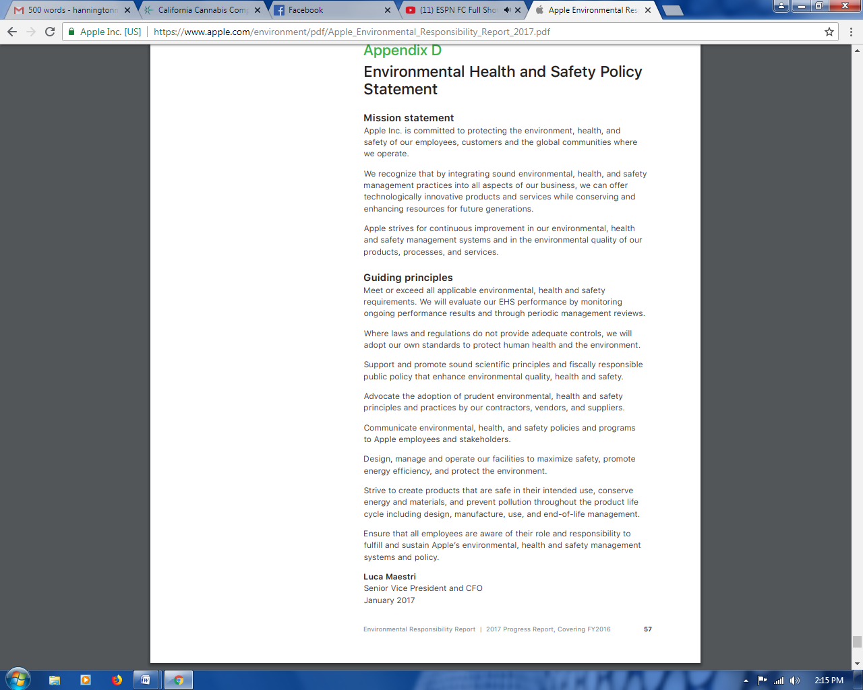

**Appendix B: Apple’s Environmental Sustainability Indicators for Fiscal Year 2016 (Source: Jackson, 2016, p. 49)**

