# Hunting in Wyoming

## Introduction

## Background

Wyoming is the 10th biggest state in terms of its area coverage, while it is also holds the lowest position pertaining to its population in North America. Therefore, the state entails a vast periphery of unreserved land for hunting, which attracts not only the resident hunters but also the non-resident ones. It plays a significant role in working towards the economic development of this region, which is well known as a persuasive tourist attraction. The hunters who visit Wyoming mostly prefer white-tailed deer, elk, moose, mule deer, bighorn sheep, antelope, and mountain goats. It implies that for Wyoming, big game hunting is not only a casual pastime but has now emerged as a widely potential business option for the nation as a whole. It has also been entertaining a wider range of subsidiary industries to perform parallel to the tourism industry, such as the hotel industry and the retail industry among the most important ones (Southwick Associates, 2017; Schmitt, 2014).

It has been owing to these developments in its trading sector that Wyoming is in need to bring about a transformation wherein the funds associated with the wildlife management is collected and hence reducing the primary burden from the hunters of costs by preventing them from incurring expenses due to political intrusion (Thuermer, 2014.). The state, besides making use of big game hunting for revenue generation, also considers offering other support services such as guide services, fishing, licensing, as well as sale of camping equipments, lodging, transportation, food and ammunitions. Besides, the availability of timber resource also enables the nation to contribute largely to its overall economic development (United States Bureau of the Census, 2014).

## Rationale

The ranch visitors mostly comprise the sportspersons associated with fishing or hunting, the anglers and the wildlife watchers. All these visitors depict completely different and unique characteristics, having segregated points of focus for visiting the ranches. Notably, the visitors are divided based on their preferences of wildlife recreation, which includes sportspersons and wildlife watchers, which can be further subdivided. For instance, the sportspersons on one hand can divided into the hunters and the anglers (fishing) population, while the wildlife watchers entail the ones who are away-from-home (non-residents) and those around-the home (residents), as represented in the figure below.

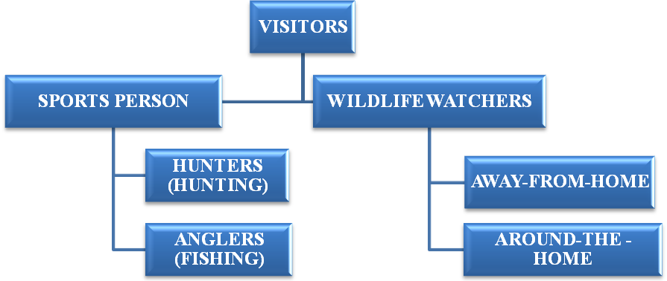

**Figure 1: Visitors of Wildlife Ranch**

Emphasizing the issue, the research paper intends to provide a comprehensive discussion on the potentials of tourist attractions in Wyoming, to offer a clear idea of the facilities that they would receive therein and the challenges that they might have to witness. The research will also help the ranch owners to analyze the demand for their properties amid the target customers to implement the required strategies in the long run.

## Aim and Objectives

The aim of the research paper is to evaluate the functioning and the need of big game hunting in Wyoming. In accordance, the below listed objectives have been framed.

* To understand the concept of Big Game Hunting for the resident as well as the non-resident visitors in Wyoming
* To assess the impacts of Big Game Hunting on the financial progression of Wyoming and the nation as a whole
* To identify the social impacts of Big Game Hunting on the population of Wyoming
* To evaluate the interaction of human beings with the eco-system

## Thesis Statement

The research paper intends to analyze the information on the HF Bar Ranch site of Wyoming along with the regional ecosystems present therein. It also focuses on providing an insight into the way of interaction between humans and the ecosystem, which in this case is the perspective of the big game of hunting within the regional boundaries of Wyoming. The economic as well as the social well-being of the individuals associated with the resident as well as the non-resident hunters have also been taken into due consideration for the completion of the research.

## Discussion

### Big Game Hunting in Wyoming

The concept of Big Game Hunting in the present scenario refers to the process of hunting big terrestrial animals for meat as well as other items for preserving, which is treated as a game of award in the form of bones and horns. The animals that form a part of the big game in the regions of North America are moose, deer, elk, pronghorn bear, mountain goat, cougar, antelope and bighorn sheep among others (U.S. Fish and Wildlife Service, 2016). The participation in Big Game Hunting requires adherence to certain pre-determined norms, identifiable principally as the age barrier, according to which the hunter must be of at least 12-17 years old to participate. The hunters should also have hunter education to be permitted into the region for hunting. Moreover, they are authorized to hunt only selected areas, as precisely mentioned in their maps. Prior to practically implementing their hunting strategies, willing hunters also need to obtain special permits or licenses, which restrict their hunt to only selected animals. Besides, the mentor must accompany the minors between 12-15 years on their big game hunts (CPW, 2017).

There are many adventurous big game options available in Wyoming, such as mountain goat, rocky mountain bighorn sheep, mule deer, moose, whitetail deer, bison, antelope and elk among others. The reason behind the state being termed as great state for hunting, harvesting trophies and drawing tags is the presence of adequate public land of high quality. Majority of the tags associated with the big games in Wyoming provides the hunters with a permit for the use of a rifle. These rifle users are also given an opportunity to procure a permit for archery, so that they can commence their hunting sessions prior to the rifle season with bows and arrows (United States Office of the Federal Register, 2005).

To be noted in this regard, the visitors in the state of Wyoming are differentiated into varied forms on the grounds of the licenses that they possess, including Wyoming Resident, Youth Hunting License, Non-Resident, Disability License, Senior Hunting License, Migratory Waterfowl Requirements and Military as well as Veteran License. To be elaborated, Wyoming resident license is applicable for individuals, who have resided in the state for a minimum of 1 year. However, residing in the state for 90 days is also deemed sufficient to attain citizenship for individuals from the military background and families. These residents of Wyoming, in order to initiate big game hunting, must possess a resident hunting license at 12 years of age or above. Moreover, they should buy the Conservation Stamp, according to which extra permits as well as stamps may be required. Correspondingly, inclusive of the Non-Resident hunting license, applicable for non-resident license holders of Wyoming aged 12 or older. Besides obtaining the Wyoming Resident hunting license, purchasing the Conservation Stamp and additional permits as well as stamps may be required. Correspondingly, the youth hunting license is applicable for residents as well as non-residents of Wyoming, in the age range between 12 and 17 years (Kalkomey Enterprises, LLC, 2017).

Contextually, the residents of Wyoming aged minimum 75 years and who has been living in this region for no less than 50 years on a continuous basis is deemed eligible to acquire a senior or a pioneer license. Moreover, the Wyoming dwellers aged minimum 70 years and with a record of 50 years of continuous residence in the region are noted to be qualified to obtain a pioneer heritage license. In these contexts, it is not mandatory for the residents to buy the Conservation Stamp. Disability license is hence applied for residents and non-residents of Wyoming having a disability. In this category of Wyoming hunting license, supplementary permits and stamps might be required. For military and veteran licenses, the active-duty military members, who enduringly resided in Wyoming are considered eligible to obtain a resident hunting license. However, one of the conditions of acquiring this license is that these members in Wyoming must reside there for a minimum of 90 days. Nonetheless, these members are not required to buy the Conservation Stamp (Kalkomey Enterprises, LLC, 2017).

Correspondingly, the resident veterans with 100% disability are entitled to obtain the free One Hundred Percent (100%) Disabled Veteran Bird, Fish And Small Game License. In this kind of Wyoming hunting license, it is not compulsory for the members to buy the Conservation Stamp. In addition, all the hunters whose age is 16 years or more should buy the Federal Duck Stamp particularly when hunting migratory waterfowl. Correspondingly, all the hunters whose age is between 14 years and above, must have a Conservation Stamp, the Game Bird License and Harvest Information Program (HIP) Permit. To be noted further, the permanent residents of Wyoming who lived in this place for a minimum period of 10 years are qualified to acquire a lifetime hunting license (Kalkomey Enterprises, LLC, 2017).

Evidence in this regard suggests that Wyoming offers adventurous hunts for six different animals with ten dedicated staff to guide with 100% shot opportunity presentation. These exclusive factors play a crucial role to attract the interested tourists to visit Wyoming on a continuous basis. Wyoming is also recognized as a prominent place in the US for the hunters, as it involves distinct sorts of hunting that entail elk hunting, deer hunting, predator hunting and antelope hunting. Elk hunting is considered to be one of the best and the most striking experiences for the hunters all over the world, as it takes place in the covered area, wherein abundant figures of record setting bulls are present. After the end of the Bull Elk season, the hunters can also enjoy Cow Elk hunting in Wyoming (Cross C Ranch, 2017a). Wyoming in addition provides attractive and best deer hunting experiences by managing the herd of deer for broad and a larger capacity of forked bucks. In deer hunting, the procedure is stalk and spot by nature, which certainly creates a pressure to harvest a nice buck increasing the impression of an adventure (Cross C Ranch, 2017b). Predator hunting also exists in Wyoming wherein the needs of the hunters are fulfilled by hunting lodges and packaging services. The place possesses massive amounts of predators that eventually help in balancing the ecosystem, as per the expectation level of the hunters (Cross C Ranch, 2017c). Correspondingly, Wyoming provides a broad range of hunting areas for antelope hunt with wider choices for the trophies and genetics (Cross C Ranch, 2017d).

### Impact of Big Game Hunting on the Economic Development of Wyoming and North America

Wyoming is regarded as the least populated region in North America. These geographical facets eventually transformed Wyoming as a huntable land, providing incredible experiences to the hunter to hunt various big game species that might comprise moose, mountain goats, elk, white-tailed deer, antelope, bighorn sheep and mule deer. Hunting these species in Wyoming is critical to the development of the state’s economy, making the state one of the most attractive hunting destinations throughout North America. Illustratively, during the recent 2015-2016 season, the non-residents expended nearly about 85% of all big game guides as well as outfitter fees. However, in comparison with the resident hunters, the non-resident big game hunters who use outfitters and guides spend approximately 178% of the amount on a yearly basis. The impact of big game hunting on the economic development of Wyoming can be better comprehended from the retail sales generated by the resident and the non-resident hunters in the year 2015 (Southwick Associates, 2017).

Based on the report published by Southwick Associates (2017), the total monetary contributions made by the resident and the non-resident hunters in Wyoming, during 2015, amounted to $303,588,073 that certainly have had a positive impact on the state’s economy. Out of these financial contributions, the total retail sales that generated by the resident and the non-resident hunters stood at $224,042,338 in 2015 (Southwick Associates, 2017) (refer to figure 1). During the 2015-2016 season, the number of residents, guided non-residents and non-guided non-residents accounted to 74,577, 10,523 and 33,921 respectively (refer to figure 2).

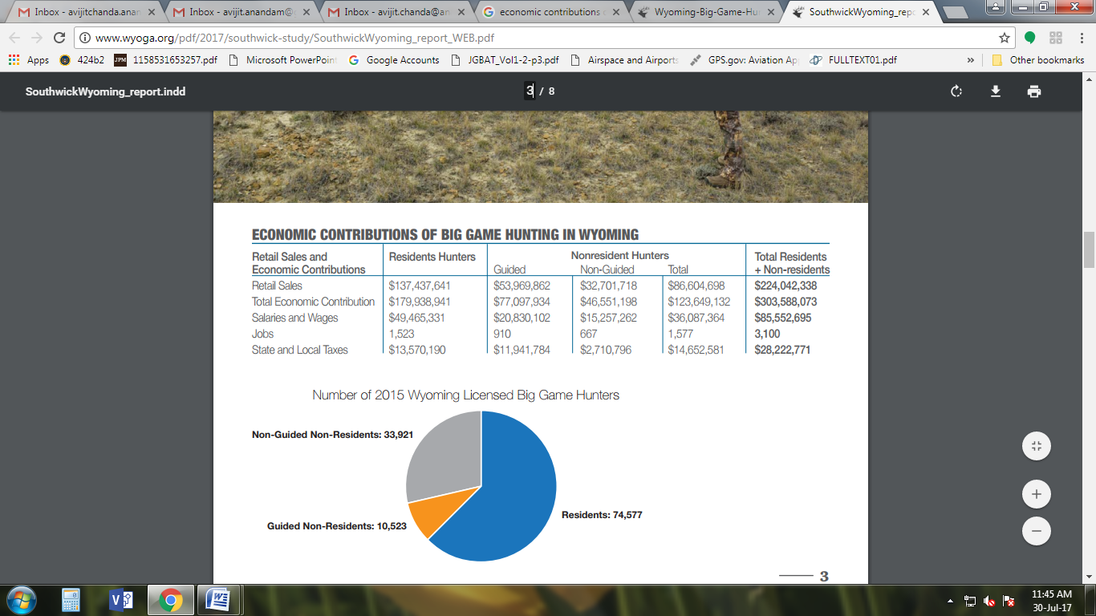

**Figure 1: Economic contributions of big game hunting in Wyoming**

Source: (Southwick Associates, 2017)

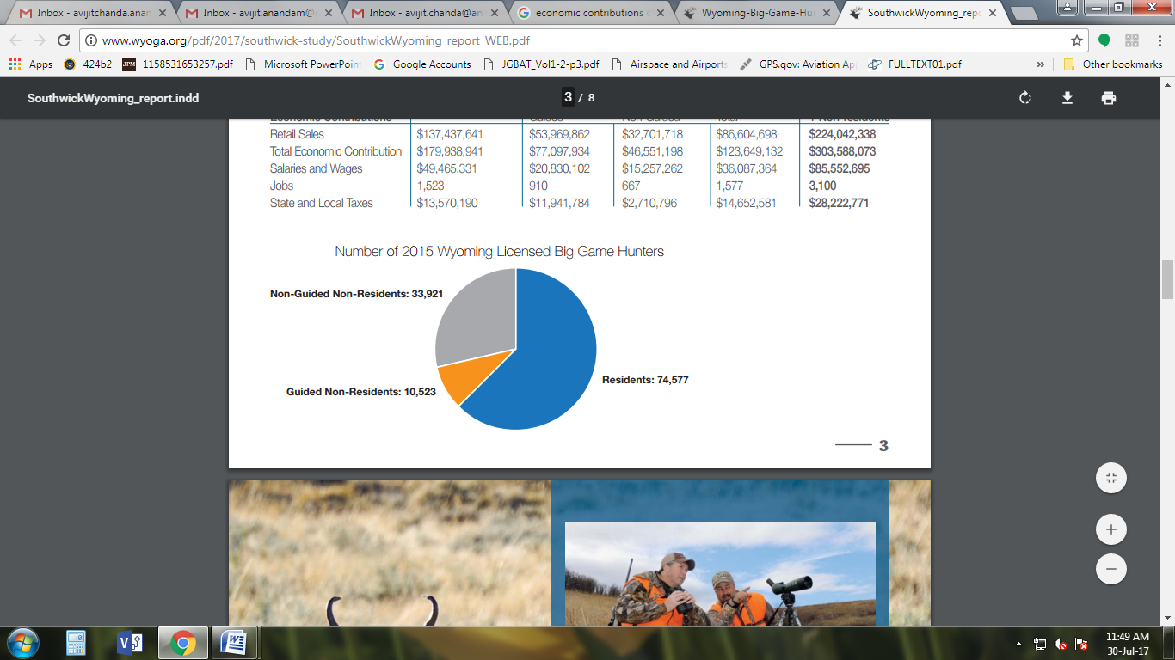

**Figure 2: Number of 2015 Wyoming licensed big game hunters**

Source: (Southwick Associates, 2017)

In 2015, Wyoming arranged in excess of 119,000 big game hunters, amongst which, 63% of these residents were the residents and the remaining 37% constituted the non-residents. The hunters in this similar year expended nearly about $224 million on travel, guides, gear and other related products and/or services in Wyoming, which imposed significant impacts on the financial status of the state and entire North America as well. For instance, money spent by the hunters on these operational aspects supported 3100 jobs in the year 2015, which was more than numerous business establishments listed in Fortune 500 companies. Evidence also suggests that for a rural state like Wyoming, hunting is considered to offer a highly potential business, which not only has an impact on developing the state’s economy and North America as a whole, but also has an influence on improvising the living conditions of the local residents. The spending of Wyoming’s big game hunters during the year 2015 can further be categorized into two sections, namely travel and equipment spending. Commercial transportation, groceries, lodging, guides or outfitters and equipment rental among others are covered under travel spending category. Correspondingly, the equipment spending category comprises the items of clothing, ammunition, maps, hunting dogs, binoculars or cameras and books and magazines among others (Southwick Associates, 2017).

During the year 2015, the big game hunters in Wyoming, including the residents and all non-residents made a total travel and equipment spending of $126,495,546 and $97,546,792 respectively. While discussing about the economic contributions by the residents and the non-residents in Wyoming, it can be observed that 63% of the residents remain involve in big game hunting of the state than the non-residents who generate 61% of monies and thereby ensure stable economic growth. Thus, it is apparent that only 37% of the non-residents are engaged in Wyoming’s big game hunting who produce 39% of wealth. Notably, the spending of both the residents and all non-residents specifically on guides or outfitters has a direct impact on creating wider employment prospects for the residents of Wyoming. In this regard, the total spending made by Wyoming’s big game hunters on guides or outfitters was recorded at $45,435,629 in 2015. Due to significant impacts of big game hunting on the monetary growth of both Wyoming and North America, it has gained a reputation that is larger than a hobby or a casual pastime. It is today considered as a serious big business, which not improvises the economic conditions of Wyoming, but also ensures its sustainability for an elongated time (Southwick Associates, 2017).

Purchase of big game licenses also has a strong impact on the economic conditions and the sustainability of Wyoming in the segment of big game hunting. Correspondingly, it was observed that a total of 119,021 hunters bought big game licenses in Wyoming during 2015 season, which included 63% residents and the remaining 37% as the non-residents. Amidst these non-residents, 24% of them made better use of guides as well as outfitters, whereas the rest 13% hunted by themselves without taking any help from the guides or the outfitters. It is believed that the direct spending by the residents and the non-residents, during the year 2015 in Wyoming, supported the local businesses and the individuals as well to obtain maximum profits. This contribution of big game hunting is typically regarded as the multiplier effect, which provides an opportunity for all to maximize returns from the sector (Southwick Associates, 2017).

As apparent, involvement of residents and all non-residents in big game hunting in Wyoming has a positive impact on the economy of North America, which can be duly measured in terms of huge figures of tourist inflow and the subsequent long-term economic sustainability. Observably, elk is the most targeted specie of the residents as well as the guided non-resident hunters. However, the unguided non-resident hunters consider mule deer and antelope as the most targeted species in this particular region of North America. This implies that elk and mule deer along with antelope hunting is largely prevalent in Wyoming, owing to which the continuous development of these hunting segments is likely to enhance the economic standing of both Wyoming and North America as a whole by an extensive level (Southwick Associates, 2017).

### Social Impacts of Big Game Hunting on the Population of Wyoming

Hunting, as a term, holds many negative connotations and oppositions, not only claimed to be unethical but also contradictory to the values of a humane community. However, it has since long been argued that hunting has an influential role to play in understanding the procedures of the natural world and ensuring utmost development in the financial conditions if treated as an economic process. It is believed that with the escalating concern of the public and the growing pressure from the environmentalists, hunters today have begun to identify the need for change by making hunting more acceptable socially (Deere, 2011). Even though hunting is perceived as immoral, it has immense and undeniable social and economic contributions on the economic structure of Wyoming. From financial perspective further, it can be noted that the impact of big game hunting on the economic development of Wyoming and North America can be witnessed in the forms of increasing retail sales and paying higher amounts of state or local taxes among others (Southwick Associates, 2017).

Similar to economic impacts, the evolution of big game hunting in Wyoming also has a strong and a direct influence on the societal conditions of this particular state and its people. The notion of big game hunting is likely to affect the societal setting of Wyoming by generating wide employment prospects in the tourism industry and infusing variations in the habitat conditions for wildlife that act as a major form of local outside leisure pursuits. The fundamental social impact of big game hunting in the living conditions of the people belonging to Wyoming is further associated with guiding the hunters during hunting, which in turn, provides an opportunity for the guides or the outfitters to improvise their own living standards (Northwestern University, 1991). Even though big game hunting positively affects the societal conditions of Wyoming, it has a negative influence on the livelihood regulations of the people residing within this particular state of North America. Taking into concern the livelihood regulations thus, it can be inferred that every hunting operator, who leases a hunting region, bears the right to utilize the natural resources available in that particular zone for their personal and economic interests. Therefore, limiting the rights of the local people of Wyoming to perform various functions, such as grazing and cutting down trees among others, certainly poses an adverse effect on the livelihood regulations on those people (Yasuda, 2012).

In rural areas, similar to that of Wyoming, hunting is widely observed to hold greater significance in developing the social conditions of the state and the people due to its contributions towards improving their individual lives. Based on theoretical perspectives and applications further, it can be stated that hunting provides a strong “belonging” sense to the involved participants in their local hunt by following shared activities. This eventually creates a greater level of social as well as economical attachment towards hunting. It was observed that the hunters are inclined to pay higher value on relaxation, being outdoors and recreation while hunting in any region throughout the globe. Thus, the hunters regard hunting as a part of their lifestyle, culture and tradition, which provides an opportunity for them to spend time with their families and friends as well. This certainly triggers the need to follow social norms by the hunters when hunting, which in turn, generates an extensive level of social attachment with the people belonging to Wyoming (Derek Murray Consulting Associates, 2006). The chance of Wyoming to construct, develop and preserve an adequate level of social attachment with the hunters is high owing to the reason that it offers greater quality of hunting experiences to the involved participants with having plentiful public land (Southwick Associates, 2017; Schmitt, 2014).

The societal impacts of big game hunting on the population of Wyoming can be better explained from the dimension of social sustainability. In general, the notion of social sustainability can be described as an effective developmental procedure, which strengthens the individuals to control their own lives and ensures equal distribution of socially sustainable advancement goals. Based on this notion, the social influences of big game hunting on the people living in Wyoming can be determined as reinforcing communal cohesion, constructing a sense of community along with commonly accepted standards, promoting social justice and enhancing the overlapping objectives of ecological sustainability. However, it can be argued that big game hunting has both positive and negative social impacts on the population of Wyoming. In this regard, the positive impacts include increased job variety, promotion of regions and amplified information flow to the hunters. Correspondingly, the negative influences embrace chances of rising conflicting situations and clashes amid the hunters and the local people. Thus, it is expected that there should lay certain space for the local dwellers as well as the visitors to reach communal acceptance for the development of big game hunting in Wyoming. If Wyoming’s big game hunting is organized in a better way and can be efficiently managed in alignment with the respective communities, it is likely to be able to mitigate ethical concerns over its economic contributions towards the development of hunting activities taking place within the region (Matalainen & Keskinarkaus, 2010).

While discussing about the social impacts of big game hunting on the population of Wyoming, the viewpoints of the chief stakeholder groups, such as the local hunters and the landowners must be considered in order to promote communal sustainability. Moreover, these key stakeholder groups should remain engaged in the procedure of maintaining sustainability of the operations and the local communities as well in the long run. In order to promote social sustainability and ensure that the living conditions of the community members dwelling in Wyoming are enhanced as per the desired level, the landowners of the hunting areas must also possess the fundamental right to withdraw access towards valuable resources. Correspondingly, the local hunters should act ethically and being aware of their influence on the decisions taken by the landowners in order to develop hunting regulations and thereby, develop social sustainability to the maximum possible extent in the near future. To be noted in this regard, in Wyoming, hunters’ organizations might have a strong role to play in serving the interests of the individual hunters in the best possible way while their stance towards reframing hunting policies may impose considerable level of impact on the population of this region (Matalainen & Keskinarkaus, 2010).

### An Evaluation of the Interaction of Human beings with the Eco-System

Interaction of human beings with the ecosystem is fundamentally described as the interface amid the human social mechanism and the underlying environment. This interaction is deemed as complex in nature due to the fact that the ecosystems and the human social procedures possess numerous facets, having connection amid them. Moreover, the interaction of human beings with the eco-system is also identified to be adaptive in nature because the ecosystems along with the human social systems possess feedback arrangements that can help in promoting survival in a continuously transforming environment. It is thus important to acquire a concise understanding about the specific facets of the human social mechanism. These characteristics fundamentally comprise values, population size, technology, knowledge, education and wealth. To be noted in this regard, a broad assortment of ecosystem services that encompass climate control along with regulation, maintenance of cultural diversity and production of food as well as water are indispensable for the development of human well-being (Lill & Graber, 2006). With reference to big game hunting in Wyoming thus, the services associated with human social mechanism can be characterized as generating wide employment prospects for the citizens dwelling in this particular state and making relevant changes in the habitat conditions for wildlife (Southwick Associates, 2017).

Human beings are exposed to form, develop as well as maintain better social relations, think about personal security and seek for fundamental materialistic needs for a good life. In this connection, ecosystems are deemed as indispensable for the human beings, as these are involved into provisioning, regulating and supporting services that directly suffice the basic needs of the human beings and assist them to lead a better life. The essence of the interaction of human beings with the underlying ecosystem emphasizes the development of their well-being with the aid of suitable institutions, technology and instruments among others. This development is most often aimed to be accomplished by maintaining transparency may contribute into rising financial, ecological and social security of the human beings by an extensive level. Biodiversity is also perceived as one of the critical approaches to several ecosystem services. For instance, it delivers resilience and sustainability for the livelihoods and the cooperating strategies of the human beings, particularly focusing on the rural poor. These people often receive distinct ecosystem services and thus are able to decrease their susceptibility via distinct and composite mixes of activities. The favorable impacts of the regulating functionalities of the ecosystems on human well-being also play a crucial role in elucidating the interactivity of human beings with the eco-systems. These adverse impacts can be duly measured in the form of local as well as regional climate stabilization, air purification, control of disease transformation and fresh air among others (World Resources Institute, 2003).

Human beings are also observed to be integral to ecosystems, as an effective ecosystem approach takes into concern their social and financial well-being. As can be apparently noted in this context, ecosystems largely vary in terms of structure as well as size, which are generally featured by a greater level of interaction and interdependence persisting amid the living and the non-living elements of a system (Dakubo, 2010). Evidence suggests that sagebrush ecosystem is largely prevalent in Wyoming wherein the Wyoming Basins are considered to be one of the enduring strongholds of this ecosystem. Based on this sagebrush ecosystem, sagebrush habitats are commonly found in the region of Wyoming, attracting the tourists in the form of hunters throughout the globe by a considerable level. Reportedly, in excess of 350 wildlife species rely on sagebrush ecosystems in Wyoming to satisfy their life requirements. The Wyoming Basins Ecoregion comprises 134,000km2 in five distinct states wherein a major proportion of this eco region, i.e. 84%, exists in Wyoming. Vegetation communities in the Wyoming Basins Ecoregion are fundamentally dominated by Wyoming big sagebrush and the rolling sagebrush uplands. Even though this eco region is vast in terms of its size, it still remains as one of the minimum closely populated areas in the US as a whole (Rowland & Leu, 2011).

Interaction of human beings with the Wyoming Basins Ecoregion can be measured by identifying the species of concern, focusing on maintaining biodiversity, increasing conservation and building a methodical as well as a clear approach to develop sagebrush communities. Ranches also constitute as the other ecosystem prevailing in the region of Wyoming for numerous years. One of the most momentous ranches existing in Wyoming is the HF Bar Ranch, which provides mesmerizing experiences to the guests with its astonishing views and rich ranch style setting. While arriving at the HF Bar Ranch, the guests feel calm after seeing boundless sceneries, cavvy of 200 horses, improved habitat conditions, earthy sounds as well as smells and re-connecting with old along with new friends. Considering that the lives of the people of this present day context continue to upgrade, move more rapidly and transform incessantly, the HF Bar Ranch is viewed as stable, which can be distinguished from a very fast-paced world (HF Bar Ranch, 2013).

The various activities that take place in the HF Bar Ranch include dining, kid team, fly fishing, shooting sports, horseback riding and outdoor activities as well. These activities are sufficient enough to attract the customers and thereby attain the predetermined targets of increased product and/or service sales, maximize huge market returns and ensure long-term sustainability. In this similar context, interaction of the humans, especially the staff of the HF Bar Ranch need to establish, maintain and develop strong as well as effective communication with the visitors so that their individual requirements are met and the predetermined objectives of the ranch are fulfilled within a definite period. Moreover, the top management team and the staff employed within this particular ranch must also levy utmost focus on protecting the ecosystem, thereby ensuring greater level of social sustainability (HF Bar Ranch, 2013).

## Conclusions

Wyoming has been renowned as one of the most attractive places for hunting in North America, which not only attracts the resident hunters but also the non-resident ones as well. Big game hunting is prevalent in Wyoming wherein the visiting hunters acquire extraordinary and mesmerizing experiences about various forms of hunting that comprise deer hunting, antelope hunting, elk hunting and predator hunting. In order to examine the operations and the requirements of big game hunting in Wyoming state, attempts have been made to understand the impacts of big game hunting on the state’s social along with financial development and the interaction of human beings with the underlying ecosystem. With reference to the overall findings retrieved for this research paper, it becomes increasingly apparent that different sorts of hunting licenses do prevail in Wyoming, comprising Youth Hunting License, Wyoming Resident and Non-Resident License, Senior Hunting License, Military as well as Veteran License, Migratory Waterfowl Requirements and Disability License.

The secondary research findings, in this study, further stressed that the notion of big game hunting imposes significant affects on the financial development of Wyoming and North America as a whole. For instance, during the year 2015, the resident as well as the non-resident hunters in Wyoming contributed nearly about $303,588,073, which in turn, developed the state’s and the region’s economy at large. Correspondingly, the societal influences of big game hunting on the population of Wyoming can be determined as generating maximum scope of employment for the residents of this state and developing the habitat conditions for wildlife. With regard to big game hunting in Wyoming further, interaction of human beings with the underlying ecosystem can be measured in distinct forms that entail attracting the tourists with its Wyoming Basins and recognizing the species of concern.

## **Self Evaluation**

### Description of the Learning Process

This particular course is related to big game hunting in Wyoming, which covered the concept of big game hunting for the residents as well as the non-residents of the region and its impacts on the economic along with the social development of the state and North America as a whole in detail. Moreover, the course covered evaluating the interaction of human beings with the ecosystem by paying utmost focus on Wyoming Basins Ecoregion and the ranches, such as HF Bar Ranch in particular. My learning process, during the weeks of work on this particular course, depended on accessing secondary data from various scholarly journals, books, articles and authentic online reports or documents. In addition, my learning process also included searching and using keywords in both online and scholarly journal databases, as found relevant to this courses that included Wyoming, big game hunting, social, ecosystems, economic and ranch or ranches among others.

### Reflection on Learning

Through this particular course and after completing the assignments, I learned the concept of big game hunting in Wyoming, its social along with economic contributions and interaction of human beings with the underlying ecosystems. Based on my understanding and learning from various secondary sources, the perception of big game hunting in Wyoming can be observed as the procedure of hunting huge terrestrial animals for meat and preserving other items, including bones and horns as a sport of trophy. After reviewing these sources critically, I observed that numerous adventurous big games are available in Wyoming such as mountain goat, moose, mule deer, antelope and elk among others. Moreover, I was also able to identify that big game hunting have had a significant level of economic and social contributions in the overall development of Wyoming and North America by directly increasing retail sales, enabling the residents along with the non-residents to procure big game licenses, generating greater level of employment prospects and enhancing habitat conditions respectively.

### Description of the Level of Excellence

The level of excellence that I have demonstrated in the final research paper relate to the course of big game hunting in Wyoming, which can be better understood from the different types of hunting facilities provided to the hunters, interaction of the humans with the underlying ecosystem and the kinds of licenses that are available for the hunters in Wyoming. Based on this research paper, I believe to have developed my skills in the fields of exploring the notion of big game hunting in Wyoming and its societal as well as economic influences on the state’s and the region’s economy.

### Explanation about Assigning a Grade with Reasons

I can assign myself an “A” grade after completing this course and the research paper, as I believe to have conducted an effective learning procedure. Since the important keywords relevant to this research paper, including big game hunting and ranches among others, have been searched in both scholarly and online databases, I can ensure higher reliability and validity of this study as per the expectation level. This particular approach proves my eligibility to assign myself as an “A” grade, due to the conformity of the overall findings retrieved for this study with the prescribed norms and regulations to complete an academic research paper.

## References

Cross C Ranch. (2017). *The best bino pack*.

Cross C Ranch. (2017a). *Elk hunting*.

Cross C Ranch. (2017b). *Deer hunting*.

Cross C Ranch. (2017c). *Predator hunting.*

Cross C Ranch. (2017d). *Antelope hunting*.

CPW. (2017). 2017 Colorado big game. *Colorado Parks and Wildlife*, 1-65.

Dakubo, C. Y. (2010). *Ecosystems and human health: A critical approach to ecohealth research and practice.* Berlin: Springer Science & Business Media.

Deere, N. J. (2011). *Exploitation or conservation? Can the hunting tourism industry in Africa be sustainable?*

Derek Murray Consulting Associates. (2006). Environmental and social impacts. *Final Report: Economic Evaluation of Hunting in Saskatchewan,* 48-50.

HF Bar Ranch. (2013). *About.* Retrieved from http://www.hfbar.com/about2.html

Kalkomey Enterprises, LLC. (2017). *Wyoming hunting license*.

Lill, A. & Graber, S. (2006). *Human-environmental interactions*.

Matalainen, A. & Keskinarkaus, S. (2010). The social sustainability of hunting tourism in Northern Europe. *Reports*, 9-62.

Northwestern University. (1991). *Deerlodge National Forest (N.F.) Harvey-Eightmile timber sale, granite county: Environmental impact statement.* US: United States Department of Agriculture.

Rowland, M. M. & Leu, M. (2011). Chapter 1: Study area description. *Sagebrush Ecosystem Conservation and Management,* 10-45.

Southwick Associates. (2017). Big money. *Big Game Hunting and Outfitting Economic Contributions in Wyoming*, 2-7.

Schmitt, K. A. (2014). *Big Game Equals Big Money in Wyoming*.

Thuermer, A. M. (2014). *Who should pay for Wyoming’s Wildlife?*

United States Bureau of the Census. (2014). 2011 National survey of fishing, hunting, and wildlife-associated recreation. *US Department of the Interior, Fish and Wildlife Service*, pp. 2-144.

U.S. Fish and Wildlife Service. (2016). Washington’s 2016 big game hunting seasons & regulations. *Washington State Big Game Hunting Pamphlet*, 3-117.

United States Office of the Federal Register. (2005). *Code of Federal Regulations*. Ohio: U.S. General Services Administration, National Archives and Records Service, Office of the Federal Register.

World Resources Institute. (2003). Chapter 3. Ecosystems and human well-being. *Ecosystems and Human Well-being,* 71-84.

Yasuda, A. (2012). Is sport hunting a breakthrough wildlife conservation strategy for Africa? *Field Actions Science Reports, 6*(6), 1-8.