# INTRODUCTION TO FILM THEORY AND CRITICISM

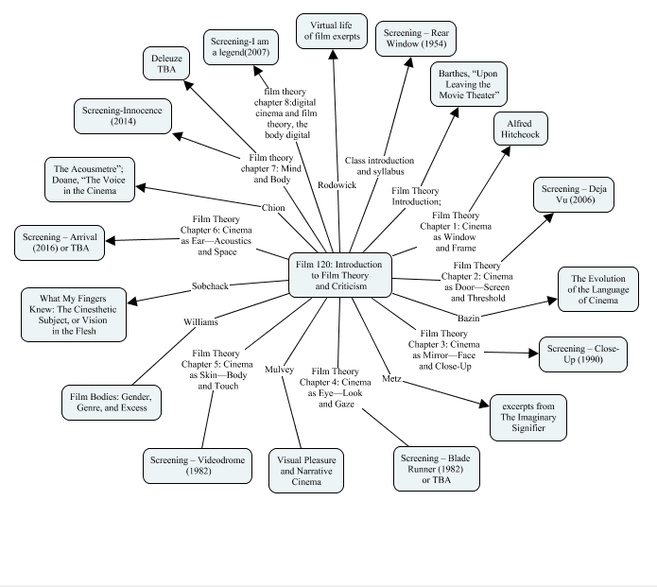

## The death drive

### Summary

Cinema and narratives possess a richness suggesting an ancient destiny fulfillment. With a different degree of triumph, The Magic Lantern, as well as other pre-cinema entertainments, tried to create a moving effect on stories.[1] However, cinema on a fantastic view was not only an extraordinary but also a transformative gift. Therefore, the effect it brings to storytelling is greater than life's illusion. Moreover, films have a structural affinity with the drive of the story taking as portrayed in the beginning over to that on end. The transition flows convey through the numerous processes of change in a cinema as not only in the echo of its duality but also between the movement as well as the stillness. Whereas the movement is a never-ending change through a time extension, the stasis echoes not only the silence of order but also affinity. Therefore, these attributes are part of any single shot, a pivot holding the mobility of cinema through the narrative movement.[2] Moreover, the shots are editable not only into consequences but also scenes hence are responsible for the creation of stories in a film. The original shot movement is a mutation with editing on an own integral space as well as time in the formation of a part of a temporal construction.

The conceptual significance of the mobility of a cinema should be in line with the free nature of the narrative besides addition, becoming, as well as change. Any literal movement pertaining to a shot or even camera is mutative and relies on the editing in a bid to be a temporal construction that is wholly new. When someone is trying to assemble a certain film together, it is the case that they can clearly articulate things such as thoughts, resonance as well as ideas. Therefore, a narrative film should possess not separations into narrative and cinema. Moreover, the elective affinity idea that exists between should translate into a rigorous interweaving of both the physical as well as the conceptual properties. On the other hand, openness attracts no space for the invariant temporality of the beginnings as well as the ends but rather it therefore, has relations to time.

Between its end as well as the beginning, the narrative has no limits and is a building with its foundation deeply rooted around series as well as repetitions. Therefore, the action image movements like their changes as well as duration depict the metonymic narrative structural aspect with a contiguity link besides combination as well as the syntagmatic relation.[3] Moreover, the movement of images and the narratives share common attributes. Therefore, the elective affinity that exists between narratives and cinema offers an allowance for cinemas to enhance movements. Therefore, it either obscures or distracts the presents in its underlying stasis.

### Main Points

As theorized by Freud in his 1920 essay, 'Beyond the Pleasure Principle,' death drive is an instinct that could override the pleasure principle. On the other hand, death drive and narrative movements have distinct parallels.[4] Firstly, an engine is mandatory for the start-up of a narrative into a drive heading to the place of movements in an inertia analogous start out. Therefore, the elective affinity that exists between narratives and cinema offers an allowance for theaters to enhance movements.[5] Moreover, it either obscure or distract the presents in its underlying stasis. In that light, the movement of a film is an illusion arising from a succession of static images shot and consequently projected at about twenty-four frames per second. The conceptual significance of the mobility of a cinema should be in line with the free nature of the narrative besides addition, becoming as well as change.

The theory of death drive points out that instinct always gets at par to metamorphose to their original states. Therefore, as a disguise, the instincts are fundamentally conservative hence assumes the nature of the movement, progress as well as change.[6] According to the Freudian 'Beyond the Pleasure Principle,' the movement stimuli inherent in the instincts of death jostle while aiming for a return to rediscover the stasis of its first departure.[7] Metaphors therefore as Freud employs them, offer a provision of a new dimension in the staging as well as the plotting of the instincts of death throughout the event of narrative besides its pattern.[8] The Freudian use and selection of language are a resonance with the narrative structure topographies. The two narrative closure grand conventions devices forces for the drive of a story back to not only stasis but also death or marriage. Marriage as a shutdown is vital in bringing up the topographical stillness conventionally as the new home implies. However, cinema on a fabulous view was not only an extraordinary but also a transformative gift.[9] Therefore, any person who cares to hit the pause button easily reveals the individual frame.

The ending to a narrative carries with it stillness as well as silence which employs an association with death. However, the death of the hero in the world of film magnifies the effect by two folds. To this effect, the intensity of the investigation into the problem of ends, the greater it compels the inquiry onto how it relates with the human end.[10] For instance the Death of the story as in the case of *The Red Shoes* is in the death of the heroine as opposed to the hero.[11] Therefore, it not only introduces the question of sexual difference to the movement of the narrative but also the question about endings. The drive of Julian in that case is an embodiment of the of the engine of the narrative as the film begins. On the other hand, the suicide as portrayed by Vicky’s death brings stillness to the movie. Since Vicky’s creative drive is intolerable to Julian, the conflict arising between them is a revolution around marriage stillness and narrative movement that stays permanently in motion by the ballet image. Marriage as a shutdown is vital in bringing up the topographical stillness conventionally as the new home implies. Therefore, after falling in love, Julian’s struggle is evident as she tries to have Vicky kept under a state of stasis that is appropriate for the role of the female in marriage. However, her dancing desire is of the movement of the ballet company that can only be described as restless and is always a show in the perpetual travel motion besides the repetitions during rehearsal as well as performance that succession of trains evokes. Vicky’s suicidal death is therefore a substitute for the death stasis in the marriage. Therefore, as illustrated in the above example, the elective affinity that exists between narratives and cinema offers an allowance for theaters to enhance movements.

### Analysis

New technologies of the media equip viewers with the ability to regulate both images as well as the story to allow for the manipulation of movies meant for collective viewing as well as following in a linear fashion to contain not only unintended but also unexpected pleasures. Therefore, any person who cares to hit the pause button quickly reveals the individual frame. Besides, easy access to slow motion as well as repletion could shift the pleasure of the spectator to a fetishistic and not a voyeuristic film investment. Therefore, the death drive is a complete fit in the movie theory in a variety of ways as discussed above.

## Theoretical Analysis

‘*The death drive'* is a short film inspired by Laura Mulvey's essay, The Death Drive. In an analysis, the film is a follow of a wanderer who continually seeks thrill, as he not only plunges into the highs of the self-destruct urge but also the low. As stated by the theory of films is a support to the death drive, the film portrays the latter as a calling to be involved in both daring and dangerous activities.[12] The drives in the adventure are so fast that it is said to be greater than one ever experienced and would experience again. This experience raises concerns about how death achieves representations in the film. Do people fear death? Is the drive greater than the likely outcome, death? Therefore, it is vital to take note that neither knowledge nor experience of death is portrayed in the film.

Several scenes in the movie run in a slow motion especially some of the beautiful drives and fall, the death drives. The film, therefore, decreases movement to enable more time in the viewing of the incredible, breathtaking speeds.[13] Moreover, there is manipulation of both space and time in the setting of the drives to bring out as well as cause the effect that portrays the presence of death. Under the guide of camera gaze, spectators witness the breathtaking nearly suicide death drives. This element comes out in the irony when is brought out that the suicidal drives are not the fear but the freedom.

## Bibliography

Elsseassar, Thomas &Hagenner, Malt. 2015. *Film Theory: An Introduction Through the Senses* (Second edition). London, Routledge.

Miller, Toby, and Robert Stam. 1999. *A Companion to film theory*. Malden, Mass: Blackwell. http://www.credoreference.com/book/wileycfith.

Mulvey, Laura. 2006. *Death 24x a second: stillness and the moving image*. London: Reaktion Books.

1. Laura Mulvey,*Death 24x a second: stillness and the moving image*. (London: Reaktion Books 2006.), 68.
2. Laura Mulvey,*Death 24x a second: stillness and the moving image*. (London: Reaktion Books 2006.), 68.
3. Laura Mulvey,*Death 24x a second: stillness and the moving image*. (London: Reaktion Books 2006.), 69.
4. Laura Mulvey,*Death 24x a second: stillness and the moving image*. (London: Reaktion Books 2006.), 69.
5. Laura Mulvey,*Death 24x a second: stillness and the moving image*. (London: Reaktion Books 2006.), 68.
6. Laura Mulvey,*Death 24x a second: stillness and the moving image*. (London: Reaktion Books 2006.), 70.
7. Tobby Miller and Robert Stam. 1999. *A Companion to film theory*. Malden, Mass: Blackwell. http://www.credoreference.com/book/wileycfith.
8. Tobby Miller and Robert Stam. 1999. *A Companion to film theory*. Malden, Mass: Blackwell. http://www.credoreference.com/book/wileycfith.
9. Laura Mulvey,*Death 24x a second: stillness and the moving image*. (London: Reaktion Books 2006.), 72.
10. Laura Mulvey,*Death 24x a second: stillness and the moving image*. (London: Reaktion Books 2006.), 68.
11. Laura Mulvey,*Death 24x a second: stillness and the moving image*. (London: Reaktion Books 2006.), 68.
12. ThomasElsseassar and MaltHagenner,*Film Theory: An Introduction Through the Senses* (Second edition). (London, Routledge.2015), 78.
13. ThomasElsseassar and MaltHagenner,*Film Theory: An Introduction Through the Senses* (Second edition). (London, Routledge.2015), 74.