# Investigation of the characteristics charity contribution by Jaguar Cars Employees

## Executive Summary

Many companies participate in Corporate Social Responsibilities so as to improve their public image thereby helping them retain their customers and government favours. In this report the findings of a research that was carried out by Jaguar Cars to find out how people contribute to charities are presented. The study mainly focused on Jaguar employees as the participants.

## 1. Introduction

This report presents the findings of a research that was carried out by Jaguar Cars to find out how people contribute to two charities funds: medical research fund, and children and young people research fund. The data was collected from 281 Jaguar employees. The data analysis was carried out using the following statistical methods: descriptive statistics, One Way ANOVA, linear regression and chi-square test. The results of the study are presented below.

## 2. Findings of the study

The data collected in this study were analysed using a number of statistical tools such as descriptive statistics, Anova analysis, linear regression, and Chi Square test.

### 2.1 Descriptive Statistics

Descriptive statistics tool was used to organize and have a basic understanding of the data collected by the questionnaires (Kohli, 2014). Here central tendencies such as medium and mean, pie charts and frequencies were used. The results of the descriptive statistics analysis that was carried out is shown in the tables and figures below. The discussion of the results have also been provided below each or figure or both.

#### 2.1.1 Descriptive statistics of medical research and children funds data

Table 1 and figure 1 below shows a summary of response by respondents with respect to their donation towards medical research. The results show that quite a number of people do not contribute towards medical research.

Table 1a: Measure of central tendencies

| **Statistics** | | |
| --- | --- | --- |
| Fund_MR | | |
| N | Valid | 231 |
| Missing | 0 |
| Mean | | .32 |
| Median | | .00 |
| Mode | | 0 |
| Sum | | 74 |

Table 1b: Proportion of respondents donating towards medical research fund

| **Medical Research fund SPSS output result** | | | | | |
| --- | --- | --- | --- | --- | --- |
|  | | Frequency | Percent | Valid Percent | Cumulative Percent |
| Valid | No | 157 | 68.0 | 68.0 | 68.0 |
| Yes | 74 | 32.0 | 32.0 | 100.0 |
| Total | 231 | 100.0 | 100.0 |  |

**2.1.2 Proportion of those who donated for Children and Young people**

In order to get the proportion of the participants who donated for children and Young people, descriptive statistics of the data was done. The results are shown in tables 2 and figure 2 below.

Table 2: Proportion of respondents donating towards children and young people fund

| **Children and Young People Fund** | | | | | |
| --- | --- | --- | --- | --- | --- |
|  | | Frequency | Percent | Valid Percent | Cumulative Percent |
| Valid | No | 148 | 64.1 | 64.1 | 64.1 |
| Yes | 83 | 35.9 | 35.9 | 100.0 |
| Total | 231 | 100.0 | 100.0 |  |

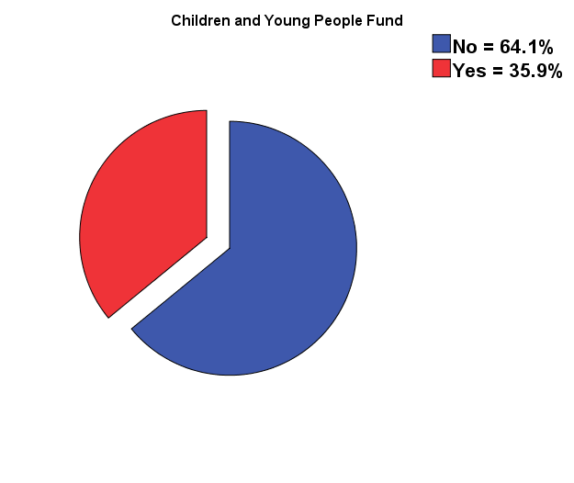

Figure 2: Percentage of who donate towards children and young people those who don’t

## Interpretation of the results

From table 1b and figure 1, it is observed that only 32% percent of the employees contributed towards medical research fund, while rest did not. From table 2 and figure, it is observed that only 35.9% percent of the employees contributed towards children and young people fund, while rest did not. This does not mean rest who do not contribute towards medical research contribute towards children and young people and vice versa. Some of the employees may contribute to both children and young people fund and medical research fund, while others may not contribute towards for all the two charity. Failure by some employees not contributing towards the charities may be due to a number of reasons, one being unwillingness and the other being lack of knowledge. That is, some participants may be unwilling to contribute towards the charity while may not understand the reasons for these contributions.

From table 1a above, it is observed that mean of the data is 0.32 and medium is 0. This mean has no meaning as data were divided into 1s and 0s where 1 represented a YES correspondence and 0 represented a NO correspondence.

#### 2.1.3 Amount to be donated by the employees

In order to get the general understanding on how people usually contribute towards these charities, descriptive statistics analysis of the survey data was done, the results are shown in table 3 below. The analysis was done in SPSS (IBM SPSS 22). It is important to note that the results have been slightly modified to include only relevant information.

Table 3: Employees’ contributions

| **Range of donation** | | **Frequency/ Number of Respondents** | **Percent** | **Cumulative Percent** |  |
| --- | --- | --- | --- | --- | --- |
| 1 | 0 | 50 | 21.6 | 21.6 |  |
| 2 | 1 - 5 | 73 | 31.6 | 53.2 |  |
| 3 | 6 - 10 | 42 | 18.2 | 71.4 |  |
| 4 | 11 - 15 | 11 | 4.8 | 76.2 |  |
| 5 | 16 - 20 | 18 | 7.8 | 84.0 |  |
| 6 | 21 - 25 | 17 | 7.4 | 91.3 |  |
| 7 | 26 - 30 | 9 | 3.9 | 95.2 |  |
| 8 | 31 - 35 | 4 | 1.7 | 97.0 |  |
| 9 | 36 - 40 | 7 | 3.0 | 100.0 |  |
| 10 | **Total** | 231 | 100.0 |  |  |

Table 4: Mean and mode of Money donation and children fund

| **Statistics** | | | |
| --- | --- | --- | --- |
|  | | Children Fund | Money donation |
| N | Valid | 231 | 231 |
| Missing | 0 | 0 |
| Mean | | .36 | 3.10 |
| Median | | .00 | 2.00 |
| Mode | | 0 | 2 |
| Sum | | 83 | 716 |

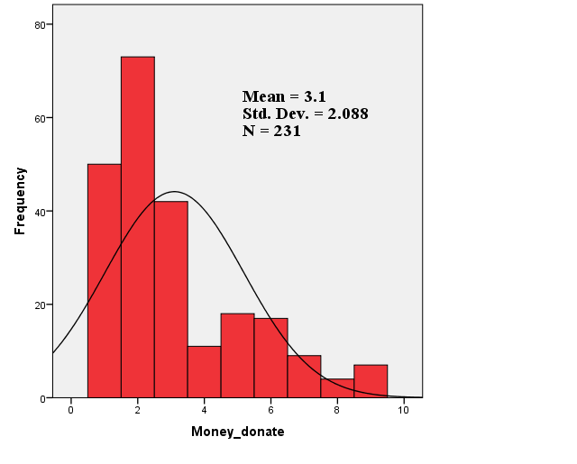

Figure 3: Histogram and Normal curve for the contributions

**Interpretation of the results**

From table 4 it is observed that mode of the donation is 2. From table 3 the 2 corresponds to £1 - £5 class. This is also observed in figure 3.This means that most of those who were surveyed contributed between £1 and £5. This was followed by those who did not contribute anything, while those who contributed between £31 and £35 contributed the least (see figure 3 for a clearer picture). The mean of contributions was 3.1 which lies within £6 - £10 class (see figure 3 and table 4). It may therefore be concluded that mean contribution lies between £6 and £10.

#### 2.1.4 Reasons for contributions

In order to identify the most important reasons for charity contributions, a seven scale linkert chart was used in the study. The scale was 1 to 7 (1 being strongly disagree with the statement and 7 being strongly agree with the statement). The reasons that were gauged on this linkert chart were as follows:

* “I feel uplifted when I help others/support worthy causes”
* “It is in line with my ethical beliefs or religious beliefs”
* “I am genuinely concerned about the particular causes that I support”
* “To help make the world a better place”
* “I can afford to give money to charity”

A descriptive statistics was carried out to understand how the respondents answered the questions. Table 5 below shows the results of this descriptive analysis. The table is an extract from SPSS software since the analysis was carried in the spss.

Table 5: Descriptive statistics results for reasons for contribution

| **Reason for charity** | | **Uplifted/Worthy course** | **Ethical/religious belief** | **Concerned genuinely** | **Make world better** | **Afford** |
| --- | --- | --- | --- | --- | --- | --- |
| **N** | **Valid** | 231 | 231 | 231 | 231 | 231 |
| **Missing** | 0 | 0 | 0 | 0 | 0 |
| **Mean** | | 4.46 | 3.95 | 5.41 | 4.33 | 3.61 |
| **Median** | | 5.00 | 4.00 | 6.00 | 4.00 | 3.00 |
| **Mode** | | 5 | 1 | 7 | 4 | 1 |
| **Std. Deviation** | | 1.771 | 2.248 | 1.811 | 1.988 | 2.021 |
| **Sum** | | 1031 | 913 | 1250 | 1000 | 833 |

**Interpretation of the results**

From the above descriptive statistics results above (table 5) it observed that most of those who contributed to the charity were genuinely concerned. These reason had mode of value 7 (see table 5 above). Being uplifted was second reason as to why some people contributed (it had a mode value of 5). Further from table 5 it is observed that the least reasons as to why people contributed towards charity were because of religious beliefs and because they could afford. These reasons had a mode of value of 1. Meaning that they did not contribute because they could afford nor because of their ethical or religious beliefs.

#### 2.1.5 Place of data collection

In order to understand how data were collected in various places, descriptive statistics was done on the “place data. The result of this analysis is shown in table 6 below.

Table 6: Place of data collection

|  | | Frequency | Percent | Valid Percent | Cumulative Percent |
| --- | --- | --- | --- | --- | --- |
| Valid | 1 | 93 | 40.3 | 40.3 | 40.3 |
| 2 | 81 | 35.1 | 35.1 | 75.3 |
| 3 | 57 | 24.7 | 24.7 | 100.0 |
| Total | 231 | 100.0 | 100.0 |  |

Key:

1 = Coventry, 2 = Warwick, 3 = Wolverhampton

**Interpretation of the data**

From table 6 above, it can be observed that most of data (40.3%) were collected from Coventry and the least data were collected from Wolvehampton.

### 2.2 Chi-Square Test

Chi-Square test was performed so understand if there is relationship between level of education and amount collected for medical research. Chi-square test was used in this analysis because the two variables are categorical in nature. The following two hypotheses were developed to explore this if indeed a relationship exists between these variables. The two hypotheses are stated below.

* **Null Hypothesis (H0):** There is no relationship between amount collected for medical research and level of education.
* **Hypothesis 1 (H1):** There is a relationship between amount collected for medical research and level of education. That is, the amount of money collected on medical research depended on level of education.

Note: In order to perform the chi-square test on the variables, it was assumed the each of the correspondents was counted once and the data was randomly collected; and hence all observations were independent. The results of performing this test are shown in table 6 (cross tabulation table) and table 7 (Chi-square test table).

Table 6: Cross tabulation of Medical research fund and Level of Educatin

| **Fund_MR * Education Cross-tabulation** | | | | | | |
| --- | --- | --- | --- | --- | --- | --- |
| Count | | | | | | |
|  | | Education | | | | Total |
| Secondary | College | Bachelors | MSc/PhD |
| Medical Research Fund | No | 25 | 44 | 56 | 32 | 157 |
| Yes | 17 | 21 | 22 | 14 | 74 |
| Total | | 42 | 65 | 78 | 46 | 231 |

Table 7: Chi-Square Test results

| **Chi-Square Tests** | | | |
| --- | --- | --- | --- |
|  | Value | df | Asymp. Sig. (2-sided) |
| Pearson Chi-Square | 1.956a | 3 | .582 |
| Likelihood Ratio | 1.916 | 3 | .590 |
| Linear-by-Linear Association | 1.257 | 1 | .262 |
| N of Valid Cases | 231 |  |  |
| a. 0 cells (0.0%) have expected count less than 5. The minimum expected count is 13.45. | | | |

**Interpretation of the Chi-square test results**

The findings of Chi-Square test analysis in table 5 satisfies the chi-square test condition that the expected frequency on any cell should always be equal or greater than 5 (Elliott & Woodward, 2014). The minimum expected count in this condition was 13.45. From the table 7 it is observed that Pearson chi-square value is 1.956 and 3 degrees of freedom, the p value (statistical significance) is 0.582 which is greater than 0.05. Since the value of P is greater than 0.05, there is no significant relationship between level of education and amount of money collected for medical research. This, therefore, means that the null hypothesis (H0) is accepted, while the alternative hypothesis (H1) rejected.

This result has also been supported by the cross tabulation analysis of level of education data and research fund data in table 6. It is observed that those whose level of education is MSc and PhD contributed the least (only 14 out 46, 30%); those with secondary education only 17 out 42 (40%) contributed; those with bachelors only 22 out of 78 (28%) contributed; and those with college degrees only 21 out of 65 (32%) contributed.

### 2.3 One Way ANOVA test

One Way ANOVA test was carried on the data to establish if there is any mean difference making world a better place and feeling uplifted, and also if the is mean difference between genuine concern and making world a better place. Since variables that were to be used in test were all continuous were all continuous, One Way ANOVA analysis was selected (Kohli, 2014). As a result the following hypotheses were established and tested.

**Null hypothesis 1 (H0)** = There is mean difference between making world a better place and feeling uplifted when helping others.

**Alternative hypothesis 1 (H1) =** There is no mean difference between making world a better place and feeling uplifted when helping others.

**Null hypothesis 2 (H0) =** There is mean difference between making world a better place and genuine concern.

**Alternative hypothesis 2 (H0) =** There is no mean difference between making world a better place and genuine concern.

The results of One Way ANOVA are shown in tables 8 and 9 below.

Table 8: Testing homogeneity of the variances

| **Test of Homogeneity of Variances** | | | | |
| --- | --- | --- | --- | --- |
|  | Levene Statistic | df1 | df2 | Sig. |
| Uplifted/Worthy course | 2.296 | 6 | 224 | .036 |
| Concerned genuinely | 29.884 | 6 | 224 | .000 |

Table 9: One Way ANOVA test results

| **ANOVA** | | | | | | |
| --- | --- | --- | --- | --- | --- | --- |
|  | | Sum of Squares | df | Mean Square | F | Sig. |
| Uplifted/Worthy course | Between Groups | 215.907 | 6 | 35.984 | 15.945 | .000 |
| Within Groups | 505.530 | 224 | 2.257 |  |  |
| Total | 721.437 | 230 |  |  |  |
| Concerned genuinely | Between Groups | 239.888 | 6 | 39.981 | 17.422 | .000 |
| Within Groups | 514.043 | 224 | 2.295 |  |  |
| Total | 753.931 | 230 |  |  |  |

**Interpretation of ANOVA test**

From table 9 above, it is observed that the values of F, degree of freedom and p for feeling uplifted and worthy course are 15.945, 6 and 0.000. Since significance value (p) is less than 0.05, there is a statistically significant mean difference between making world a better place and feeling uplifted when helping others. Since the mean difference between these variables is statistically significant, the null hypothesis is accepted while the alternative hypothesis is rejected. This means that those of contributed for charity because they felt uplifted also contributed so as to make the world a better place to live in.

Also from the table above, it is observed that the values of F, degree of freedom and p for genuine concern are 17.422, 6 and 0.000. Since significance value (p) is less than 0.05, there is a statistically significant mean difference between genuine concern and making the world a better. Since the mean difference between these variables is statistically significant, the null hypothesis is accepted while the alternative hypothesis is rejected. This means that those of contributed for charity because they were genuinely concerned also did so because they wanted to make the world a better place to live in.

### 2.4 Linear Regression

Linear regression was also carried out in this study to determine if making world a better depended on genuine concern. The hypothesis that was tested is stated below.

* **Null hypothesis (H0):** Making world a better depends genuine concern of the participants

Table 10: Linear regression result

| **ANOVAa** | | | | | | |
| --- | --- | --- | --- | --- | --- | --- |
| Model | | Sum of Squares | df | Mean Square | F | Sig. |
| 1 | Regression | 281.572 | 1 | 281.572 | 102.769 | .000b |
| Residual | 627.424 | 229 | 2.740 |  |  |
| Total | 908.996 | 230 |  |  |  |
| a. Dependent Variable: Make world better | | | | | | |
| b. Predictors: (Constant), Concerned genuinely | | | | | | |

**Interpretation of regression results**

From table 10 above, it is observed that F = 102.769, degree of freedom = 1, p = 0.000. Since the value of p is less than 0.05, there is dependence of dependent variable on independent variable is statistically significant, hence the null hypothesis is accepted and alternative hypothesis rejected (Elliott & Woodward, 2014). Therefore, “making world a better place” depends on genuine concern of the participants.

## 3. Conclusion

In summary this study found out that of the 231 participants, 74 contributed towards medical research fund, and 83 contributed towards children and young people fund, the rest did not contribute. It was found out that the main reason as to why people contribute towards charity was because they are genuinely concerned and they did so as to make the world a better place. It was also found out that level of education does not affect decision to contribute towards a charity or not.

## References

Aljandali, A., 2016. Quantitative Analysis and IBM® SPSS® Statistics: A Guide for Business.

London: Springer.

Elliott, A. C. & Woodward, W. A., 2014. IBM SPSS by Example: A Practical Guide to Statistical

Data Analysis. London: SAGE Publications.

Kohli, S., 2014. The usefulness of the quantitative method of statistical analysis. Germany:

GRIN Verlag.

# 