# RESEARCH PAPER ON SUPERSONIC FLIGHTS

## Abstract

This research paper provides alternative configurations that can be used to make the supersonic flights more efficient. These configurations have been achieved after considering the drag sources when the craft is at its maximum speed. The results of this research show that it is possible to achieve supersonic aircrafts which are more efficient if the Mach number is reduced. The targeted solutions on this paper include the configurations of the laminar flow and the oblique wings. With these two considerations, it is possible to achieve a high speed and more efficient supersonic aircraft. This research paper also reviews the fundamental considerations from the NASA research center.

## Introduction

Sound barrier is the sudden increase in the aerodynamic drag together with other effects that an aircraft experiences as it approaches the supersonic speed. When the aircraft is in dry air at a temperature of 200C or 680F, it will attain its sound barrier when its speed reaches 343 m/s. this term was first used in World War II when several aircrafts which were in use began to encounter compressibility effects. These are several effects found in aerodynamics and are unrelated in nature. These effects were overcome in 1950’s when the new designs of the aircrafts broke the sound barrier (Nemiroff & Bonnell, 2007).

A supersonic aircraft is an aircraft capable of flying at a speed higher than the speed of sound, whereby the speed of sound is Mach 1. Their development started in the 2nd half of the 20th Century. They are mostly applied in military purposes and research. The aerodynamics of supersonic flight is known as compressible flow since the compression within the shock waves is created any object that can achieve a speed faster than that of sound. If the aircraft flies at a speed beyond Mach 5, it is known as hypersonic aircraft (Gunston, 2008). As the jets move at this supersonic speed, the air pressure that is localized around it becomes lower, together with the temperature around the jet. When this drop in temperature goes below the saturation temperature, a cloud will form around the jet. This cloud resembles condensed water and is visible when the jet is moving through the air that is moist. This thick cloud is known as vapor cone, or shock egg or shock collar (Wilkinson, 2012).

## Supersonic fundamentals

Though there is efficiency in the supersonic flights, it is sometimes considered as very expensive in the long run, that is, an oxymoron, so to say. This is because though it saves on time, reduces the costs of the crew and is potential in higher utilization, it fuel consumption is very costly, together with the dramatic environmental impact that comes with such consumptions. Figure 1 shows that the ratio of the lift to that of the drag in supersonic planes is haft the one for the subsonic aircrafts (Tracy, 1994). This continues to be low with the increase in the Mach number. In the process, the fuel consumption in the supersonic aircrafts is nearly three times that used by the subsonic aircrafts for the same distance of travel. This drop in performance from Mach 0.9 to Mach 1.2 is due to a fundamental change in the way the fluid flows, thus leading to differences in the aerodynamic efficiency and configuration design. The aim of this research paper is thus to address the effect that these changes in the character of flow affects the configurations at optimum levels and then provide ways in which they might be used at maximum to achieve a supersonic design of Mach number 1.0 (Gerhardt, 1996).

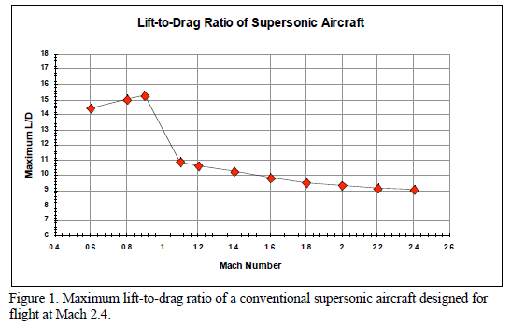

The following factors are put into consideration in this research:

* The drag directly affects the emissions, fuel and the size of the engines
* Missions for supersonic aircrafts include operations which are important in the off-design.
* The L/D of a typical supersonic aircraft is below 50% that of subsonic aircraft.

Jones in the 1950’s developed a formula used to investigate the efficiency of the supersonic aerodynamics drag, which this research greatly considers. The formula is as below: (Jones, 1952)



The expression above holds when the supersonic speed is low and the sweep of the wind is greater than the Mach lines sweep and the familiar vortex and viscous drag is included, together with the volume-dependent and lift dependent wave drags. The following symbols are used in the expression above:

q; the dynamic pressure

W; the weight

M; Mach number

b; the span

Vol; overall volume

S; wing area

*l*; effective craft length

From the expression it can be noticed that there is an inverse variation of two wave terms for the drag with the length of the aircraft. This finally leads to supersonic aircraft which are longer in size (Lee, 1961). Figure 2 below shows the drag distribution among the components of a large supersonic with Mach 2.4

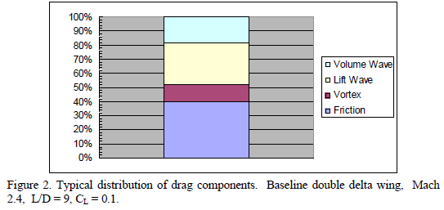

From figure 2, 60% of the total drag is accounted for by volume dependent wave drag and friction. The reduction in the Mach number leads to the decrease in the ratio of the relative contribution of the vortex drag to that of the lift-dependent wave drag. Increase in the Mach number leads to a corresponding increase in the optimal altitude. This gives significant implications on the structure, cabin safety and the environmental impact (Jones, 1991). Figure 3 shows some of these effects

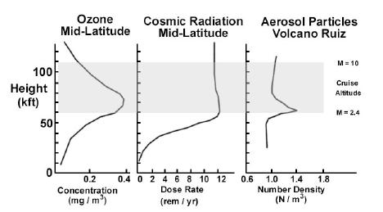



From figure 3, there is an indication that even small changes in the altitude of the design cruise can lead to very important effects. Considering more recent analyses, there is a suggestion that water and other influence emissions which include NOx have very high sensitivity to the deposition altitude. This makes the flight at 45,000-50,000 ft to be very different from that between 60,000 – 70,000 ft due to a reduced mixing taking place in the stratosphere (Intergovermental panel on Climate Change, 1999). Figure 4 below shows several unconventional designs which is proposed for a supersonic flight to be more efficient

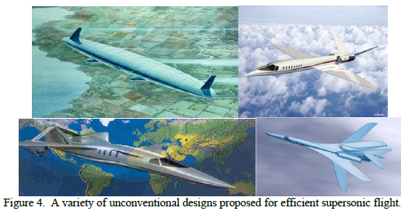

## 3. Configuration concepts

This section examines aspects which are vital for a supersonic aircraft, with a desire to achieve a Mach number range of 1.4 to 1.6

### 3.1 Canard and Conventional designs

Conventional supersonic aircrafts need cabin leads with minimum cross-section, distribution in the optimal area, and high fineness ratios. There must also be careful integration of the engine nacelles into the wing configurations in order to maintain area distributions which are reasonable. The aspect ratio and the ideal wing sweep are also different from those of the subsonic aircrafts. All these affect the fundamental stability and structure of the aerodynamics. The reduction of the ratio of the wing aspect makes the wing downwash to approach the attack angle at the tail. This is achieved when the theory of the slender body is considered. It is thus worth noting that the increase in the aspect ratio or the size of an aft tail increases not the stability at the point of low wing aspect ratio. Figure 5 indicates the conventional designs, while figure 6 shows the canards designs.

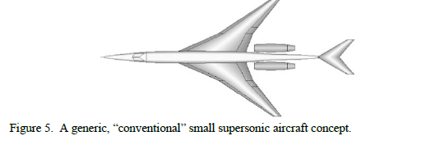

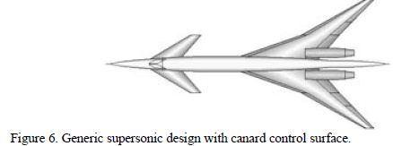

In order to achieve a canards design shown in figure 6, the wing aft should be movable, while the control authority of the tail at the conventional point should be reduced. Again having the aft location at the large wing helps in reducing the intrusion of the cabin. Canard design assist in increasing the landing CL or usable take-off in case there is a limit of the maximum usable CL in relation to the ground angle or the altitude of approach and also in case there is limited use of devices in the high lift. This is always the case during high sweep wings and low aspect ratio.

If the canard configurations or the aft tail is carefully designed with Mach numbers ranging from 1.4 to 1.6, the conventional designs can be achieved with efficiencies higher than the designs of Mach number 2+ which are currently cherished as having high speed. When the Mach number is low, the achieved wing sweeps will be better suited to operate at low speed, maximum bypass ratio for engines that will then lead to a reduction in the take-off noise, and altitudes of the cruise leading to the reduction in the impact that the emissions would cause globally. With all these concepts at hand, practical possibilities may be arrived at in order to get aircrafts whose speeds are about twice those of the civil ones.

### 3.2 Oblique wings

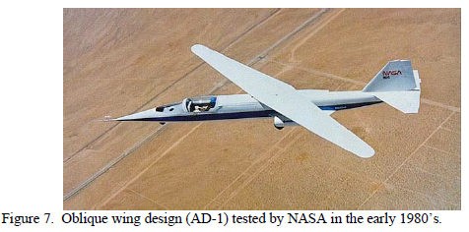

When developing the theory of supersonic flow, Jones considered for there to be minimum drag with low supersonic speeds, there should be an elliptical distribution of the span and the wing lift of a given length in both streamwise and spanwise directions (Jones, 1951). With a uniform distribution of the loading over the area, the platform of the wing will have a distribution that elliptically covers the area in both directions. In order to achieve this, yawed ellipse is used. This is shown in figure 8 below

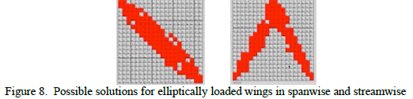

This oblique arrangement of the wing gives a lift distribution which about twice the length of the wing as a sweep wing which is conventionally having the same sweep and span, thus providing a reduction in the wave drag that is lift-dependent by a factor of four. The volume wave drag at low supersonic speed, where this scaling law applies, is 1/16th that of the wing which is symmetrically-swept of equal sweep, volume and span. This oblique sweep additionally avoids unsweeping of the isobars lying at the centerline. This in turn helps to maintain the sweep effect in the section of the critical center of the wing. This is shown in figure 9, together with the formulas for generating these parameters.

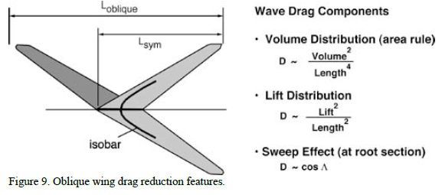

Figure 10 shows the structural advantages obtained from the oblique wings

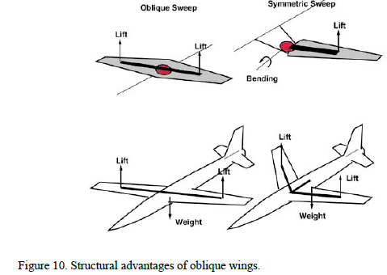

Figure 11 shows further advantages of oblique wings

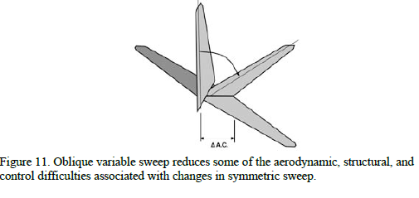

Figure 12 shows the applications of the oblique wings during the test by the NASA research center

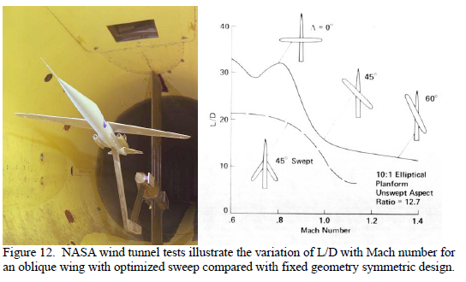

## Conclusion

One of the most crucial factors as illustrated in this research is the Mach number. This research aimed at designing a Mach number of 1.4 to 1.6. Though this Mach number is lower than the possible technical level that can be achieved, it still provides speeds with large gains which are in relation to the civil aircrafts that is currently available, but much more efficient and environment friendly. The supersonic aircrafts which are small in size are attractive in appearance, have greater assurance in the markets and help in reducing the noise in the community. The configurations of the oblique wing supersonic aircrafts that has been researched in this paper has all these advantages with it, thus making it a viable product for the market choice and fits well in its use in the military and space discoveries.

## References

Gerhardt, H. (1996, July 23). Supersonic natural laminar flow wing. U.S. Patent #5, p. 201.

Gunston, B. (2008). Faster than Sound: The Story of Supersonic Flight. . Somerset, UK: Haynes Publishing.

Intergovernmental Panel of Climate Change. (1999). Aviation and the Global Atmosphere.

Jones, R. (1951). The Minimum Drag of Thin Wings in Frictionless Flow. Journal of the Aeronautical Sciences.

Jones, R. (1952). Theoretical Determination of the Minimum Drag of Airfoils at Supersonic Speeds. Journal of the Aeronautical Sciences.

Jones, R. (1991). The Flying Wing Supersonic Transport. Aeronautical Journal.

Lee, G. (1961). Slewed Wing Supersonics. The Aeroplane.

Nemiroff, R. B. (2007). "A Sonic Boom.". Astronomy Picture of the Day. NASA, 1.

Tracy, R. (1994, June 21). High efficiency, supersonic aircraft. U.S. Patent #5, pp. 322,342.

Wilkinson, J. (2012). Wilk4: Breaking the Sound Barrier: Vapor Cones around Jets.