# Sociological Aspect and Perspective of Homophobia

## Table of Contents

Abstract……………………………………………………………………………………….. 3

Introduction……………………………………………..………………..…………………….4

Literature Review……………………………………………………………………...………. 4

Case study…………………………………………………………………………….………..10

Personal Opinion……………………………………………………………………………….17

Conclusion ………………………………………………………………………………….…17

Photos ………………………………………………………………………………………….19

References………………………………………………………………………………………21

## Abstract

In the Middle East, the LGBT communities have for a long time suffered from oppression from social, economic, and legal institutions. Historical marginalization has also contributed to the oppressions over the years. In the Middle Eastern countries, there is a perception that the practice of homosexuality and lesbianism is a concept that has been imported from Western nations to corrupt the culture and the morals of the people. The countries indicate that their religious affiliations do not allow the practice and tolerance of such 'vices' as they not only undermine the morals of the society, but are also a form of obscenities. Over the years, these perceptions have led to increased persecution and discrimination of the LGBT societies. However, the situation is slowly changing with some of the countries becoming more tolerant to the homosexuals and other members of the LGBT community.

## Introduction

The societal attitudes towards same-sex marriage vary in different cultures. Similarly, over different historical periods, the attitudes towards sexual desires, activities, and relationships have changed in different perspectives. Different cultures have different values which define the appropriate and the inappropriate sexual behaviors. For instance, some of the customs might sanction same-sex sexualities while others might disapprove such activities. In the past, most of the world cultures have considered procreative sex as the recognized sexual norm. However, over the years, there has been a rise in same-sex marriages and LGBT communities. Some cultures have legalized these LGBTs while others have remained adamant considering the move as contrary to their religious and cultural beliefs. The situation is a reflection of the current development in the Middle East. For instance, in some cultures, there has been increased hostility toward same-sex marriages. However, some sections are accepting the LGBT communities, even though most of the parts have been against the practice for an extended period. The paper seeks to analyze the social aspect and perspective of Homophobia in the Middle East. It draws close attention to the Lebanese communities and their perceptions towards same-sex relationships.

## Literature Review

In the Middle East, the sociological perspectives of Homophobia are influenced by the cultural traditions and the religious beliefs of the inhabitants of the region. For a long time, several countries from the Middle East have received international criticism for their persecution of the transsexual and homosexual communities (Amar & Prashod, 2013). Over the course of time, some of the countries have developed tolerant societal attitudes to protect these communities from harassment and discrimination. Some of the countries that have developed a societal tolerance for the LGBT people include Israel. For instance, it has taken steps to legalize and recognize these communities. Furthermore, in other countries such as Iraq, Bahrain, and Jordan, homosexuality has been authorized. In some of the countries such as Lebanon and Turkey, changes in sociological perspectives have been initiated by campaigns to promote greater tolerance, respect for other people's rights, and pluralistic democracy (Amar & Prashod, 2013). However, some of the countries still do not allow the existence of human rights groups and LGBT communities. Such countries include the United Arab Emirates, Kuwait, and Saudi Arabia. Such nations criminalize cross-dressing, same-sex sexuality, and any perceived support for the LBGT communities. Moreover, there are some Middle Eastern countries which have legal protections and tolerance for the transgender and transsexual people but not the bisexual and homosexual people. For example, the government of Iran has approved transgender operations under the approval of a medical practitioner.

Ilkkaracan (2016) argues that in the Middle East, Homophobia is linked with the rise of Islam. The issue of stigmatization is shared by both the secularists and the religious people. Before the 1979 Iranian Revolution, the period preceding the revolution saw a backlash against the gender reforms proposed by Shah. During this time, the Pahlavi autocracy critics and western imperialists joined forces with the conservative Islamists to campaign against the regime (Ilkkaracan, 2016). The leftist-Islamic thinker, Ali Shariati condemned the cultural revolution of the West especially women emancipation. He also denounced their recognition of open gay lifestyles (Ilkkaracan, 2016). In response to the small gay subcultures taking root in the Tehran elite circles by ignoring the century-old persistent practices, Shariati accused the Western countries of recognizing a social ill that had been disregarded in the Middle East. These perspectives have remained in some of the countries in the region. Until modern day Turkey Islamists and Kremalists still share negative responses towards the LGBT communities (Ilkkaracan, 2016). The Kremaliists are the most aggrieved group as they consider the practice as a threat to the essence and principles of their nation.

According to Maalouf (2004), the antipathy to homosexuality cannot be associated with the Islamic culture in the region. The rise of the Iranian revolution worsened the tendency of vilifying homosexuality and depicting it as corrupting cultural influence from the West. Following the revolution, an Islamic Republic was installed in Iran. The establishment of the Republic systematically increased the persecution and harassment of the homosexuals (Maalouf, 2004). The war against the heterosexual women and openly gay men intensified during the presidency of Mahmoud Ahmedinejad. During his term in power, two teenage boys were tortured and executed in 2005. The President claimed that there were no homosexuals allowed in Iran.

The 2000s ‘Queen Boat' case shows that homosexuality has become a contentious issue in the Middle East. In 2001, Egyptian authorities raided the Queen Boat, a gay nightclub, and arrested 52 people (McGee, 2016). The case elicited international criticism for the harassment and persecution of the homosexuals. In Egypt, homosexuality is not illegal. Therefore, the individuals that were arrested were charged with contempt of religion and convicted. The debate about the case constructed homosexuality as a threat to the nations (McGee, 2016). The chief prosecutor stated that Egypt was not and would not be a corruption den of manhood. Therefore, homosexual groups had no right or authority to be established in the country. Egypt described gay dresses as un-Egyptian and deemed homosexuality as a concept of global perversion. McGee (2016) argues that the nation considered the practice as a process driven by the Western forces and meant to corrupt the Egyptian culture and its national values. The ruling elicited varied responses from international bodies, Western Governments, and the European Parliament. The responses confirmed that the Western Countries were intervening in defense of the practice. As a consequence, it enabled the Egyptian Judicial System to portray the prosecutions as a way of protecting their cultural values from the cultural decadence of the Western culture. As at that time, the human rights groups in the country were left in a dilemma. They became divided and ultimately declined to defend the rights of the homosexual community. Just like the Queen Boat case, similar cases in the Middle East show how cultural authenticity can be regarded as collective good which requires protection from external cultures (McGee, 2016). Therefore, religion can be able to clear dimensions as there is an increased focus on identity in the national societies with disregard to international confrontation.

In his studies, Mohamed (2015) places culture at the core of his works. He links culture to the notion of hegemony proposed by Gramsci. Authority is primarily based on consent rather than coercion. Mohamed (2015) defines culture as the practices which have relative autonomy from the political, social, and economic realms existing in the aesthetic fields essential to ensuring pleasure. Mohamed (2015) also regards it as a concept which comprises of the elevating and refining elements of the society which have been there and know for a long time. Mohamed (2015) places culture at the center of the international relations. By making culture core in international relations, he links it with power which highlights essential aspects of cultural wars in the Middle Eastern Countries over homosexuality. Massad (2002) examines the academic discourse and intense political debate on homosexuality in the region. According to Massad, the intention of the Western nation to protect the rights of the LGBT societies in the area is part of its hegemonic project underpinned by exporting homosexual ideas and concepts to the countries. He indicates that ‘Gay International'- a network of activists promoting homosexual rights globally- is concerned with the creation of the homosexuals it seeks to protect (Morrow& Messinger (2006). In the Arab countries, the emergence of the agenda on sexual rights propagated by international human rights group has made the homosexual groups' victims harassment and other human rights violations in the region.

Massad (2002) argues that inciting a debate on homosexuals which did not exist before is heterosexualizing a world which is being coerced to be inclined to the Western binary. He indicates historically, non-Western societies such as the Muslim Arab societies have not ascribed to the categories defined by Gay International. As a result, their imposition is resulting in less liberatory outcomes. Massad (2002) argues that men considered as the affected parties in male-male relationships are forced to identify either as gays or homosexuals. On the other hand, the men that are regarded as active partners are also forced to restrict their sexual choices and identify either as men or women. As most of the active partners identify as part of the societal norms, heterosexuality also becomes compulsory based on the alternatives outlined by Gay International which indicates that such communities are marked out of the standard societal model (Morrow & Messinger, 2006). Most of the Arab countries do not have mechanisms that can respond to such practices of sexual conduct. Therefore, they react to Gay International's incitements by engaging in anti-homosexual campaigns by professing stances based on their social views. The situation is likely to cause police harassment which prompts the creation of legislation against homosexuals. Therefore, the countries that could have unenforced the laws begin enforcing them again.

Massad (2002) makes some arguments which highlight the neglected issues regarding class and its impact on the discourse of homosexuality in the Middle Eastern countries. He emphasizes that there is need to place the discussion within an international scope to reveal its dimensions. Massad’s (2002) arguments echo various postcolonial interpretations of modernity emphasizing on differences rather than commonality suggesting distinct historical experiences as opposed to typical universal experiences. While rejecting the concept of ‘native essentialism', other scholars like Morrow and Messinger (2006) entertain the possibility of other conceptions of the laws, morals, and the society. They also aspire to different kinds of Universalism, which is based on consultation and deliberation among diverse political players.

Furthermore, Roscoe and Murray (1997) argue that in the Middle East; modernity is associated with problematic ideas implied by their concepts on homosexuality. Their views indicate that the Western actors are concerned with shaping and controlling the debate on homosexuality in the Middle East. They stress that the gay and the lesbian identity in Egypt is European-based transnational organizations and the US. They suggest that the homosexual community in Egypt and the rest of the Middle East are not free and morally responsible for their choices on sexuality and gender (Roscoe & Murray, 1997). Furthermore, they indicate that the decisions are enforced on them by the Western countries through their international organizations and activist groups. In this context, Roscoe and Murray’s (1997) arguments have various similarities with the post-colonial standpoint, which treats the elites dominant after the colonial period as creatures imbued with the Western culture and ideas. They are right to suggest that the intervention of the Western forces in the issue of homosexuality in the Middle East distorts the local realities. On the other hand, it is also right to say that it is difficult to understand the local realities without referencing them to the international scope within which the identity of culture is invariably defined against the West. Roscoe and Murray (1997) pushes the argument further ahead and associates it with domination and abilities to determine the realities. The arguments are challenged by scholars that object that the homosexual in the Middle East is products of the West. According to Scott Long, Roscoe and Murray (1997) present an exaggerated view of Gay International's capacity to achieve its objectives. Long suggests that in the Middle Eastern Countries, a collective identity among the homosexuals has developed indigenously.

Whitaker (2011) maintains that in some of the Arab countries, the sociological perspectives on the lesbians differ from that of the gays. For instance, in Egypt, the lesbians are left alone by the authorities, unlike the gay men. However, he does not provide the links to support the proposition. He argues that homosexual women do not have pick-up points, unlike the gays and the heterosexuals. Whitaker (2011) bases his assumption on the proposition of a fellow scholar, Iman al-Ghafari who indicates that Arabs consider lesbianism a ‘temporary substitute' for the men's love. Whittaker (2011) uses this hypothesis to explain that the Arab lesbians enjoy positive attitude because they are not perceived as threats to the heterosexual system. He further adds that in the Middle Eastern countries, lesbianism is used primarily among the married women to spice up their sex lives. Unlike the homosexual communities, he considers lesbianism in Arab as an activity as opposed to identity (Whitaker, 2011). The explanations behind the invisibility of the identity indicate that the debate which turns the lesbianism practice into a political character is not liberating.

## Case study of Lebanon

The LBGT movement in the Arab countries is most active in Lebanon. For instance, in this country, the gay communities have designated meeting points where they get to interact and associate with members of similar sexual orientations.

## Institutional Homophobia

Institutional homophobia is the condemnation and stigmatization against homosexuality at all levels of the community, including the political, economic, educational, social, and religious institutions (Puar, 2013). These institutions are fundamental in setting the moral standards in societies, therefore, becomes the primary causes of marginalization among the LGBT communities (Puar, 2013). In most cultures, there is a perceived and intentional ignorance towards the issue of homosexuality, which is considered as a defense against the problem as it does not elicit any actions. In the Lebanese communities, the religious leaders command respect and authority within their communities. Often, the leaders do not entertain homosexuality within their localities (Puar, 2013). In most cases, the leaders work with other non-state agents to organize campaigns against the homosexual people. In 2003, a leading Cleric stated that it was essential to impose a death penalty to prevent people from pacifying their societies and deter criminals. The Cleric referred to the Islamic law and pointed out the cases where the death penalty needed to be imposed (Keddie, 2012). In the case, the Cleric pointed out homosexuality indicating that it went against the natural norms of the relationships between men and women. He also pointed out that the practice would have a negative impact on the society. Additionally, reports indicate that in 2003, five suspected homosexual men were kidnapped by the Hezbollah member and handed to the police. Further reports suggest that in Lebanon, the LGBT communities have been targets of institutional discrimination and stigmatization (Pullen, 2012). For instance, some people have experienced adverse attitudes against these groups from teachers and other authoritarian people in the educational institutions. Helem reports that two school teachers were fired when the knowledge of their sexual orientation was discovered. The discrimination can be further manifested in the way some of the institutions that had initially accepted the LGBT communities re-structured their policies to discriminate against the same people (Pullen, 2012). An example can be seen when Dunking Donuts, a famous hangout joint for the homosexual men in Beirut, changed its policies to prevent ‘gay looking' men from accessing the premises indicating that these people were troublemakers. They also argued that their external appearance compromised the family environment at the place.

Keddie, N. R. (2012) indicates that there have been cases of sexual discrimination at Gay clubs in Lebanon. In most of these clubs, feminine looking gays have been denied entrance. In one instance, a transsexual that was a regular at a popular nightclub in Beirut was thrown out of the premises and barred from re-accessing the premises (Keddie, 2012). The transsexual woman had gotten into a controversy with a homosexual man that thought that the lady was flirting with his boyfriend. In her defense, she indicated that she was not flirting with the ‘boyfriend' in question. On the other hand, when asked about the situation that had led to the blacklisting of the transsexual lady, the club's owner indicated that it was for the good of the levelers that were usually provoked by the transsexuals as they were bound to cause trouble.

Despite the attitudes, there are various gay clubs in Lebanon. One of the most prominent is the Acid Club located in Sin el-Fil district. The club is supported by former President Lahoud's son. In the past, the police have conducted raids in relation to drug use and cruises between the Muslims and the Christians (Keddie, 2012). However, in this raid, apart from targeting the devil worshippers and drug users, the law enforcement officers also pursued the lesbians and the gays. There are other gay clubs in the region, but they have adopted an underground approach. Some examples of the underground gay nightclubs include the MILK.

Most of the people in the country have struggled to accept their sexual orientation towards same sexes. Among the Lebanese communities, the gays and lesbians feel a sense of duty towards their families making them choose family loyalty at the expense of their sexual orientations. Therefore, they become reluctant to come out as they fear that they might lose their respect and status in the society. They also fear that they might be excluded from their families making them deal with their guilt and conflicts on their own (Morrow & Messinger, 2006).The environment in Lebanon is hostile to the gay and the lesbian members. As a result, these groups must learn to develop their self-identities in these settings. The hostility causes deviance as the members of the gay, and the lesbian communities try establishing their identities. The deviance is usually carried out within gay or lesbian communities or private environments (Sakalli, 2002). Reports indicate most of the Lebanese people feared entering the gay life as they saw that it would be difficult to turn back to straight ways. Most of them still believed that they had a chance of becoming straight if they resisted their attractions towards same sexes. On top of that, other people fear that exposing themselves to the gay communities would increase their chances of being caught and labeled (Sakalli, 2002). As a consequence, most of the gay and lesbian members fear entering gay clubs in Lebanese. Most of them resort to masquerading behind professions such as bartenders to get to know members of the communities that make them change their perceptions about their sexual orientations. Due to the fears to come out, many LGBTs have expressed their desires to leave Lebanon and migrate to other countries where they could be allowed to have children. The discrimination against their sexual orientations makes them feel unsafe in their homelands hence the need to migrate.

There are tensions between the sexual and the religious identities of the LGBT communities in Lebanon. As a result, most of the LGBT people deal with the issue of the conflicts by separating their religious characters with their sexual identities. Others prefer struggling to reconcile the conflicting personalities (Morrow & Messinger, 2006). In this section of the population, they try fixing what their religion disregards. As a consequence, they find themselves struggling with guilt as they grew in a country defined by traditions and structured laws that prohibited and despised same-sex relationships. Most of the Lebanese people with such sexual orientations are afraid of the consequences that could result if they adopted gay or lesbian lifestyles (Morrow & Messinger, 2006). Most of them still feel that being in the same-sex relationships is just a phase as one would at one time need to get married and have a family in the future. Therefore, they consider getting psychologist's help to change their perspectives on life. Also, they need to talk to someone on a personal level that can understand them without judging their sexual orientation.

Just like in other Middle Eastern Countries, the debates on homosexuality in Lebanon are restricted to view the practice as immoral rather considering it as a sexual identity or orientation. In this context, the attitudes towards homosexuality are defined by the patriarchal structures that constitute aspects of control and power (Habib, 2007). The main challenge is the lack of public discourse regarding the homosexuality. The situation is manifested by the lack of relevant materials such as scientific books, articles, and TV programs addressing the issue without prejudice. The lack of debate has been cited as the major cause of homophobia in Lebanon. Some of the biggest non-Arabic newspapers, L'Orient-Le Jour and The Daily Star, have conducted studies and published articles on the struggle of the LGBTs for recognition in Lebanon and the price they pay. According to Habib (2007) Helem indicates that the newspapers have interviewed members of the lesbian and gay communities and came to a common conclusion that homosexuality was not tolerated in the Lebanese community. The findings of the study indicated that the LGBT community suffers from emotional and physical abuse since the people did not condone their sexual orientations (Habib, 2007). Despite the efforts to open debates on issues of homosexuality, the Arabic newspapers have continued to label the LGBT societies as sodomites, perverts, and deviants. They are classified in the categories of bestiality and pedophilia. Over the years, there has been a silenced debate on the homosexuality issue in the Arab world. Therefore, it has made the adaptation of the deviant identities difficult as it prevents most of these people from making their identities public.

On top of that, there is a concern arising from the lack of public awareness concerning homosexuality causing familial problems. In countries like Lebanon, the stigma attached to same-sex relationships makes it difficult for the families to seek for advice from family members and friends since they fear that they might be excluded from the family or friendship relationships(Ilkkaracan, 2016). Therefore, many of the families of the LGBT members prefer getting the professional help that would have a different view of the situation. Unlike the family members and the friends, the professional psychiatrist has a better opportunity to understand and address the case in a manner that could not undermine the sexuality of the individual which is fundamental in taking away empathy(Massad, 2002). However, the perceptions in Lebanon indicate that even though the behaviors of these groups might be corrected, they are more likely to get back to their old ways hence the increased discrimination and marginalization.

However, the situation is slowly changing is some of the Lebanese cities such as Beirut. The young people living in the city are becoming more liberated and open-minded increasing the hope of having a tolerant society in the future years (Merabet, 2004). Over the years, the concept of homosexuality has slowly become universal credit to the media and the internet. Report findings indicate that in the after years, one could not be able even to utter the gay term in the country. However, over the course of time, due to increased activism and lobbying from international bodies, the concept of homosexuality has gained some tolerance in Lebanon (Merabet, 2004). However, over the years, findings indicate that the trend is likely to reduce as the lifestyle is expected to go out of fashion. The Lebanese mentality suggests that the lifestyle is a showoff and is expected to fade with time. The society is increasingly becoming open to the LGBT members are they no longer prohibited from accessing malls, restaurants, and gay clubs (Merabet, 2004) However, the religious leaders continue emphasizing the significance of maintaining morality to maintain social order. Therefore, they keep using the LGBT people as scapegoats for corruption and crimes.

Helem has increased its operations in Lebanon to ensure that the rights of the LGBT people are taken into account. Even though Helem and other LGBT groups are secular, they at times support religions organizations to ensure that there is reconciliation between Muslim identity and homosexuality(Ilkkaracan, 2016). The movements do not have direct impacts on the religious debates. However, they help to address the anti-homosexual rhetoric. For instance, when groups claim that the rights of the LGBTs are human rights and that homosexuality is an identity issue and not sexual acts, the groups contribute to the discourse creating a debate which describes them as being perverse. The groups confirm that there is an emergence of homosexual identity in Middle Eastern countries. During the discussions, the local differences between the various groups in the Middle East should not be disregarded. Massad (2002) argues thattheir variability should be taken into account since there are multiple cultural and religious minorities. Furthermore, the groups should be aware that there are countries that are more liberal than others in the issues of sexuality. Therefore, their approaches used to advance their interest in these countries should consider such factors.

## Personal opinion

Despite the challenges facing the LGBT communities in the Middle East, they hope that the situation is likely to change soon. With the existence of Helem and other LGBT organizations indicates that there is hope for the acceptance and social inclusion of the homosexuals in the Middle Eastern countries like Lebanon. The activists and the groups not only work to support the LGBTs, but their campaigning and activism are aimed at overturning the policies prohibiting homosexuality and lesbianism in these regions. Moreover, they are focused on promoting awareness regarding the LGBT societies by educating the Lebanese society integral in changing their sociological perspectives on the issue. While it is hard for the homosexuals in the Middle Eastern countries, I believe that Lebanon is progressive becoming a liberal society. The progress is being made due to efforts to foster an environment of tolerance and understanding the LGBT member that creates a safer environment for their existence. I think that the environment should be made safer for every individual to be free to express their sexual orientations without the fear of victimization. The changes of the perceptions should incorporate all the concerned institutions to achieve the desired objective.

## Conclusion

The environment in the Middle East has not been welcoming to the LGBT communities. Most of the people in the region hold negative attitudes towards the LGBTs. In most cases, the views have been propagated by authoritarian governments, matriarchs, traditional patriarchs, and conservative religious leaders. These authorities argue that the promotion of immoral tendencies such as homosexuality and lesbianism would undermine their cultural and social values. They organize campaigns against the LGBT communities in the pretense of protecting their culture that might have been wiped out a long time ago. Since most of the people in the Middle Eastern countries are Muslims, they tend to lead others into directions of willful ignorance and sheer oblivion when it comes to issues regarding the rights of the LGBT societies. However, the situation is slowly changing. Some countries such as Lebanon are starting to change their attitudes towards the LGBTs. Full acceptance and integration into the Arab societies might prove difficult at the moment, but there is hope that the situation is likely to change in the future years. The tolerance and acceptance of the LGBTs are slowly gaining shape with the emergence of activists and international lobbying organizations advocating for their recognition.

## Photos

Protestors Playing Drums during Anti-homophobia camp in Beirut, Lebanon. (Photo Courtesy of Al-Arabiya English)

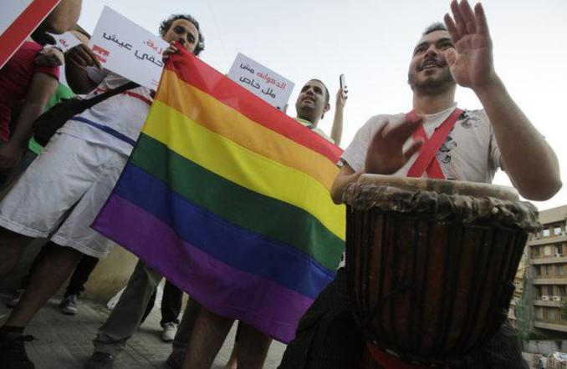

Anti-Homophobia Rally in Beirut 2013 (Photo Courtesy of The New Arab)

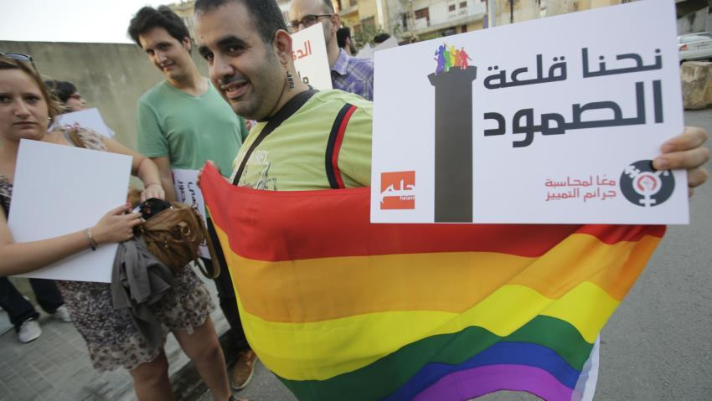

Release of 26 suspected to be gays in Cairo Egypt

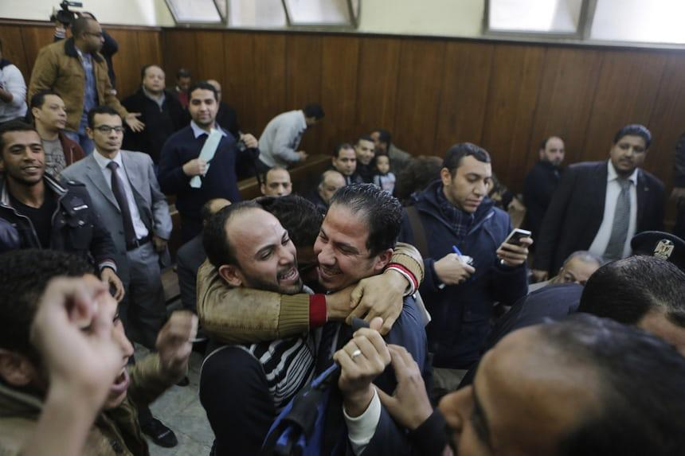

LGBT Rally in Muslim Countries (Photo Courtesy of The Guardian) 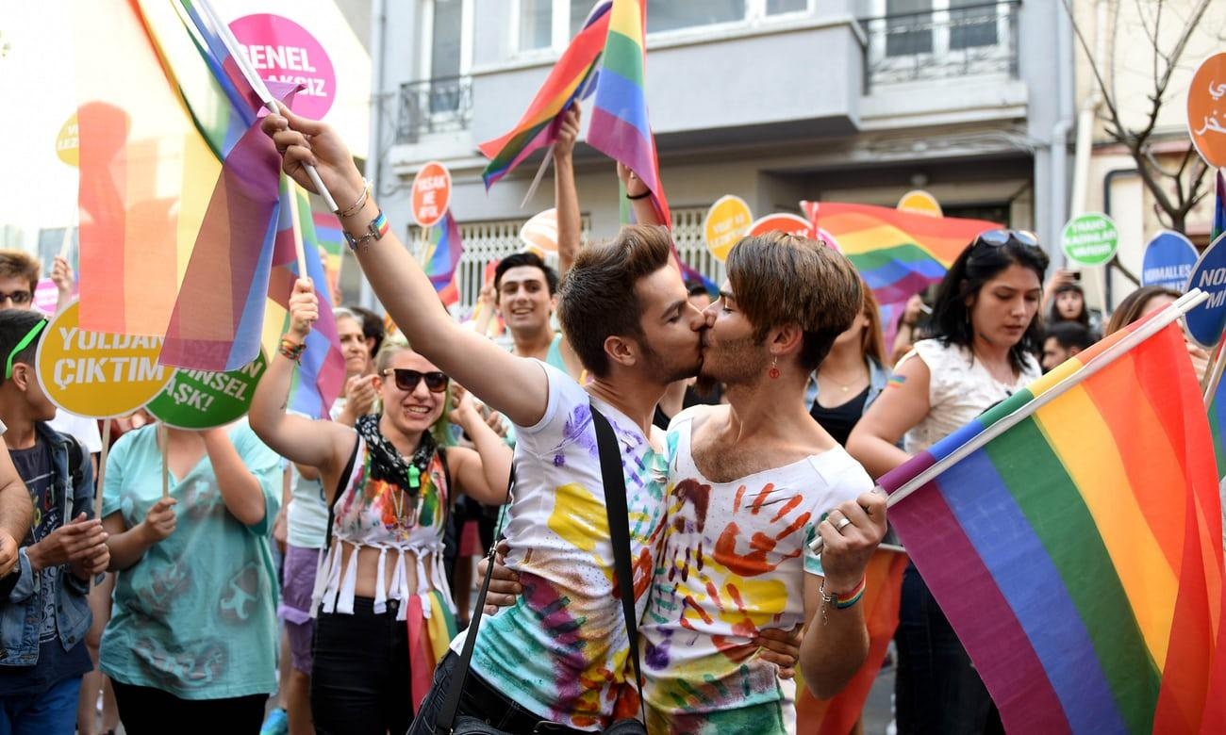

## References

Amar, P., & Prashod, V. (2013). *Dispatches from the Arab Spring. Understanding the New Middle East*.

Habib, S. (2007). *Female homosexuality in the Middle East: histories and representations (Vol. 13)*. Routledge.

Ilkkaracan, P. (Ed.). (2016). *Deconstructing sexuality in the Middle East: challenges and discourses.* Routledge.

Keddie, N. R. (2012). *Women in the Middle East: Past and present.* Princeton University Press.

Maalouf, L. (2004). Imagined masculinities: Male identity and culture in the modern Middle East. *Al-Raida Journal*, 119-120.

Mohamed, M. S. (2015). *Sexuality, Development and Non-conforming Desire in the Arab World: The Case of Lebanon and Egypt* (No. IDS Evidence Report; 158). IDS.

Massad, J. A. (2002). Re-orienting desire: The gay international and the Arab world. *Public Culture*, 14(2), 361-385.

McGee, R. W. (2016). *Does Religion Influence Views toward Homosexuality: An Empirical Study of 16 Countries*.

Merabet, S. (2004). Disavowed homosexualities in Beirut. *Middle East Report*, (230), 30-33.

Morrow, D. F., & Messinger, L. (Eds.). (2006). *Sexual orientation and gender expression in social work practice: Working with gay, lesbian, bisexual, and transgender people.* Columbia University Press.

Pullen, C. (2012). *LGBT transnational identity and the media.* Springer.

Puar, J. (2013). Rethinking homonationalism. *International Journal of Middle East Studies*, 45(2), 336-339.

Roscoe, W., & Murray, S. O. (Eds.). (1997). *Islamic homosexualities: Culture, history, and literature.* NYU Press.

Sakalli, N. (2002). The relationship between sexism and attitudes toward homosexuality in a sample of Turkish college students. Journal of homosexuality, 42(3), 53-64.

Whitaker, B. (2011). *Unspeakable love: gay and lesbian life in the Middle East*. Saqi.