# Solar Magnetic Field at the Sunspots

## Introduction:

The sun is defined as a magnetically driven star. It is entirely composed of Plasma which is a gas whose temperature has risen to such a high level that it becomes very sensitive to magnetism. On the solar surface, sunspots appear from time to time and show up as black spots, comparing to its brighter surroundings, where intense magnetic activity takes place. The sunspots magnetic field can be represented as in figure below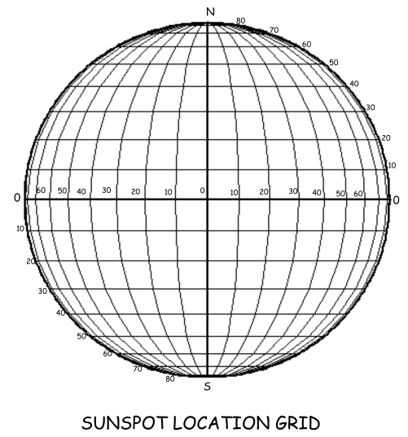

As a matter of fact, the sun’s magnetic field is responsible for the explosions which occur on sun’s surface, the interplanetary magnetic field and radiation. These explosions are formed because of the interaction between the magnetic field’s lines with each other causing big explosions on the sun especially in the case of the interaction between small loops. The sun is surrounded by an electric field that is responsible for the generation of a magnetic field which is present in the entire solar system. The field causes activities such as surging and ebbing on the surface of the sun. During the time when the sunspot activities are at maximum, the polarity of the field flips at the peak of the cycle. The magnetic field of the sun exhibits two types of poles similar to those present on a bar of magnet. The polarity of the poles normally flips during the peak moments of the solar activity cycle in every 11 years. The sun should not be confused with a solid ball. It is in form of a fluid that has different rotations where the surface moves at different speeds according to latitudes. This nature of the sun causes the wounding of the magnetic field lines.the suns magnetic field can be illustrated as in the figure below:

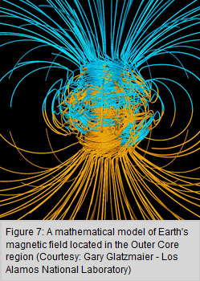

The sun’s magnetic field has its influence extended to long distances extending past planets and into interstellar space. NASA has provided photos from X-ray machines that show images obtained from a TRACE satellite showing loops of solar magnetic field lines wounding around the sun. Each loop is composed of a bundle of field lines .The sunspots mark the positions where the ends of the loops emerge and reenter into the photosphere. The flow of the hot plasma is the zone of convection creates a solar magnetic field. The rotation of the sun is vital to consider in the study of solar magnetic fields because it is the force that facilitate some of the processes. The Sunspots are positions that contain very strong magnetic fields where the field lines are crowded together pushing through the space, thus causing some of the hot plasma with them to have a loop. This point can be viewed on the photosphere .

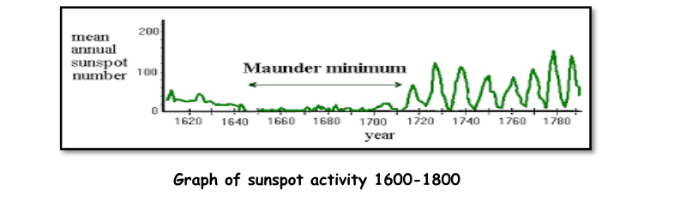

The more the magnetic field lines are made to scrunch together, the higher the magnetic pressure created causing them fields to push apart. The outer side of the sunspot contains only gas pressure that is dependent of temperature (Publishing, 2013). This research paper seeks to define solar magnetic field components that are linked to the production of the magnetic fields from the solar. The objectives of the paper is to understand solar magnetic field pressures, what causes the magnetic fields on the surface of the sun and compare it to other magnetic fields in the solar system such as the stellar.

## The formation and the types of the Solar Magnetic Field:

It is discovered that the sun has a massive and a complex magnetic field. In addition, it is very strong, approximately 1-2 Gauss which is bigger than the earth’s magnetic field which is around 0.5 Gauss (Dr. David R. Williams 2016). Dynamo is considered a theory which explains the transform from mechanical energy into electricity which generates the magnetic field for different celestial bodies (Planets or stars). The sun consists of very heated charged particles. These particles in motion are a current and produce the fields. This is similar to the current in coil of wire wounded around a nail. In this case the convection current is made to move by the heat from the fusion of the Sun. This flow is called solar dynamo. It is a mechanical motion that is involved in the generation of the magnetic fields that will result to sunspots (Publishing, 2013). There are two types of magnetic field’s lines on the sun’s surface: those which extend from within the sun to all the way out in space, but they stay attached to the sun, and the other ones come out from the surface of sun and they return to the sun making small loops near the solar surface. The magnetic field can be diagrammatically related as follows:

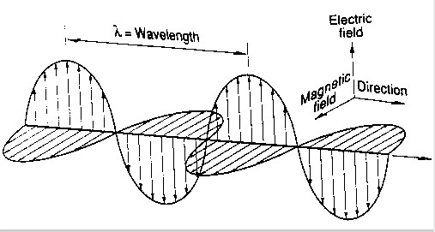

## Magnetic Pressures around the Sun

The sunspot can be imagined as a bubble that is covered with gas pressure of the photosphere were the surface upper layer produces the light we see. For the spot to exist it has to contain a pressure outwards so as to balance the inner pressure region. The magnetic field produces a magnetic pressure that ensures the cooling of the sunspots. The magnetic pressure inside the spots allows the gas pressure to remain lower than the surrounding areas outside to contain the conditions. This process slows down the convictive motion which normally makes hot matter to rise up from the interior area of the sun making the spot cooler. The pressure balances the opposite sides of the spot to keep it cool. Due to the effect of cooling, the sunspots are more likely to reach a temperature of 4000 degrees kelvin instead of being about 5800 degrees kelvin. However this temperature is still very high compared to other places on the surface of the earth. In calculation, the produced magnetic pressures inside the sunspot is strong enough to cause a cooling effect that can cool the surface of the sun by almost one third. Because the spots are approximately one third cooler than the surrounding areas, they are much darker than the other regions around (Whittaker, 2010). A small change in temperatures will result into a big change in brightness.

One of the reasons as to why sunspot intensity is of particular signinficance is the brightness ratio. Brightness ratio is the ratio of continuum in the darkest part of the umbra to the average surrounding continuum intensity of the photosphere, an ballpark figure of magnetic strength.

$brightness ration=\frac{minimum\left(Ic umbra\right)}{average\left(Ic photosphere\right)}$

Considering a flux tube, from the interactions of the solar surface with large magnetic flux tubes,we can calculate the pressure balance:

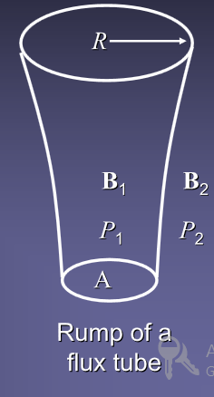

Magnetic field produces a pressure as a result of which opacity in sunspot is decreased and is responsible for half of the observable effects. $\frac{B_{spot}^{2}}{8π}+P_{spot}=P_{surrounding }→P_{spot}$ $≪P_{surrounding }→P_{spot}≪P_{surrrounding}$

The sunspots are darker from strong magnetic field not permitting movement across the magnetic field, quenching convection inside the spot and vice versa. Convection being the principal energy source below the surface, less energy reaches the surface through the spot. This can be illustrated as follows:

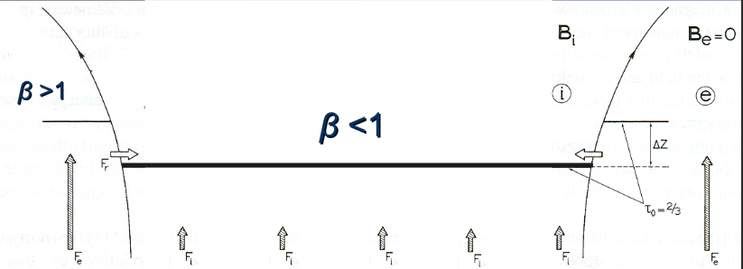

The sun darkens whenever spots moves across its discs and the blocked heat are retained over time, maybe days to weeks.

## References:

Elliott, D. (2012). *Earth science* (1st e.d.). Ipswich, Mass.: Salem Press.

Publishing, S. (2013). *Earth Science* (1st e.d.). Irvine: Saddleback Publishing.

Schrijver, C., & Zwaan, C. (2008). *Solar and stellar magnetic activity* (1st e.d.). Cambridge, U.K.: Cambridge University Press.

Stenflo, J. (2011). *Solar magnetic fields* (1st e.d.). Dordrecht: Springer.

Whittaker, H. (2010). *Space science* (1st e.d.). South Yarra, Vic.: Macmillan Education Australia.