# UK Macroeconomic Position

The United Kingdom (UK) has one of the strongest economies in the world and ranked highest in the world based on gross domestic product (GDP). Since 2010 the UK economy has been growing steadily and recovering fast from the effects of 2008/2009 global financial crisis with an annual average growth rate of 1.0%. However, since early 2017 the growth of the UK economy started slowing as inflation increased and consumer spending slowed. The slowing economic growth has been attributed to increasing uncertainty caused by expected Brexit scheduled for 2019 and increase in consumer price inflation (CPI) which has increased from 0% in 2015 to 3% in 2018 (pwc, 2018, p. 4). The unemployment rate has decreased significantly to the lowest level of 4.4%, but real income has declined. The GDP growth reached the high of 9.5% in GDP while balance of payment deficit reduced to about 3% and borrowings reduced to 95% of GDP (OECD, 2017, p. 14). However, the increasing uncertainties over Brexit and strengthening global economies may require the government to take other measures to stabilise the economy and improve the standards of lives of its people. This document examines the current macroeconomic position of the UK, the sates of monetary and fiscal policies over the last one year and the expected changes in monetary and fiscal policies over the next year to achieve anticipated growth.

The current state of UK economy is above average compared with the rest of the world. A stable developed economy implies better living standards of the citizens. The growth in employment individual security, higher health status, social connections and a better environmental quality defines the UK economy (Bank of England, 2017). However, declining productivity require rigorous measures to improve the quality of life of the people and minimise inequalities. Also, the planned Brexit is likely to weaken the UK economy unless the government implements policies to contain the situation. Furthermore, withdrawal from the EU which constituted about 45% of the total UK’s export could have adverse effects on UK’s economies if there is no government intervention (IMF, 2017). The economic growth plummeted since 2016 after the successful June 2016 Brexit referendum which caused growth rate to fall to 1.8% and declined further to 1.1% in the first quarter of 2017 over the increasing uncertainties (OECD, 2017, p. 22). The downgrading of the UK’s sovereign rating, the decline in short-term confidence indicators and suspension of various commercial property funds were some of the immediate effects of declining economic growth and diminishing labour productivity.

Since 2010 the UK government has been using various policy instruments to strengthen economic and enhance its recovery from the effects of the global crisis. As of February 2018, the rate of consumer price inflation had increased to 2.7% (IMF, 2017). The rate of inflation has been on the rise over the last one year due to increase in interest rate. The government reverted to the use of various policy interventions to achieve economic stability. The policies focused on promoting private consumption which was achieved through tax reduction, stimulation of employment growth and raising of the minimum wage. Low inflation and higher productivity were also contributing to increase in private consumption hence economic stability. The recent fiscal and monetary policy interventions have strengthened the UK economy (Bank of England, 2017). The declining labour productivity is one of the greatest challenges the UK is facing at the moment. The decreasing labour productivity is also affecting consumer purchasing power thus contributing to economic stagnation. The government should focus on fiscal policies which will promote productivity

The bank of England uses monetary and fiscal policies to influence inflation and stimulate economic growth. Monetary policies aim at influencing demand and supply of money using interest rates and other monetary tools to stabilise the economy by maintaining inflation low and avoiding a financial crisis by influencing consumer expenditure and aggregate demand. The Bank of England uses monetary policies to achieve target inflation of about 2% and improve economic growth through reducing rate of unemployment (IMF, 2017). The monetary policies involve the use of interest rates, quantitative easing and open market operations to achieve economic stability. Use of monetary policies such as increase of interest rate is used as an effective tool for reducing inflation because it makes prices of goods or product to go hence reduce consumer purchasing power which in turn reduces consumption as well as the rate of economic growth. Also, increasing interest rate attracts savings since investors can earn higher interests.

Fiscal policy is involved with public expenditure and taxation. Since government spending affects aggregate demand. The Bank of England uses either expansionary or contractionary fiscal policies to influence government’s budget position Bank of England, 2017). The use of fiscal policy to reduce inflation could involve measures such as increasing taxes and reducing government spending. By 2016 the UK’s GDP growth rate was highest 9%. The use of various monetary policies and fiscal policies contributed to the higher economic growth and more stable economy.

The Bank of England has been using fiscal policies to achieve economic stability. For instance, in 2016, it reduced the interest rate to 0.25% to restore confidence following the successful referendum seeking to withdraw from European Union (Bank of England, 2017). Also, it used expansionary policy by purchasing government and corporate bond worthy £70 billion. The expansionary policy targeted at increasing money in circulation which in turn lead to higher inflation. Though higher inflation reduces the purchasing power of consumers, it supported export which is essential for helping the UK government reduce the balance of payment deficit. The balance of payment deficit occurs when the country is importing more than it exports. Therefore, the recent government’s fiscal policies have helped in reducing the deficit in the balance of payment by supporting the growth of export hence higher economic stability.

Figure 1. The contribution of private consumption on economic growth

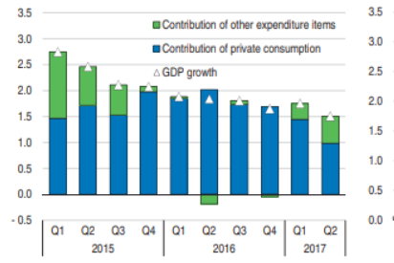

Source: OECD, 2017, p.23.

The figure above shows contribution of private consumption to GDP growth. Since the third quarter of 2016 the private consumption has been declining, and this can be attributed to decrease in real wages of the consumers.

Figure 2

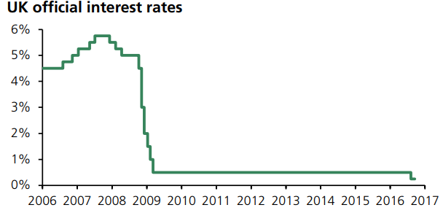

Source: House of Commons Library, 2016.

The figure 2 above shows the trend of interest rate reduction in the UK before and after the financial crisis.

The implementation of various fiscal and monetary policies such as reduction of interest rates, reduction of inflation and quantitative easing helped in stabilising the economy and enhancing growth to achieve quick recovery from the effects of financial crisis. As of 2014, the quantitative easing had an estimated impact of increasing GDP growth by 0.18% and increase in consumer price inflation by 0.3% since 2009 (Bank of England, 2017). After the successful referendum for Brexit on 23 June 2016, the Bank of England decided to cut the interest rate further to the lowest value of 0.25% to instil confidence about the UK economic growth. It further engaged in quantitative easing by purchasing a total of £70 billion of government and corporate bonds. In 2017, the unemployment rate fell to lowest level in four decades to 4.4%, but the inflation led the decline in real earnings. The review of the balance of payment in 2017 indicated that the UK had a deficit of about £22 billion while inward investment showed a deficit of £25 billion (ONS, 2017).

The UK economic growth forecast for 2018 and 2019 stands at 1.5% and 1.6% respectively. As global and Eurozone economies grow stronger and pound, the currency remains competitive particularly about Euro the UK economy is expected to relatively stable due to growth in exports (House of Commons Library, 2016). The services sector and manufacturing are expected to maintain their position over the throughout the 2018 and 2019. The Bank of England is set to raise interest rates in 2018 through 2019. According to projections from PWC the UK economic growth in 2018 and 2019 will be 1.5% and 1.6% respectively (PWC, 2018, p. 8). The monetary and fiscal policies should target increasing consumer’s purchasing power to promote private consumption.

Figure 3. The trend of UK’s GDP, consumer expenditure and services.

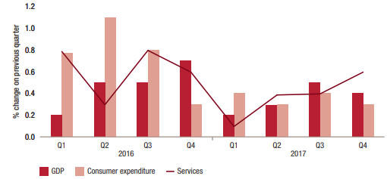

Source: (pwc, 2018, p. 8).

The figure above shows the growth of GDP, consumer expenditure and services for the year 2016 and 2017. The growth highest in the second quarter of 2016 and lowest in the first quarter of 2017, but it has been growing at varying trend.

Figure 4. Employment and productivity trend.

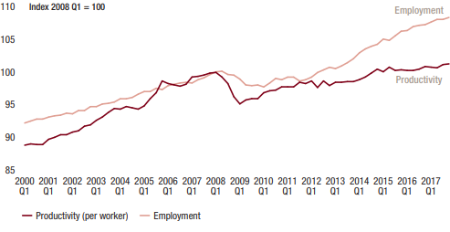

Source; (Pwc, 2018, p. 10).

The figure above shows employment and productivity trend before and after the financial crisis. It is apparent that since 2009, the rate of employment has been growing steadily while the productivity of labour has been growing at slowing pace. The decline in productivity could be due to shifting in the employment of labour from manufacturing to other industries especially the service industry.

In conclusion, Monetary and fiscal policies play a significant role in influencing economic growth. Since 2009, the Bank of England has been using various monetary and fiscal policies to enhance economic growth and speed-up economic recovery from financial crisis. Low-interest rates and quantitative easing are some of the policy instruments which have contributed to steady economic growth. Higher employment rate and low inflation promoted private consumption to increase economic growth. Since the last quarter of 2016, the interest rate was reduced to almost 0% while the government expanded quantitative easing to achieve economic stability. Going forward, the UK government is set to increase interest rate and use other policy interventions to achieve economic stability. Also, the government should reduce quantitative easing to contain inflation at the required average of 2%. The focus should be on increasing labour productivity and steady economic growth.

## List of References

Bank of England, 2017, Financial Stability Report.

House of Commons Library, 14 September 2016, Quantitative Easing.

IMF, July 2017, *World economic outlook.*

ONS, (22 December 2017), Balance of Payment.

pwc, 2018, *The UK Economic Outlook*.